|  |  |
| --- | --- |
| f |  |
| CDS Ops Guide and As-Built Phases 1 & 2.1 |  |
| PWP1DL23 - CDS Ops Guide and As-Built | |
| **Presenter name**  Avanade  22 April 2022 | |

Ops Guide and As-Built

1. **DOCUMENT OVERVIEW**

| **Project Title** | CFS Core IT – Phases 1 & 2.1 |
| --- | --- |
| **Author** | Avanade: Kevin Co, Lalyn Mendoza, Prakash Indorkar |
| **Reviewer** | Soumith Rao, John Stannard |
| **Current Version** | Release 1.0 |
| **File Name** | PWP1DL23 - CDS Ops Guide and As-Built.docx |
| **Publication Date** | 22 April 2022 |

* 1. Revision History

| **Version** | **Date** | **Author** | **Changes** |
| --- | --- | --- | --- |
| 0.1 | 06/04/2022 | Kevin Co  Lalyn Mendoza  Prakash Indorkar | Initial Version |
| 1.0 | 22/04/2022 | Kevin Co  Lalyn Mendoza  Prakash Indorkar | Version submitted to client.  Submitted as “PWP1DL23 - CDS Ops Guide and As-Built-FINAL-v1.0.docx” |
| 1.1 | 26/05/2022 | Kevin Co | Post-submission.  Added section on miscellaneous configuration of GitHub Enterprise Application in AAD. |
|  |  |  |  |
|  |  |  |  |
|  |  |  |  |

Table of Contents

1. DOCUMENT OVERVIEW 2

1.1 Revision History 2

2. INTRODUCTION 6

Purpose 6

Guidelines 6

3. GitHub Enterprise Cloud EMU 7

3.1 GitHub Enterprise Cloud EMU Setup – Enterprise, Organization and Repository 7

3.1.1 Create new organisation 10

3.1.2 Create a new repository 13

3.2 Provision GitHub Enterprise Cloud – Enterprise Managed Users (EMU) with AAD as Identity Provider 14

3.2.1 GitHub Enterprise Cloud EMU Setup – SAML SSO 14

3.2.2 Add SAML settings to GHEC 18

3.2.3 Configure automatic user account provisioning to GitHub in Azure AD. 20

3.2.4 Configure users and groups in Azure AD - Enterprise Application for GitHub 25

3.3 Managing access with roles in GitHub 27

3.3.1 For GitHub “Enterprise Administrator” 27

3.3.2 For “GitHub Users” 28

3.3.3 For “Team-level roles” 30

3.4 Branching Strategy 32

3.4.1 Branching Workflows 32

3.4.2 Branch protection rules on the repository 33

3.4.3 Pull Request Process 37

3.5 GitHub Actions for CI 38

3.5.1 Components of GitHub Actions 38

3.5.2 CFS GitHub workflows 39

3.5.3 Workflow jobs for pull request and merge to develop/main branch 39

3.5.4 Azure Artifacts Publish 39

4. AZURE DEVOPS 40

4.1 Azure DevOps user and security setup 40

4.1.1 Organizational Settings 40

4.1.2 Manage group rules 43

4.1.3 Organization-level permissions 45

4.1.4 Project-level permissions 45

4.2 Connecting to GitHub Enterprise to Azure Artifact Feed 47

4.3 Azure DevOps Boards – Connecting to GitHub Enterprise 48

4.4 Azure Pipelines – Connecting to GitHub Enterprise 53

4.5 Azure Pipeline Library 55

4.5.1 Create variable groups 56

4.5.2 Set variables in YAML pipeline 58

4.5.3 CFS core-it variable groups 58

4.6 Azure “CFSCo Master Pipeline” 59

4.6.1 Pipeline filename 59

4.6.2 Pipeline Parameters and Variables 59

4.6.3 Pipeline Stages 60

4.6.4 CFSCo Master Pipeline stages 61

4.6.5 Deployment Process – Manual trigger 63

4.6.6 Deployment Approval 63

4.7 Azure Artifact 64

4.7.1 Artifacts Feeds 64

5. SELF-HOSTED AZURE DEVOPS AGENT AND GITHUB RUNNER 65

5.1 About Azure DevOps/GitHub self-hosted agents/runners 65

5.1.1 Self-hosted agent and runner specification 65

5.1.2 Application or tools installed 65

5.1.3 Firewall rules 66

5.1.4 Library and variable setup 67

5.1.5 Auto Shutdown Config 68

5.1.6 Scheduled and manual start-ups of VMs 68

5.2 GitHub Runners/ADO Agents and Tools Installation 68

5.2.1 Parameters Specification/Description 69

5.2.2 Steps to run Agent/Runner pipeline 69

5.2.3 Verify tools installation was successful 72

5.3 Verify ADO Agents are running and registered 73

5.4 Verify GitHub Runners are running and registered 75

5.5 Production only GitHub Runners 76

5.6 De-register and Delete GitHub Runner/ADO Agent resource 77

5.6.1 Parameters Specification/Description 77

5.6.2 Steps to run De-register/Delete Agent Runner pipeline 77

5.7 Manually deleting the Runners/Agents 79

5.7.1 Delete the ADO agents manually 79

5.7.2 Delete the GitHub runners manually 80

5.8 More details on ADO agent pool and GitHub Runner Groups 81

5.9 Testing the Runners/Agents for running a Pipeline 83

5.9.1 Test pipeline to use ADO Self-Hosted Agent 83

5.9.2 Test Pipeline to use GitHub Self Hosted Runner 83

5.10 Troubleshooting 85

5.10.1 Agent/Runner failed to register 85

5.10.2 Agent/Runner showing Offline 85

5.10.3 Tools Installation failed on Agent/Runner 86

5.10.4 Agent/Runner failed to de-register 86

5.10.5 Timed Out 86

6. BROWSERSTACK 86

6.1 About BrowserStack 86

6.2 BrowserStack Account 86

6.3 Install the BrowserStack Azure DevOps Extension 87

6.4 Service Connection 89

6.5 Testing DevOps pipeline with sample C# code 92

6.5.1 Sample code for Selenium Webdriver tests with C# 92

6.5.2 Integrate BrowserStack Automate with Azure Pipelines 93

7. BLAZEMETER 96

7.1 About BlazeMeter 96

7.2 BlazeMeter Account 96

7.3 Creating a performance test 96

7.4 Install the BlazeMeter Azure DevOps Extension 98

7.5 Testing via Azure DevOps Pipeline 99

7.5.1 YAML Pipeline for BlazeMeter Integration 100

7.5.2 BlazeMeter test reports 100

8. GITHUB PACKAGE REGISTRY 101

8.1 About GitHub Package 101

8.2 Publish NuGet packages with GitHub Actions 101

1. **INTRODUCTION**

## Purpose

The scope of this document is to provide details of the Phase 1 and Phase 2.1 CFS Core IT – CDS build. This document outlines the overall As-Built view and Ops Guide for CFS Core IT – CDS stream.

## Guidelines

Images and screenshots have been taken from a mixture of production and non-production instances. In almost all cases, production and non-production instances are configured in the same/equivalent way.

1. **GitHub Enterprise Cloud EMU**
   1. GitHub Enterprise Cloud EMU Setup – Enterprise, Organization and Repository

This will guide you on how to configure enterprise-level policies and create organisation and repositories.

**Prerequisites:**

* GitHub Enterprise Owner Account
* Configure enterprise-level policies – repository policy settings

The idea is to maximize use of enterprise administrators so there is centralized management of GitHub. This approach reduces repository permissions for repository administrators and will likely eliminate the need for repository administrators. As much as practically possible, Contributors/Reader access should be assigned at repository level.

1. At enterprise-level, set “no permission” for organization members to organization repositories.

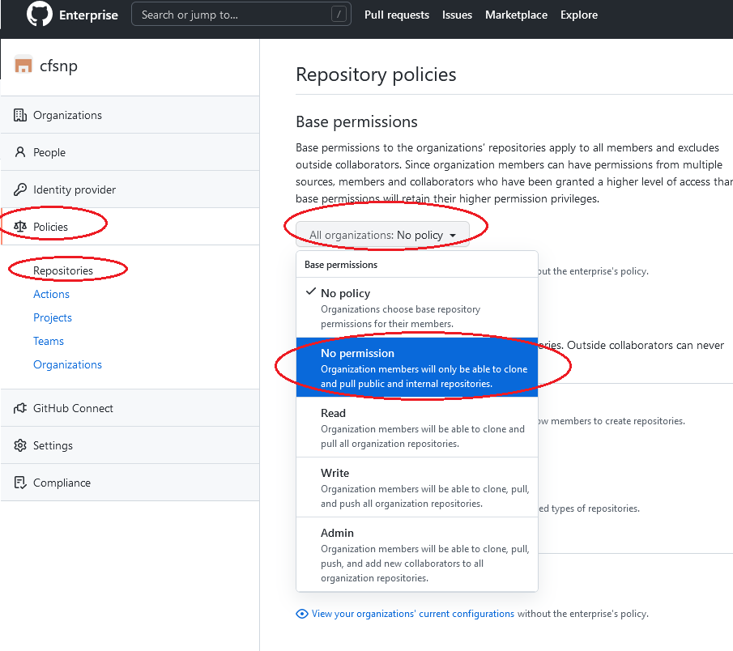

1. Confirm change base permission.

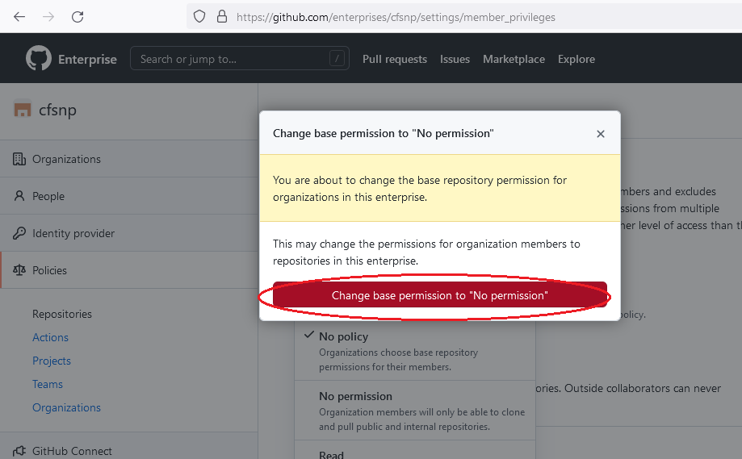

1. Disable members creating any repositories

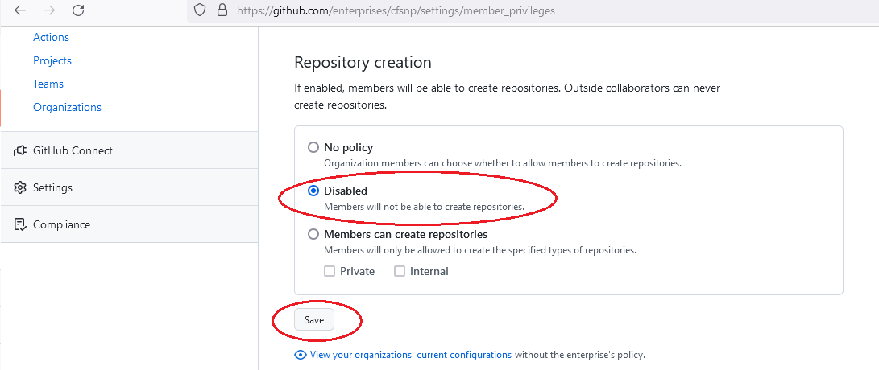

1. Disable repository forking

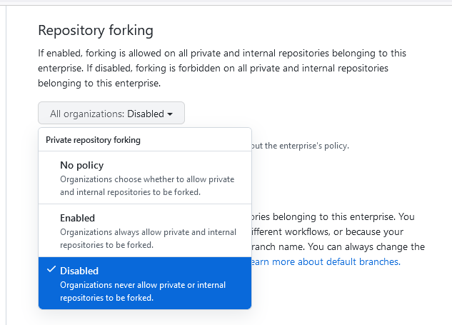

1. Ensure default branch name is “main”, however do not enforce in all organizations across the enterprise. This allows individual repositories to have a different default branch, depending on team’s choice, or legacy git history that is migrated from legacy git system.

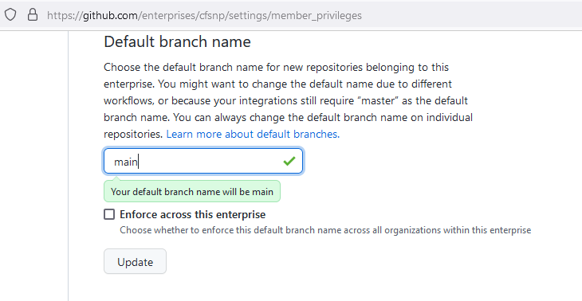

1. Disable repository administrators from changing repository visibility.

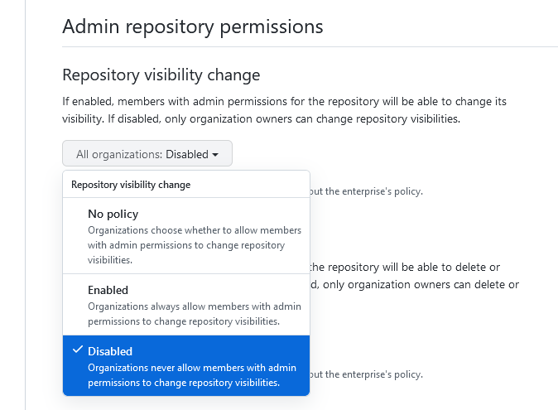

1. Disable repository administrators from deleting the repository and transfer

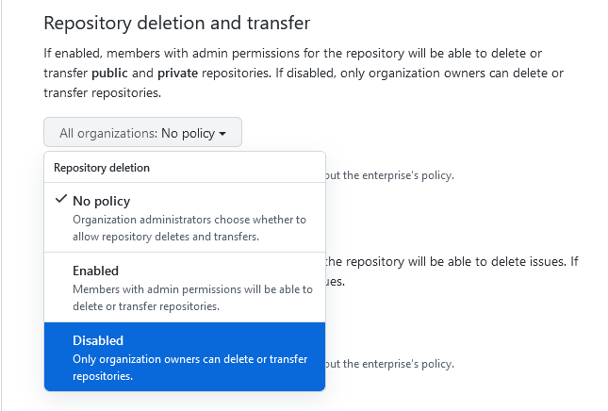

1. Disable repository administrators from deleting issues

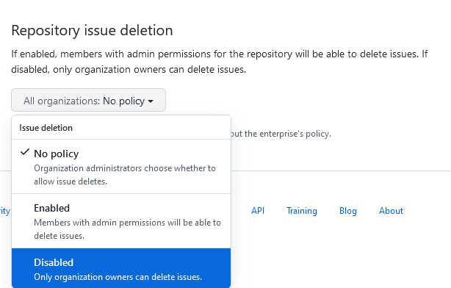

* + 1. Create new organisation

1. Go to GitHub enterprise page, click ***New organization***.

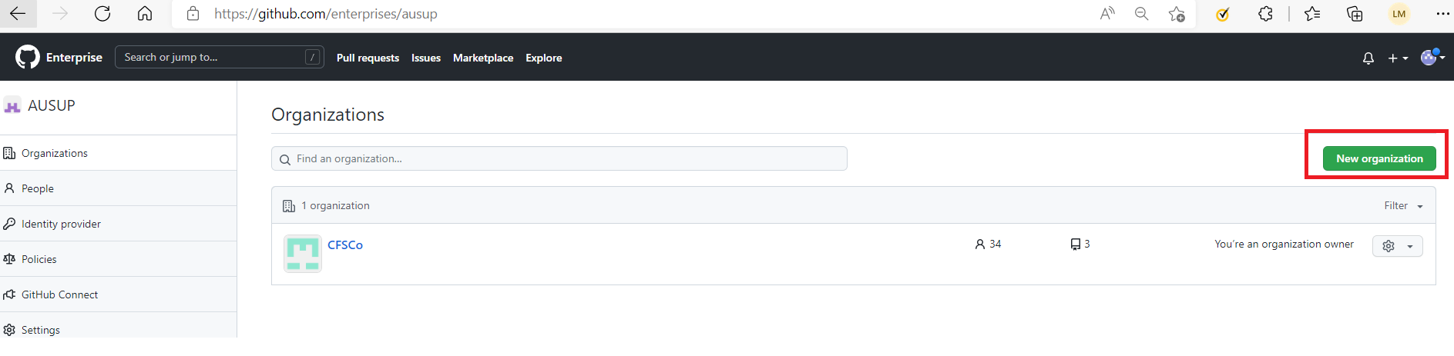

1. Enter Organisation name (it needs to be globally unique), then Create Organisation.

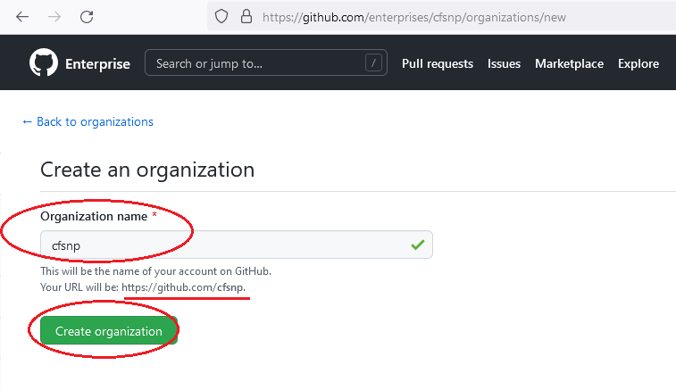

1. Created successfully.

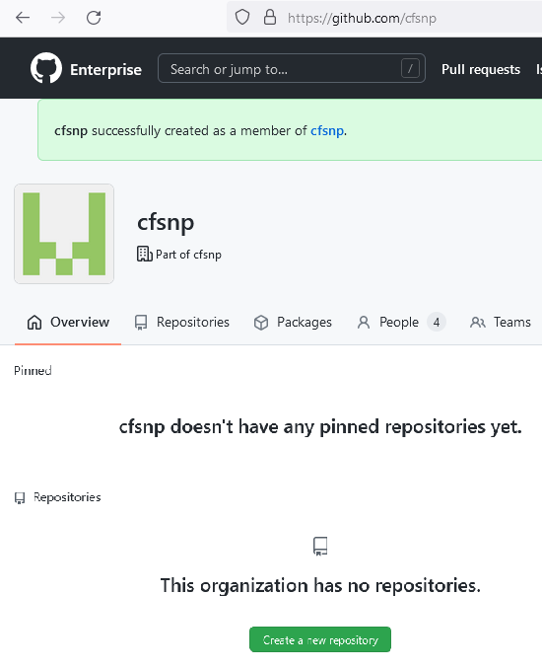

1. You can confirm that the organisation is not publicly visible by opening a private browser and access https://github.com/{yourorganization}.

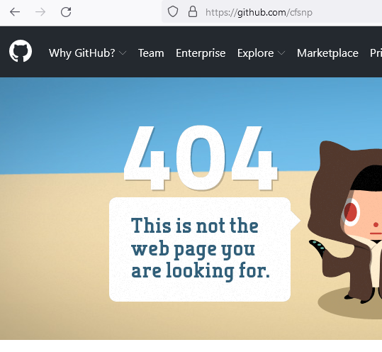

* + 1. Create a new repository

1. Go to organization page, select “Repositories”and then click “Create a new repository”.

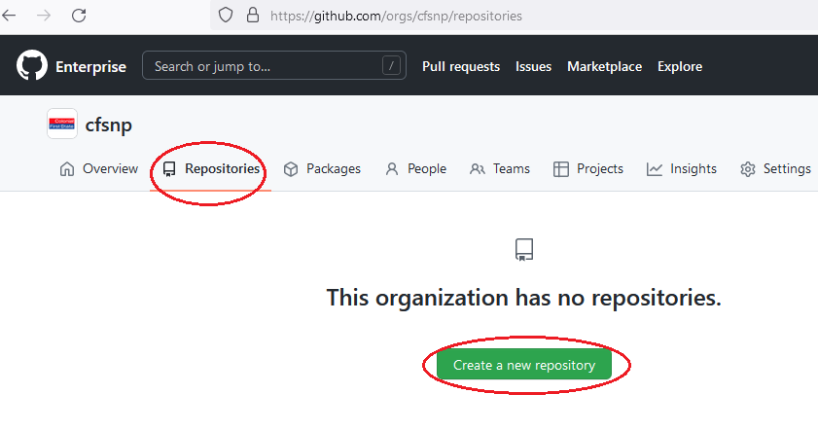

2. Type a name for your repository, an optional description. Select “Private”, check “Add a README file” and ”Add .gitignore” (optional). Also check the default branch being set.

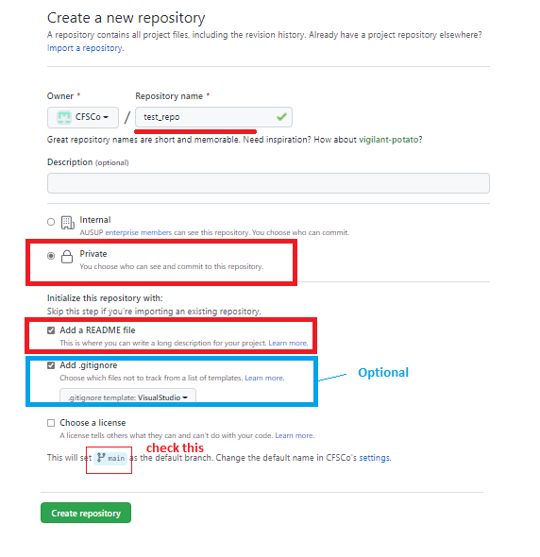

* 1. Provision GitHub Enterprise Cloud – Enterprise Managed Users (EMU) with AAD as Identity Provider

This provides a different SSO experience to standard GitHub Enterprise Cloud. Users are completely managed in Azure Active Directory. Users are not GitHub native users, and won’t have a public profile, nor have ability to create public repositories using that user.

**Prerequisites:**

* Azure AD subscription
* Activated PIM Role - Cloud Application Administrator (privileges to configure enterprise application)
* GitHub Enterprise Managed User single sign-on (SSO) enabled subscription.
  + 1. GitHub Enterprise Cloud EMU Setup – SAML SSO

1. Configure SSO

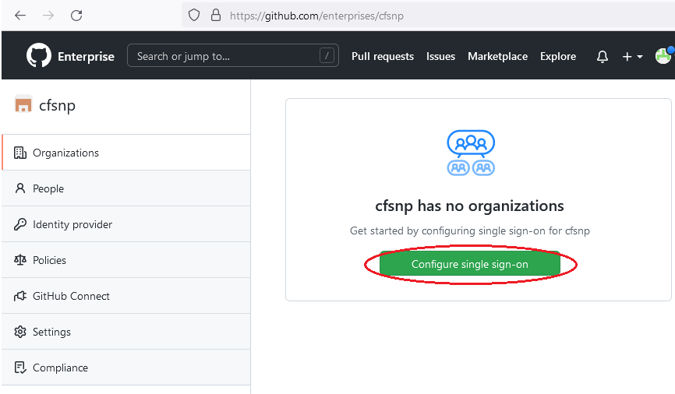

1. Setup Organization Security – Go to [Azure Active Directory single sign-on (SSO) integration with GitHub Enterprise Managed User](https://docs.microsoft.com/en-us/azure/active-directory/saas-apps/github-enterprise-managed-user-tutorial)
2. In the Azure portal, on Enterprise Application, create new application.

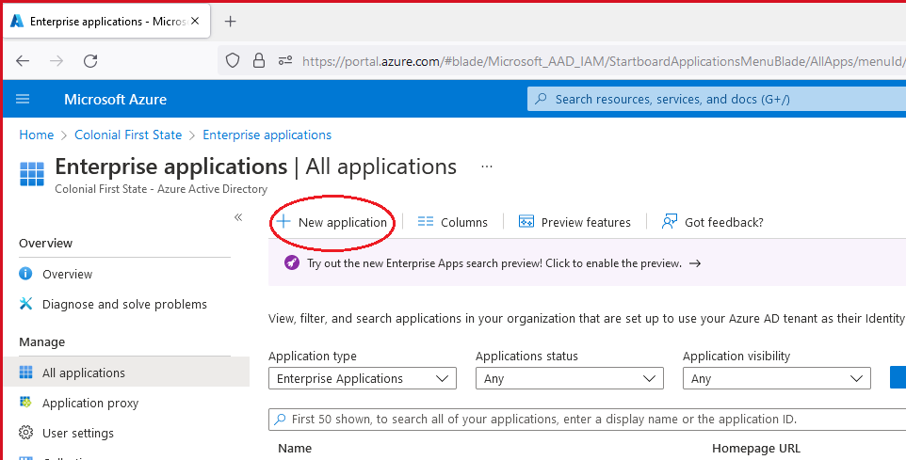

1. Search for “GitHub Enterprise Managed User” and Create Application.

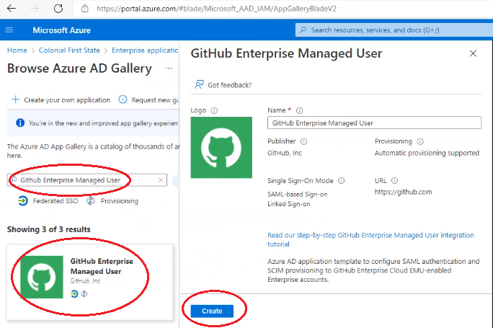

Name: GitHub Enterprise Managed User

Application ID: a9c5a1a6-efff-4e18-9ab4-6ccfce67ff1b

ObjectID: 7621f05d-f4a8-4e88-b3ea-c199482f9f8a

1. Switch to SAML method.

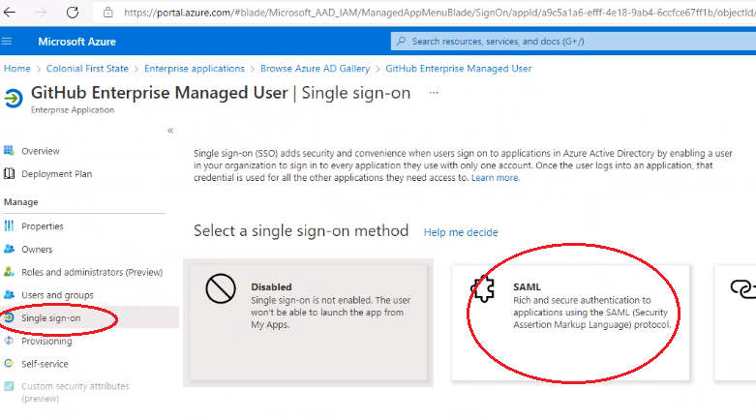

1. Edit SAML configuration

Identifier: https://github.com/enterprises/{yourorganization}

Reply URL: https://github.com/enterprises/{yourorganization}/saml/consume

Sign-on URL: https://github.com/enterprises/{yourorganization}/sso 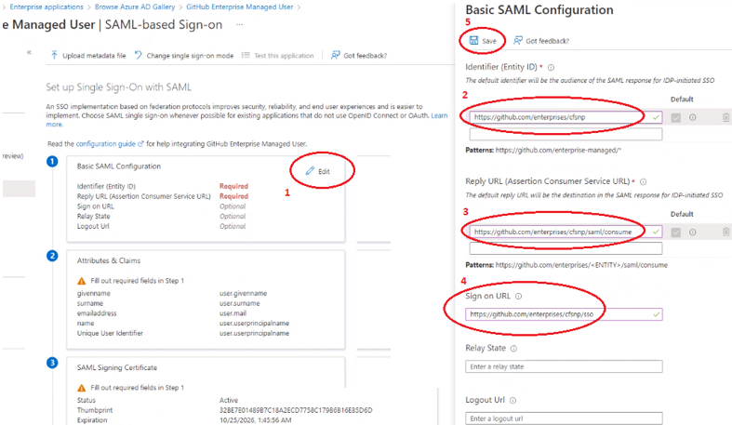

1. Capture details for GHEC setup. Download the Certificate (Base64) and copy the following URLs:

* Login URL
* Azure AD Identifier
* Logout URL

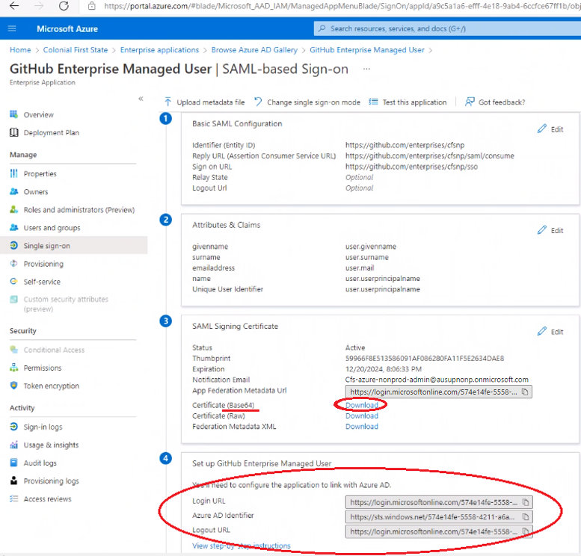

* + 1. Add SAML settings to GHEC

1. Go to [https://github.com/organizations/{yourorganization}/settings/security](https://github.com/organizations/%3corg_name%3e/settings/security)

Please note of the following:

* Sign on URL: Populate with "Login URL" from the Enterprise Application's config in Azure portal.
* Issuer: Populate with "Azure AD Identifier" from the Enterprise Application's config in Azure portal.
* Public Certificate: Populate with the downloaded base64 certificate from the Enterprise Application's config in Azure portal.

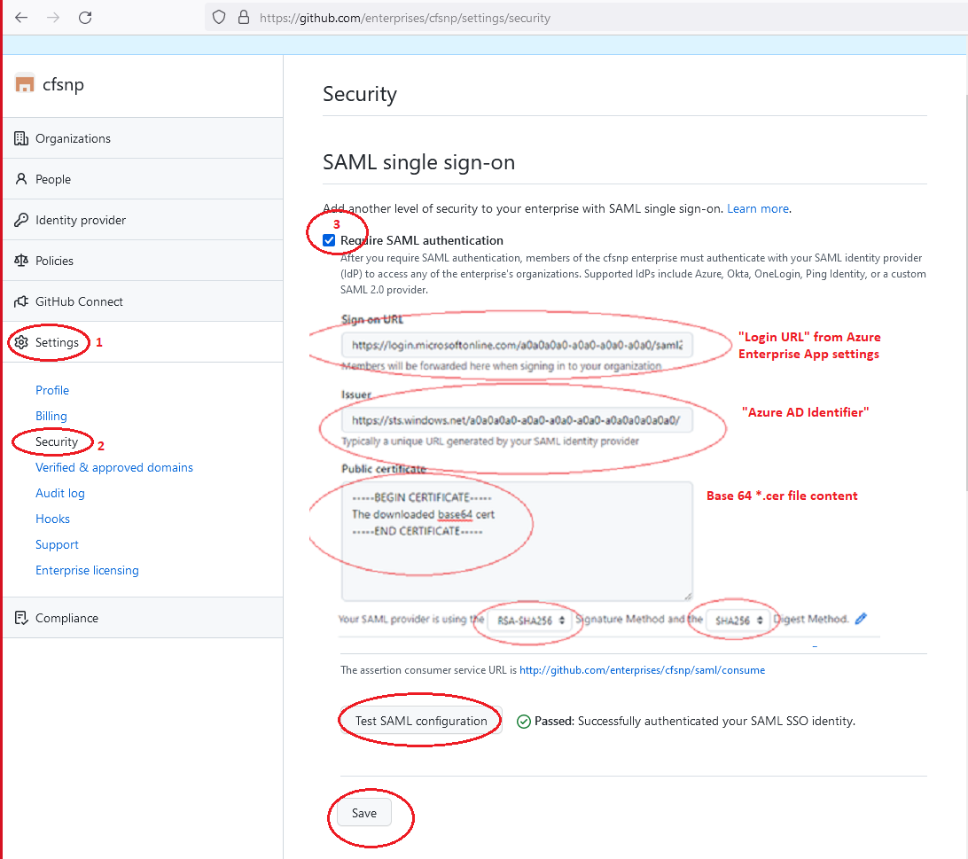

1. Backup the single sign-on recovery codes.

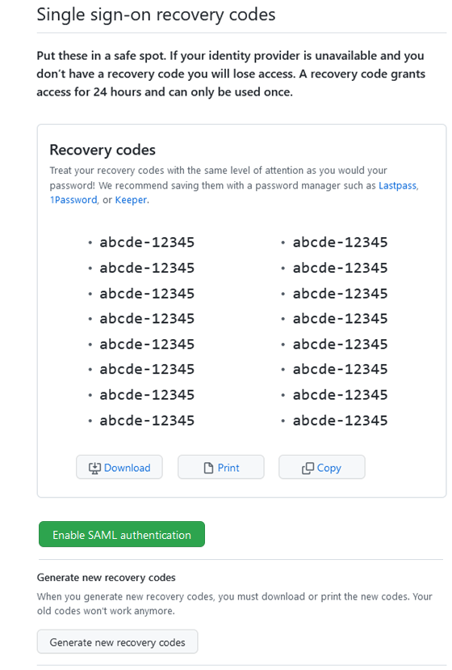

* + 1. Configure automatic user account provisioning to GitHub in Azure AD.

This integration, which leverages an OAuth app, automatically adds, manages, and removes members’ access to a GitHub Enterprise Cloud EMU based on user and group assignment in Azure AD. This is done via SCIM.

Please see reference: <https://docs.microsoft.com/en-us/azure/active-directory/saas-apps/github-enterprise-managed-user-provisioning-tutorial>

1. Create a PAT token for the enterprise owner who is setting this up – recommend logging in using a service or admin account (that is perpetual), not an employee account.

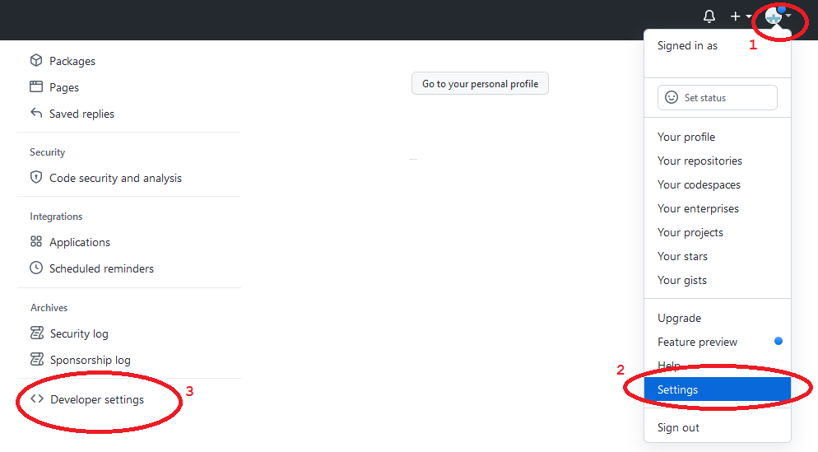

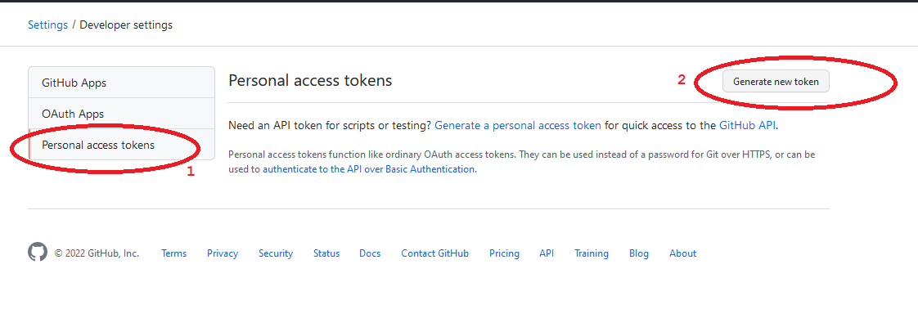

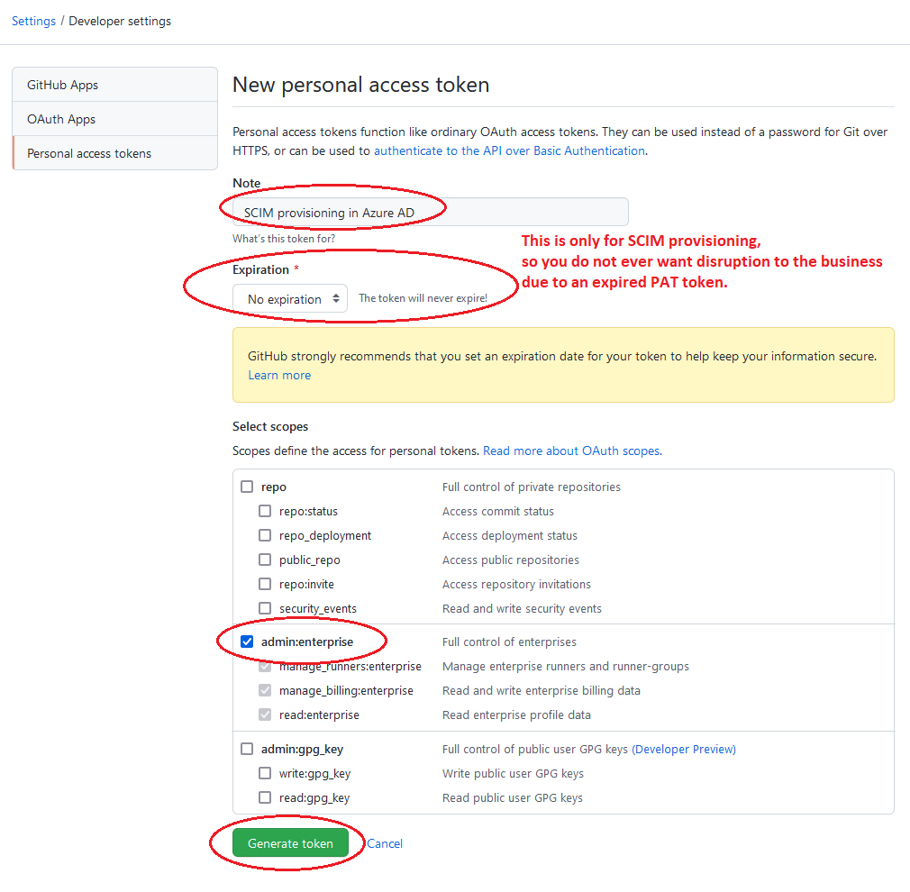

1. Set to automatic provisioning in Azure Portal.

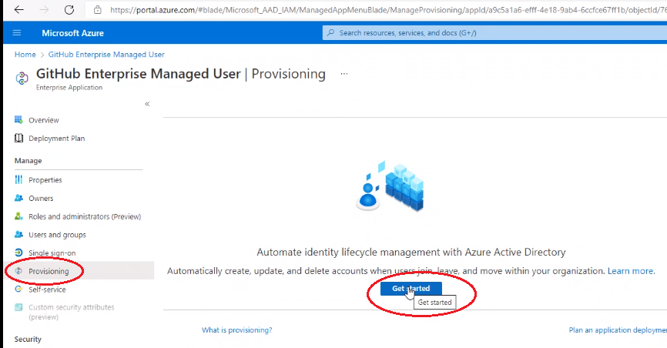

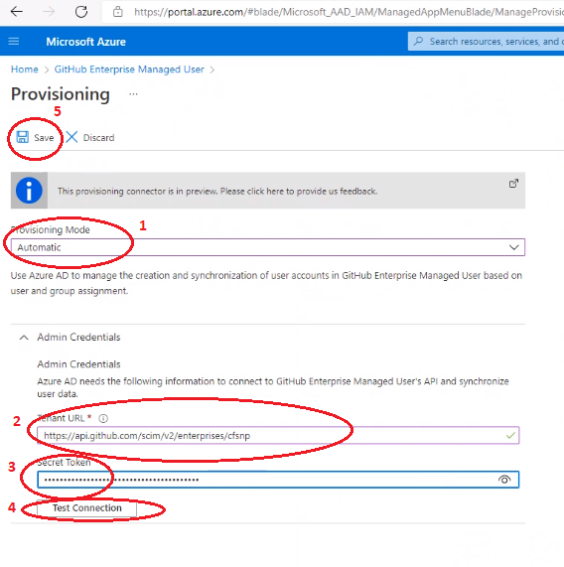

1. Please see below settings.

* Set the notification email address (for any provision errors)
* Set scope for sync to “Sync only assigned users and groups”
* Turn Provisioning Status to ON.

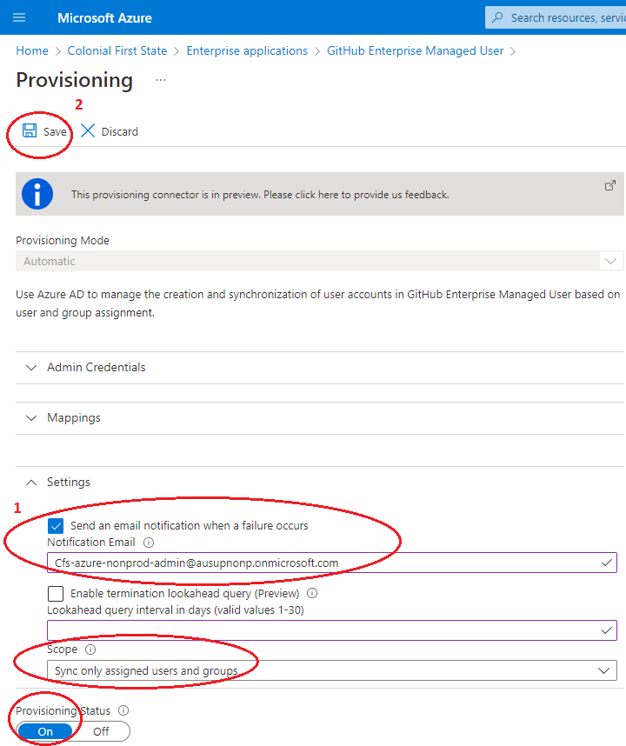

1. Refresh the Provisioning page, and you’ll see the status of the provisioning.

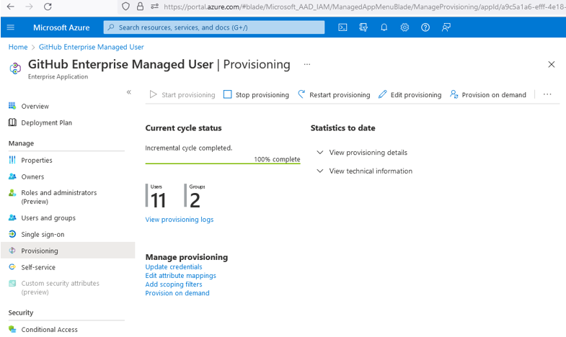

* + 1. Configure users and groups in Azure AD - Enterprise Application for GitHub

1. If new group is required you can create a group by following this Microsoft documentation “**[Create a basic group and add members using Azure Active Directory](https://docs.microsoft.com/en-us/azure/active-directory/fundamentals/active-directory-groups-create-azure-portal)**”.
2. Sign in to the Azure portal and search for Azure Active Directory. On the Active Directory page, select Enterprise application and go to GitHub Enterprise Managed User.
3. Select GitHub Enterprise Managed User and then select **Users and Groups.** Click **Add user/group.**

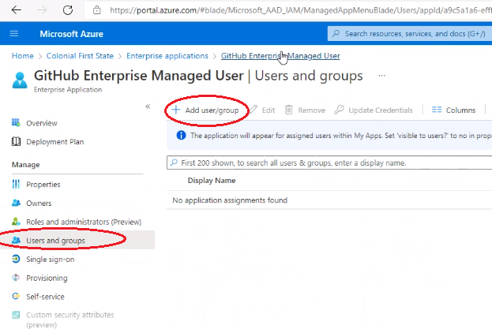

1. Select as many groups or users as you want, then click or tap Select to add them to the Add Assignment list. You can also assign a role to a user at this stage.

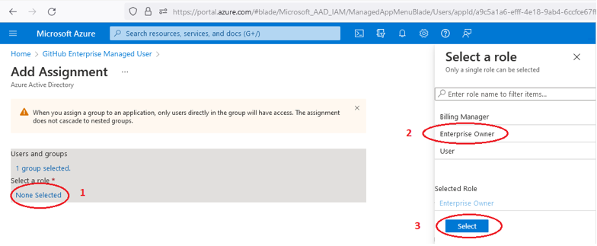

1. Select Assign to assign the users or groups to the selected enterprise application.

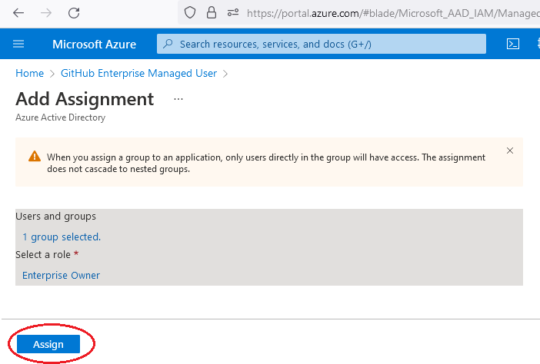

* + 1. Set not visible in My Applications portal.

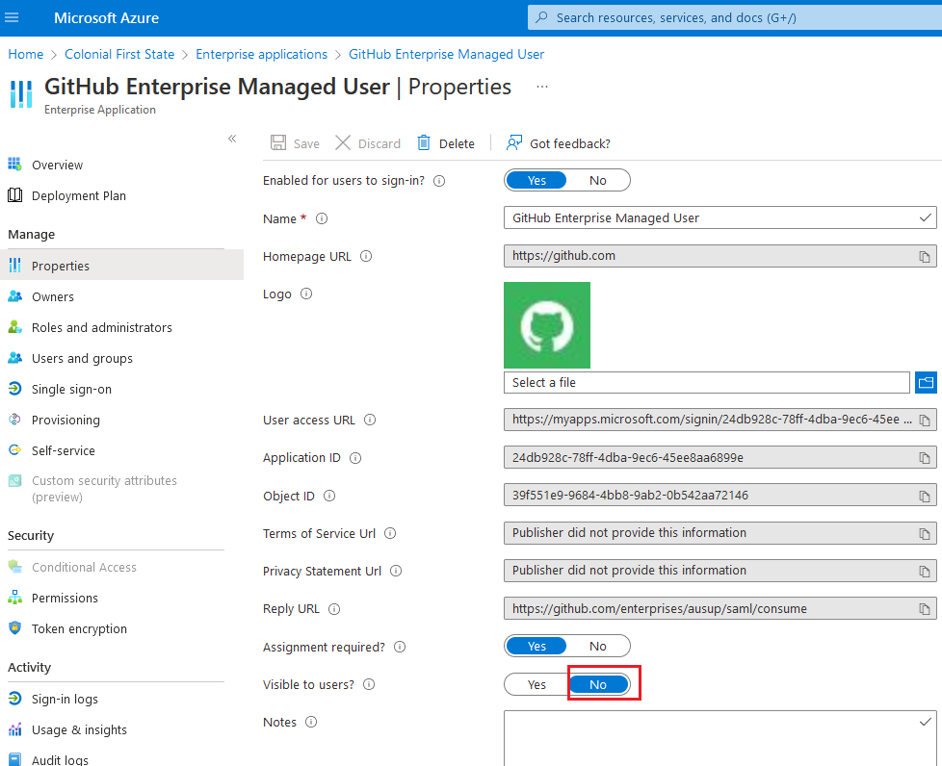

Verify:

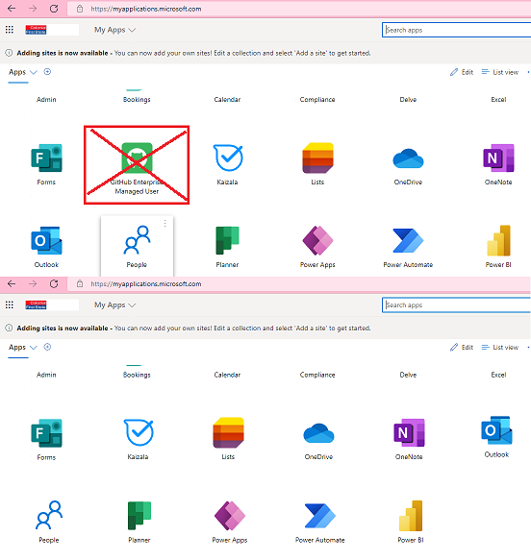

* 1. Managing access with roles in GitHub
     1. For GitHub “Enterprise Administrator”

These users will be able to view, administer and manage the enterprise.

1. Add groups – for GitHub “enterprise administrators”

* SG-AA-BUILD-GitHub-Enterprise-Administrators

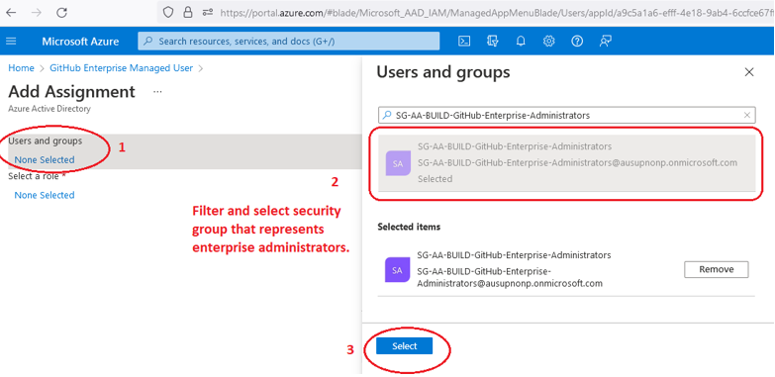

1. Add role – for GitHub “enterprise administrators”



1. Add assignment – for GitHub “enterprise administrators”



* + 1. For “GitHub Users”

These users that are allowed to login. They can view the enterprise but should not be able to view any organization.

1. Add groups for GitHub users

* SG-AA-BUILD-GitHub-Users

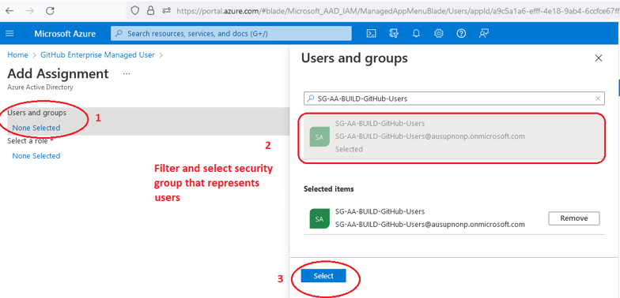

1. Add role – for GitHub users

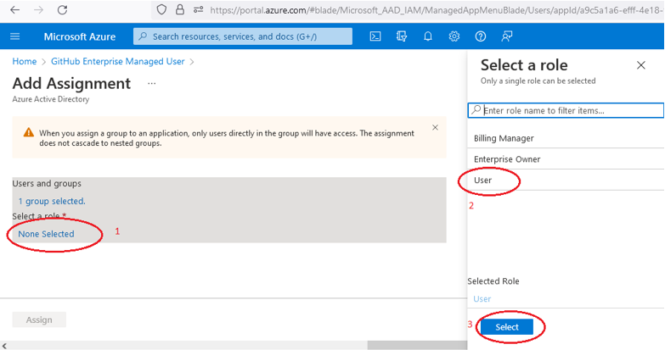

1. Add assignment – for GitHub users

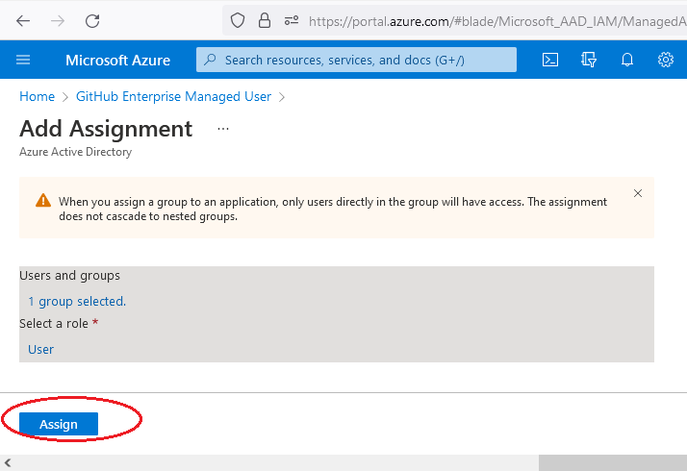

* + 1. For “Team-level roles”

Repeat the steps of “For GitHub Users” for all Team-related Security Groups

* SG-AA-BUILD-GitHub-CoreIT-Administrators
* SG-AA-BUILD-GitHub-CoreIT-Writers
* SG-AA-BUILD-GitHub-CoreIT-Readers

It's needed for linking a GitHub Team to each team-related security group and granting a certain level of access to each of the repositories.

1. Add groups - for all Team-related Security Groups

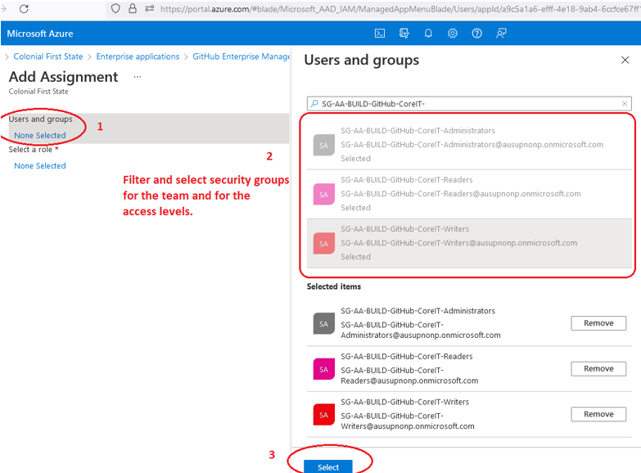

1. Add role - for all Team-related Security Groups. This must/should be “user” role. We **do not want** to be adding “enterprise owner” to any team members.

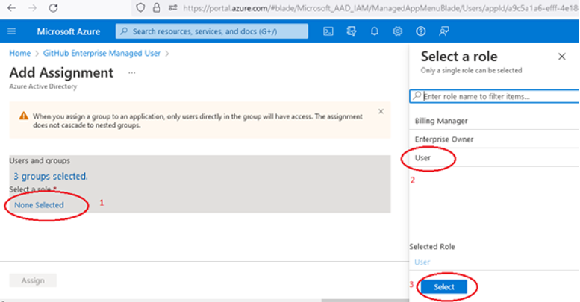

1. Add assignment - for all Team-related Security Groups

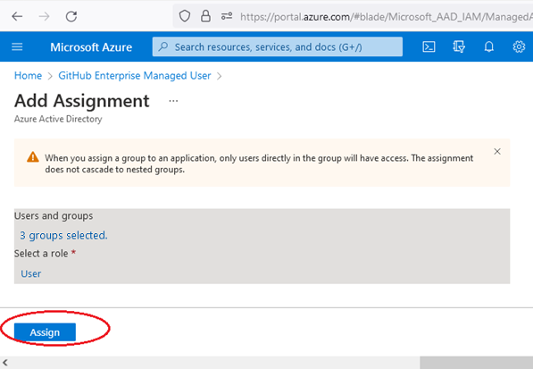

* 1. Branching Strategy

Branches are central to collaboration on GitHub. You can create a branch protection rule to enforce certain workflows for one or more branches, such as requiring an approving review or passing status checks for all pull requests merged into the protected branch.

* + 1. Branching Workflows

Branching allows team members to work on a common codebase with minimal disruption to others and provide a process to incorporate changes into a common branch.

Decision: Use a lightweight variation of Gitflow branch workflow (see “Comparison” slide). Feature branches will merge to Develop branch which is the CI branch. Develop branch will be merged to Main, which represents a future deployment to production. Where required, hotfixes can be applied to Main, and merged back into develop branch.

* **Develop branch -** This is the CI (continuously integrated) branch. Short-lived feature branches are merged to this, and CI artifacts are created, which can then be deployed to non-production.
* **Main branch -** Release artifacts created from this code and represent a near-future deployable to production.

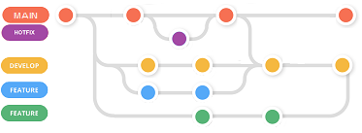

* + 1. Branch protection rules on the repository

**Prerequisites:**

* GitHub CoreIT team with Administrator access

1. Go to organization repository settings, select branches and then click “Add rule” ([https://github.com/{yourorganization}/<repo_name>/settings/branches](https://github.com/%3corg_name%3e/%3crepo_name%3e/settings/branches))

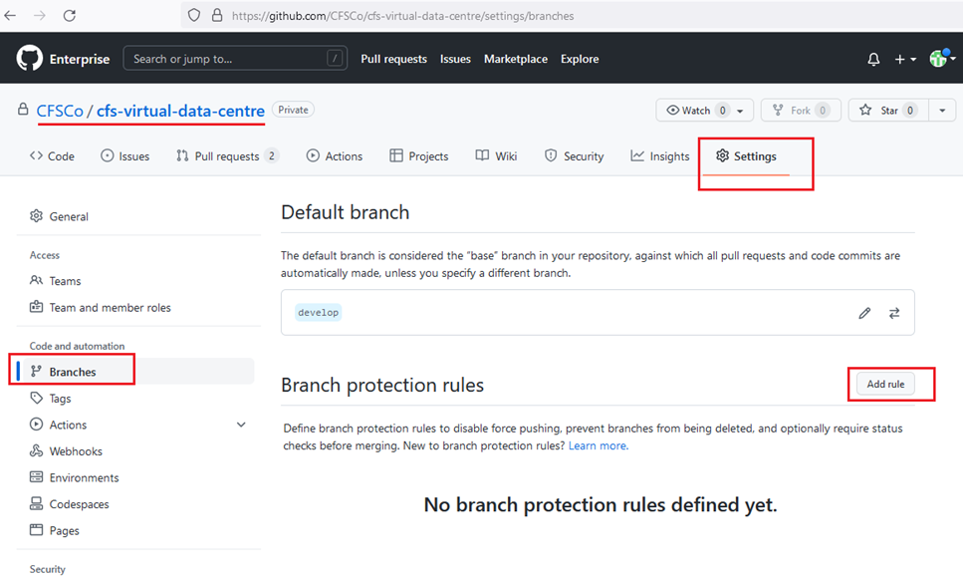

1. Add and configure rule for “main” branch.

List 1:

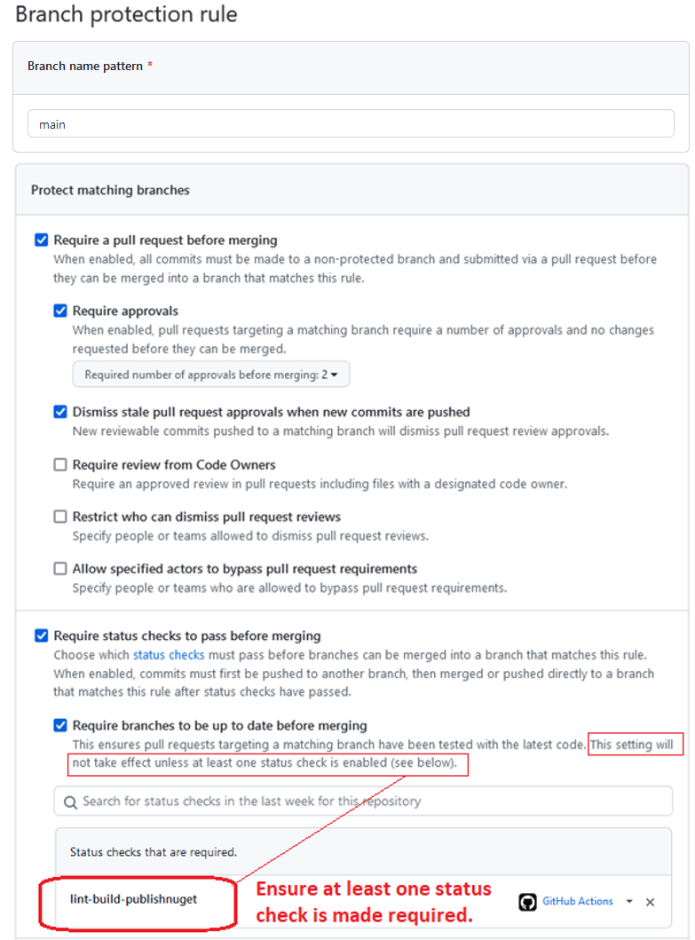

List 2:

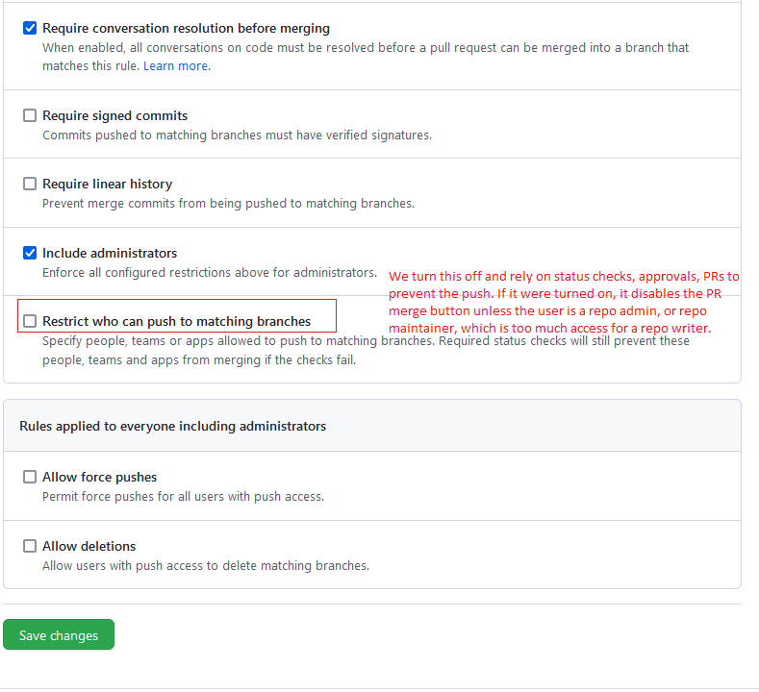

***Note***: We turn off “Restrict who can push to matching branches” and rely on status checks, approvals, PRs to prevent the push. If it were turned on, it disables the PR merge button unless the user is a repo admin, or repo maintainer, which is too much access for a repo writer.

1. Repeat add and configure rule for “develop” branch.

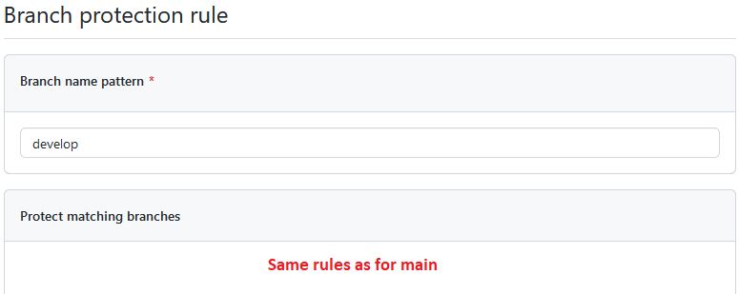

1. Do a test commit, push on main or develop.

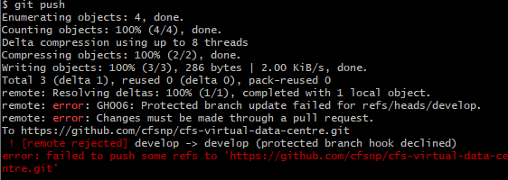

1. Switch to “develop” to be the default base branch (pull requests will default to this as the base, rather than the “main” branch)

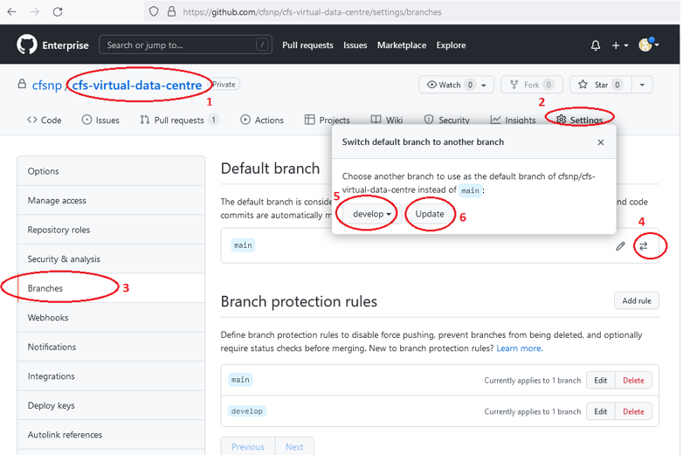

1. Set auto-delete head branch after pull request is merged to the base branch

Please see reference: https://docs.github.com/en/repositories/configuring-branches-and-merges-in-your-repository/configuring-pull-request-merges/managing-the-automatic-deletion-of-branches

This makes for simpler housekeeping of already merged branches – no reason to keep them on the server.

* Go to the repo, go to Settings

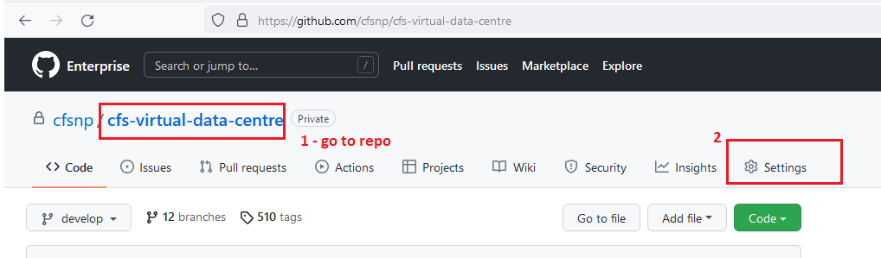

* Settings -> General -> “Pull Requests” section: Select “Automatically delete head branches”

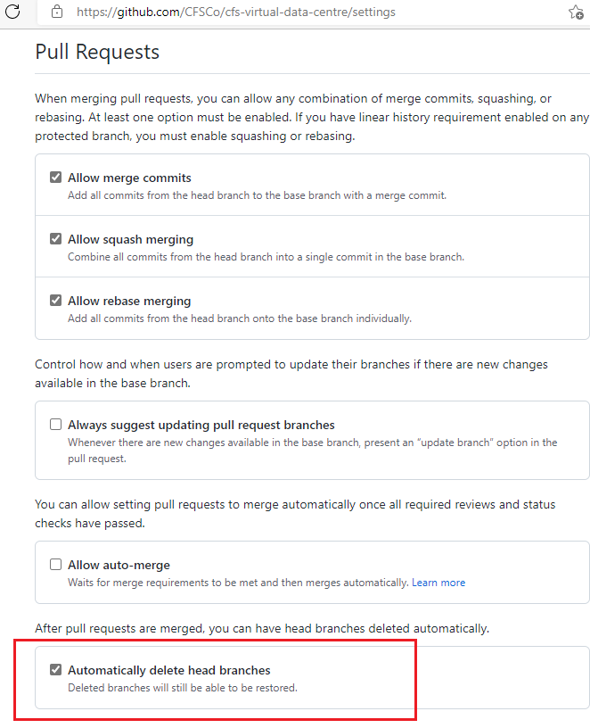

* + 1. Pull Request Process

This is a request to “pull” code from another branch. Completing a pull request results in merging code from one branch onto the target branch. Below is the branch protection rule enforced before you can merge a pull request to develop or main branch.

1. **Require pull request reviews before merging**

Pull requests targeting a matching branch require two approvals and no changes requested before they can be merged.

1. **Dismiss stale pull request approvals when new commits are pushed.**

New reviewable commits pushed to a matching branch will dismiss pull request review approvals.

1. **Require status checks before merging**

Status checks must pass before branches can be merge into a branch that matches this rule.

1. **Require branches to be up to date before merging.**

This ensures pull requests targeting a matching branch must have been tested with the latest code.

1. **Require conversation resolution before merging**

All conversations on code must be resolved before a pull request can be merged into a branch.

* 1. GitHub Actions for CI

GitHub Actions is a continuous integration that allows to automate the build. It creates workflows that build and test every pull request to repository.

* + 1. Components of GitHub Actions

You can configure a GitHub Actions workflow to be triggered when an event occurs in your repository, such as a pull request being opened, or an issue being created. Your workflow contains one or more jobs which can run in sequential order or in parallel. Each job will run inside its own virtual machine runner.

1. **Workflow**

A workflow is a configurable automated process that will run one or more jobs. Workflows are defined by a YAML file checked in to your repository and will run when triggered by an event in your repository, or they can be triggered manually, or at a defined schedule.

1. **Events**

An event is a specific activity in a repository that triggers a workflow run. For example, activity can originate from GitHub when someone creates a pull request, opens an issue, or pushes a commit to a repository.

1. **Jobs**

A job is a set of steps in a workflow that execute on the same runner. Each step is either a shell script that will be executed, or an action that will be run. A job is a set of steps in a workflow that execute on the same runner. Each step is either a shell script that will be executed, or an action that will be run.

1. **Actions**

An *action* is a custom application for the GitHub Actions platform that performs a complex but frequently repeated task. Use an action to help reduce the amount of repetitive code that you write in your workflow files. An action can pull your git repository from GitHub, set up the correct toolchain for your build environment, or set up the authentication to your cloud provider.

1. **Runners**

A runner is a server that runs your workflows when they're triggered. Each runner can run a single job at a time.

* + 1. CFS GitHub workflows

|  |  |  |
| --- | --- | --- |
| GitHub Workflow File | Workflow Trigger | Azure Artifact Feed  (published artifact) |
| **branch-name-check.yml** | Push on all branches except main, develop, hotfix, release, feature, bugfix and support branches | n/a |
| **ci-build.yml** | Push to develop branch | cfs-infra-ci |
| **pr-to-develop-build.yml** | Pull Request to develop branch | cfs-infra-pr-develop |
| **pr-to-main-build.yml** | Pull Request to main branch | cfs-infra-pr-main |
| **release-build.yml** | Push to main branch | cfs-infra-release |

* + 1. Workflow jobs for pull request and merge to develop/main branch

1. **Run checkov**

This job will run code linting on the Bicep templates and parameter files in the ./CFS.VirtualDataCentre/bicep-templates folder.

1. **Super Linter**

This linter help validate the source code for multiple languages. It automates the process to help streamline code reviews. The super-linter finds issues and reports them to the console output. Fixes are suggested in the console output but not automatically fixed, and a status check will show up as failed on the pull request.

1. **Tag build**

This job will create a git tag.

1. **Dotnet build and pack**

This job will build and pack a NuGet package from the project, and attach version information.

1. **Dotnet publish**

This job will publish the NuGet package to Azure Artifact feed specified.

* + 1. Azure Artifacts Publish

GitHub Actions is used to build an artifact and push or publish it to azure artifacts.

* **CI Build workflow -** This will trigger on push to the develop branch. The NuGet package created on this workflow will be published to “**cfs-infra-ci**” artifact feed in Azure DevOps.
* **Release Build workflow -** This will trigger on push to the main branch. The NuGet package created on this workflow will be published to “**cfs-infra-release**” artifact feed in Azure DevOps.

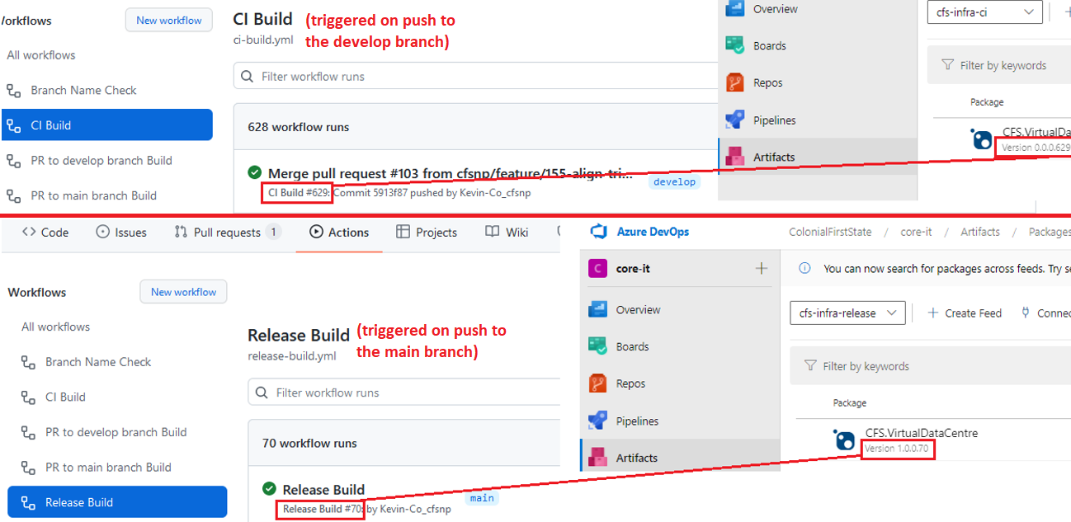

1. **AZURE DEVOPS**
   1. Azure DevOps user and security setup

**Prerequisites:**

* Azure Basic or Stakeholder access
* Azure DevOps Project Collection Administrator access
  + 1. Organizational Settings

You configure resources either for yourself or for your team, project, or organization from an administrative Settings page. The settings you can configure depend on the security group or administrative role that you belong to.

1. **Organization time zone settings**

By default, all Azure DevOps organizations and user accounts are set to UTC (Coordinated Universal Time) irrespective of what zones they are hosted in. This setting is where all your iteration dates, builds, and release schedules depend upon, and so on. Changing your organization time zone affects its dependencies.

1. Sign in to your organization ([https://dev.azure.com/{yourorganization}](https://dev.azure.com/%7byourorganization%7d)).
2. Select **Organisation settings.**
3. Go to **Overview**, and then select the time zone from the dropdown menu.

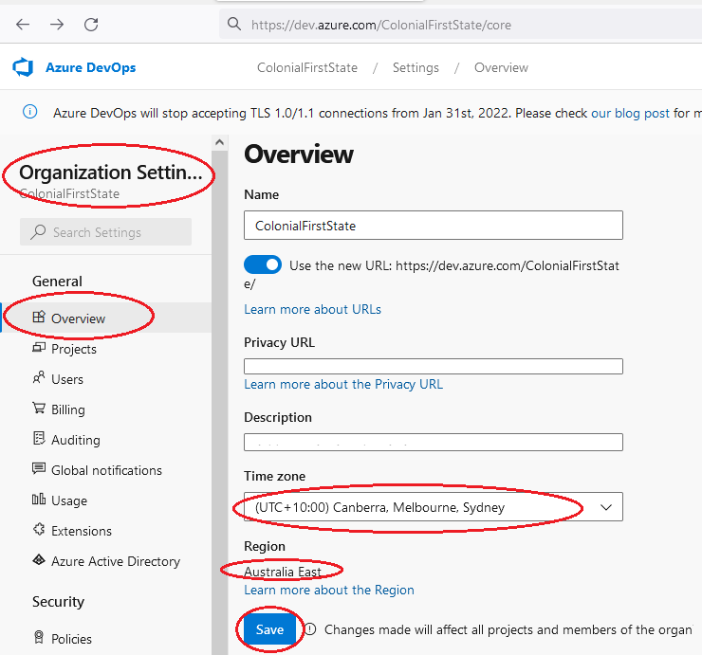

1. **Azure Boards Configuration**

The Scrum process provides several work items types—for example, product backlog items, tasks, bugs, features, and epics among others—to plan and track work.

1. Sign in to your organization ([https://dev.azure.com/{yourorganization}](https://dev.azure.com/%7byourorganization%7d)).
2. Select **Organisation settings.**
3. Go to **Boards**, and then set **Scrum** as default process.

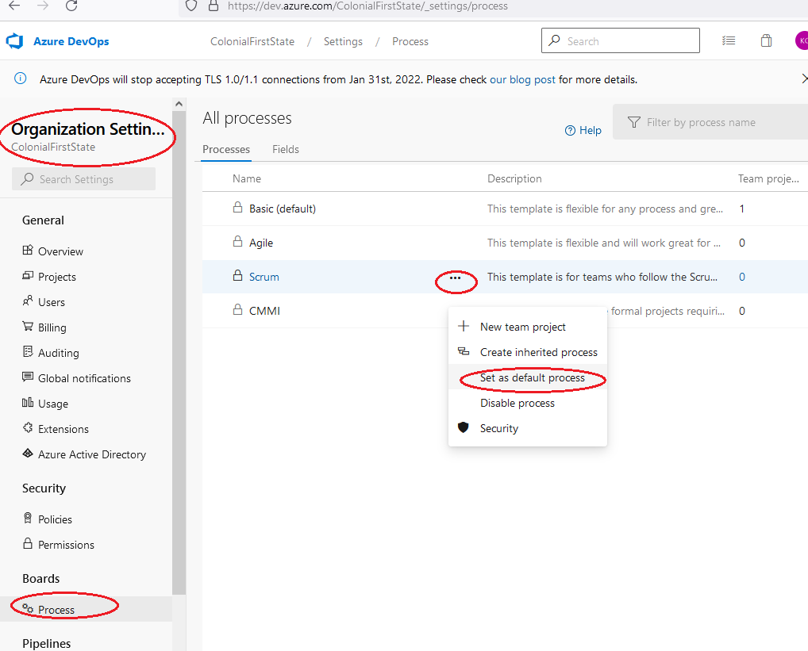

1. **Set the “core-it” project process to scrum**
2. Sign in to your organization ([**https://dev.azure.com/{yourorganization}**](https://dev.azure.com/%7byourorganization%7d)).
3. Select Organisation settings.
4. Go to Boards, Go to the “Basic” process, where the Team project column should show the number 1. Click there.

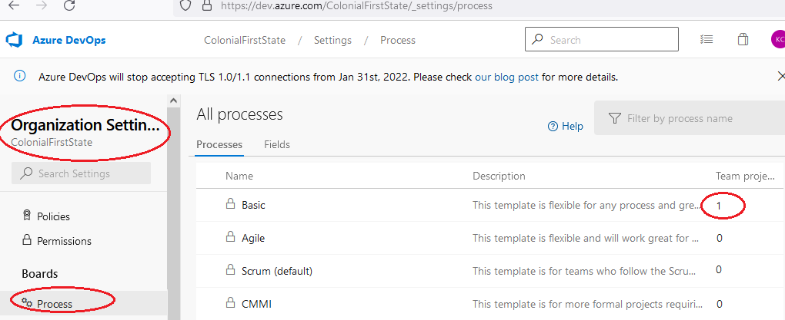

1. Change the process for the project in the project list

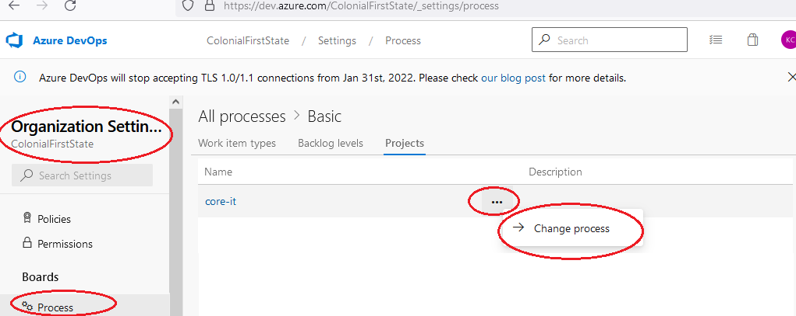

1. Select the process as Scrum

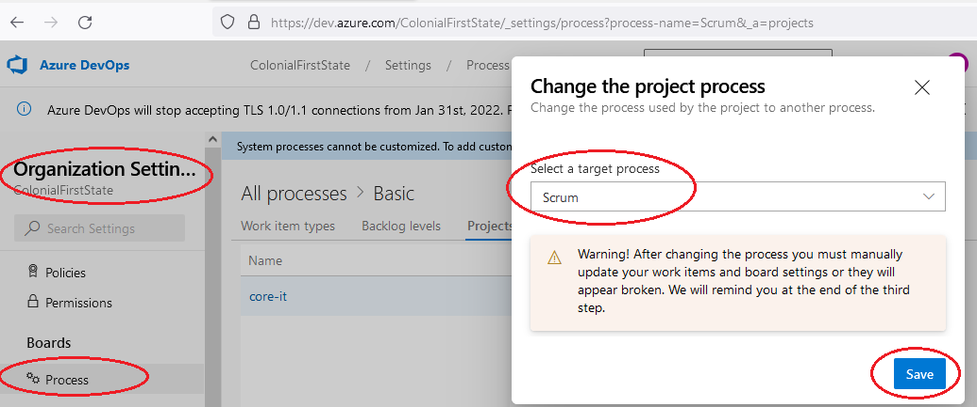

* + 1. Manage group rules

Group rules are used to add users to team projects and other specific groups, like Contributors, Readers, and Administrators.

Go to the DevOps Organisation, then click settings (bottom left).

1. **Stakeholder access**

Can be assigned to unlimited users for free. Provides partial access to private projects and mostly full access to public projects.

* SG-AA-BUILD-AzureDevOps-Users-Stakeholder

1. Sign in to your organization ([https://dev.azure.com/{yourorganization}](https://dev.azure.com/%7byourorganization%7d)) -> Organization settings -> Users -> Group rules.
2. Add *SG-AA-BUILD-AzureDevOps-Users-Stakeholder* AAD group and the select **Stakeholder** access level.

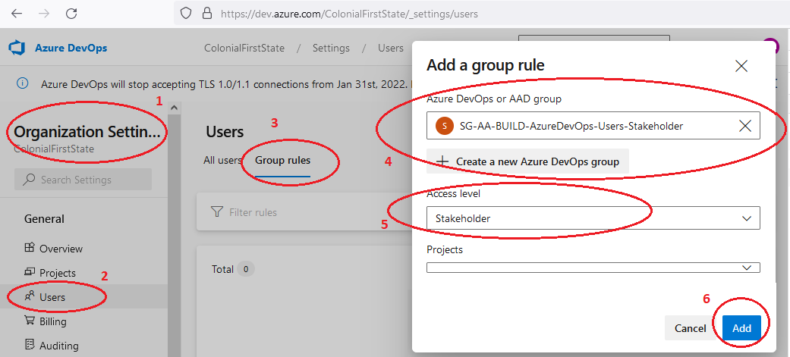

1. **Basic access**

Provides access to most features.

* SG-AA-BUILD-AzureDevOps-Users-Stakeholder

1. Sign in to your organization (https://dev.azure.com/{yourorganization}) -> Organization settings -> Users -> Group rules.
2. Add SG-AA-BUILD-AzureDevOps-Users-Basic AAD group and the select Basic access level.

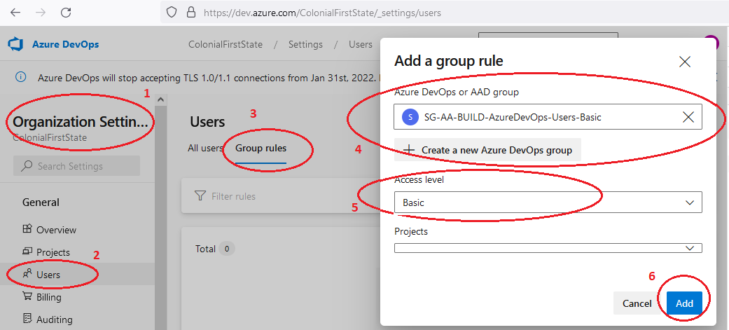

1. **Visual Studio Subscriber**

Assign to users who already have a Visual Studio subscription. The system automatically recognizes the user's subscription—Visual Studio Enterprise, Visual Studio Professional, Visual Studio Test Professional, or MSDN Platform—and enables any other features that are included in their subscription level.

* SG-AA-BUILD-AzureDevOps-Users-VisualStudioSubscriber

1. Sign in to your organization (https://dev.azure.com/{yourorganization}) -> Organization settings -> Users -> Group rules.
2. Add SG-AA-BUILD-AzureDevOps-Users-VisualStudioSubscriber AAD group and the select Visual Studio subscriber access level.

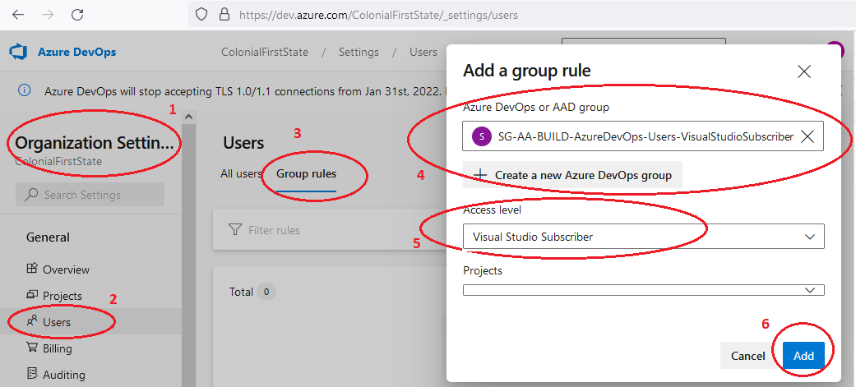

* + 1. Organization-level permissions

1. **Project Collection Administrator**

Project Collection Administrators are granted all organization-level permissions.

* SG-AA-BUILD-AzureDevOps-ProjectCollection-Administrators

1. Sign in to your organization (https://dev.azure.com/{yourorganization}) -> Organization settings -> Security -> Permission
2. Add SG-AA-BUILD-AzureDevOps-ProjectCollection-Administrators AAD group to users and/or group to <Your Organization>\Project Collection Administrators and then Save.

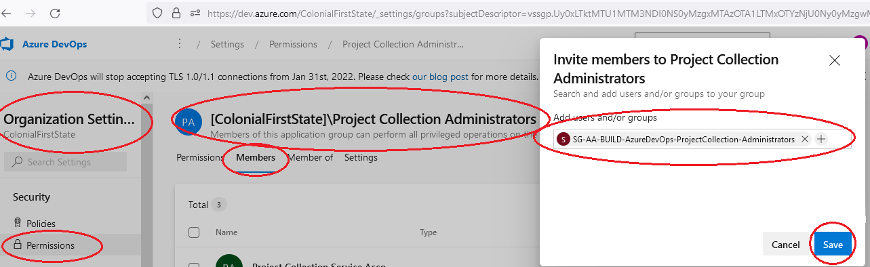

* + 1. Project-level permissions

Several permissions are set at the project level. You can grant these permissions by adding a user or group to the Project Administrators group. Or, you can grant select project-level permissions to a custom security group or to a user.

**Prerequisite:**

* Member of the Project Administrators security group

1. **Project Readers**

Users who require read-only access to the project.

* SG-AA-BUILD-AzureDevOps-CoreIT-Readers

1. Sign in to your organization (https://dev.azure.com/{yourorganization}/{yourproject}) -> Project settings -> General -> Permission -> {yourproject}\Readers -> Members
2. Add SG-AA-BUILD-AzureDevOps-CoreIT-Readers AAD group to users and/or group to {yourproject}\Readers and then Save.

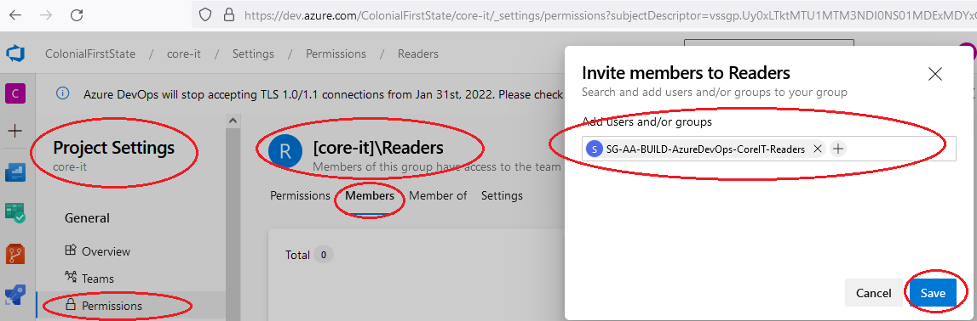

1. **Project Contributors**

Users who contribute fully to this project.

* SG-AA-BUILD-AzureDevOps-CoreIT-Contributors

1. Sign in to your organization (https://dev.azure.com/{yourorganization}/{yourproject}) -> Project settings -> General -> Permission -> {yourproject}\Contributors -> Members
2. Add SG-AA-BUILD-AzureDevOps-CoreIT-Contributors AAD group to users and/or group to {yourproject}\Contributors and then Save.

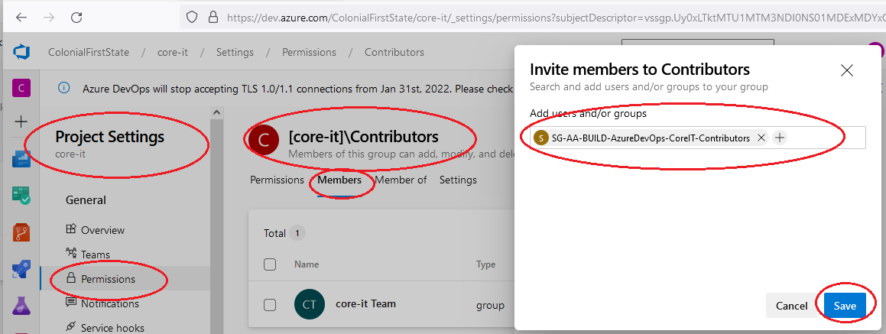

1. **Project Administrator**

Users who needs to administrate the project.

* SG-AA-BUILD-AzureDevOps-CoreIT-Administrators

1. Sign in to your organization (https://dev.azure.com/{yourorganization}/{yourproject}) -> Project settings -> General -> Permission -> {yourproject}\Project Administrator -> Members
2. Add SG-AA-BUILD-AzureDevOps-CoreIT-Administrators AAD group to users and/or group to {yourproject}\ Project Administrators and then Save.

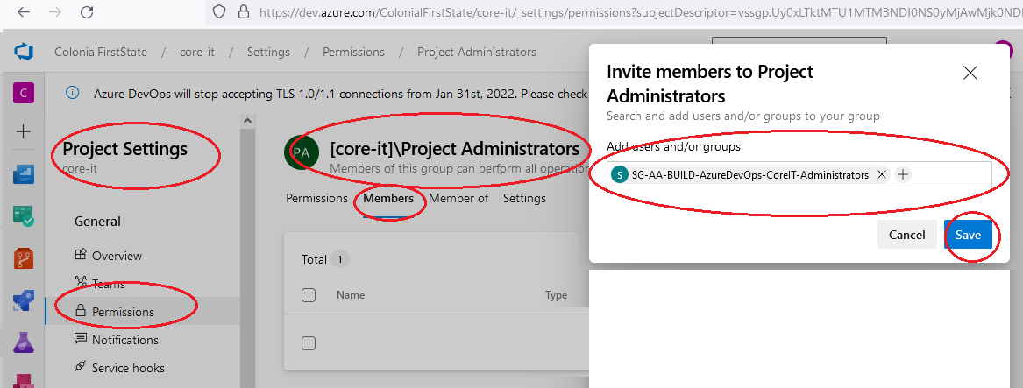

* 1. Connecting to GitHub Enterprise to Azure Artifact Feed

GitHub Actions help you automate your software development workflows from within GitHub. You can use GitHub Actions to deploy to an Azure Artifacts feed.

**Prerequisites:**

* A GitHub account with a repository.
* An Azure Artifact feed that you'll push your NuGet package to from a GitHub workflow.
* An Azure DevOps personal access token (PAT) to use with your GitHub action.

1. Sign in to your Azure DevOps organization ([https://dev.azure.com/{yourorganization}](https://dev.azure.com/%7byourorganization%7d))
2. Sign in to GHE ([https://github.com/enterprises/{yourenterprise}/sso](https://github.com/enterprises/%7byourenterprise%7d/sso)
3. In ADO, go to project -> Artifacts and then click Create Feed for “cfs-infra-release”

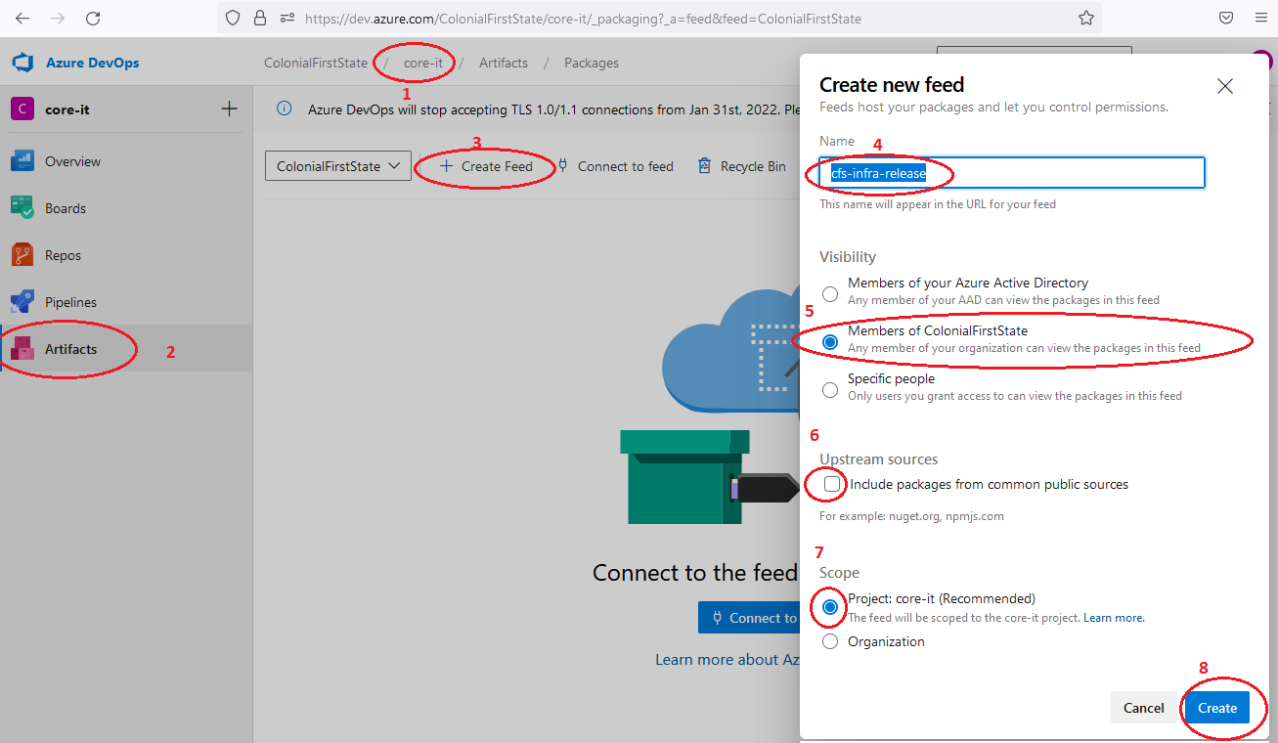

1. Create ADO Artifact Feed for “cfs-infra-ci”.

Repeat step 3.

* 1. Azure DevOps Boards – Connecting to GitHub Enterprise

This will show how to connect Azure DevOps Boards to GitHub Enterprise. This is so that Azure DevOps Boards can inspect git commit comments for work-items (e.g. Comment: “AB#123 Update yaml file”) and provide links to the respective git commit or pull-request from within Azure DevOps Boards.

**Prerequisites:**

* You must be a member of the Project Collection Administrators group and the project's Contributors group.
* You must be an administrator or owner of the GitHub repository you'll connect to. You can connect to multiple GitHub repositories so long as you're an administrator for those repositories.
* Azure Boards or Azure DevOps project.

1. In ADO, go to Project settings, then select GitHub connections, click “Connect your GitHub account”

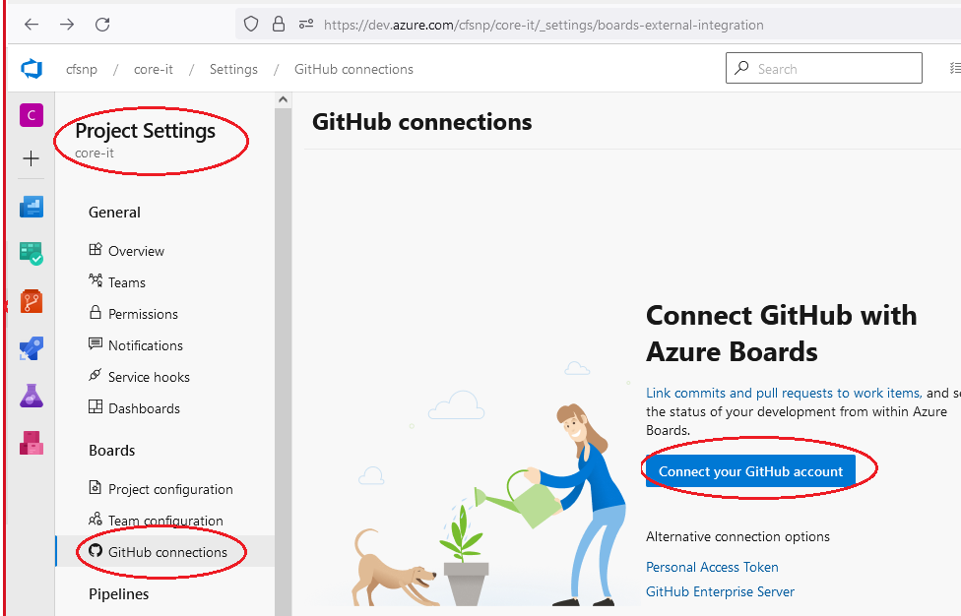

1. Review the authorizations you will make, ensure the organisation is authorized/selected and click “Authorize AzureBoards”

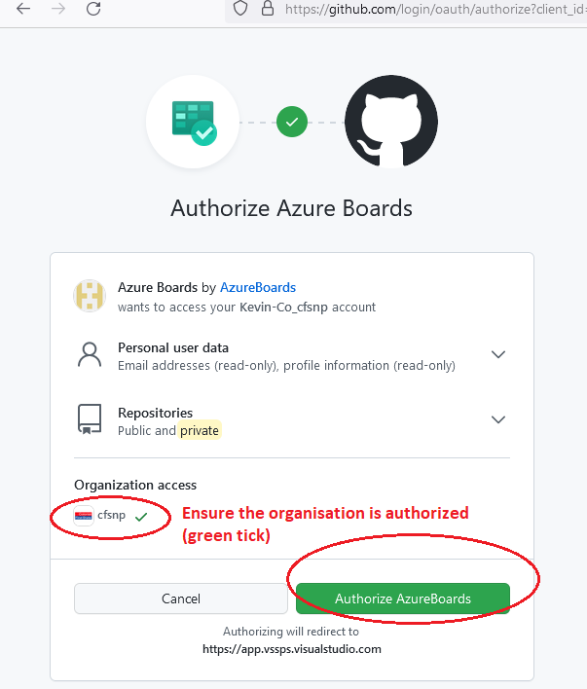

1. Select the organization.

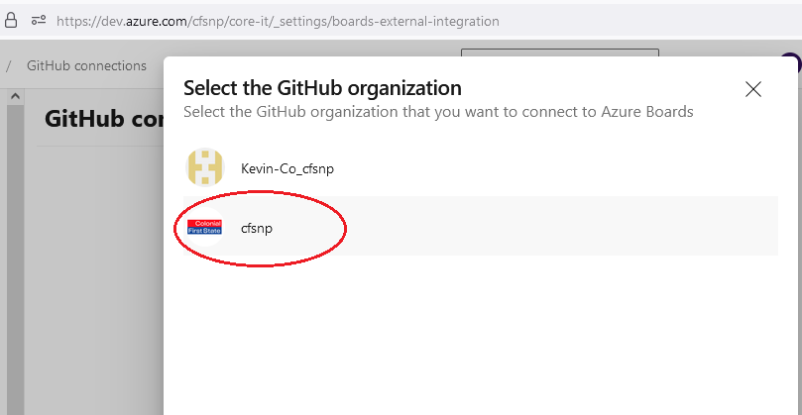

1. Select just the code repository you require. You can connect to multiple GitHub repositories so long as you're an administrator for those repositories.

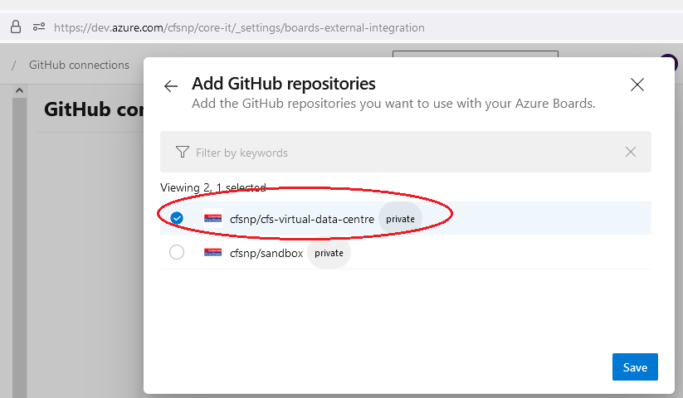

1. Double-check the selections and click “Approve, Install & Authorize”.

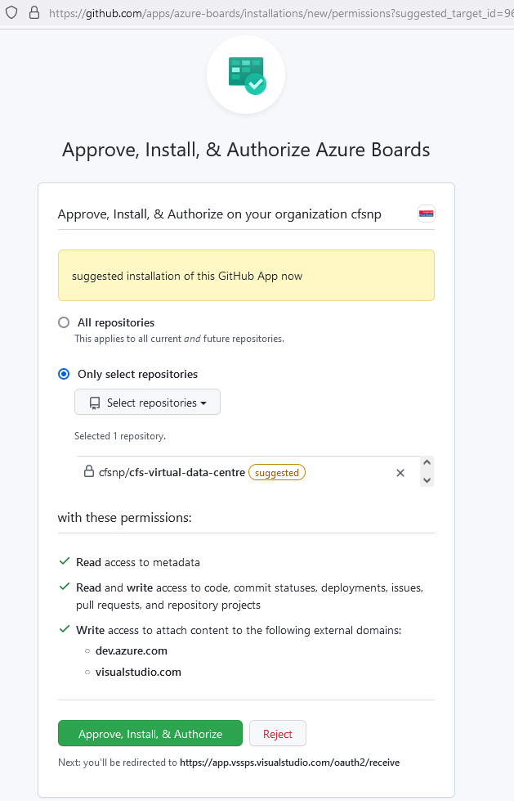

1. Complete installation will look like this.

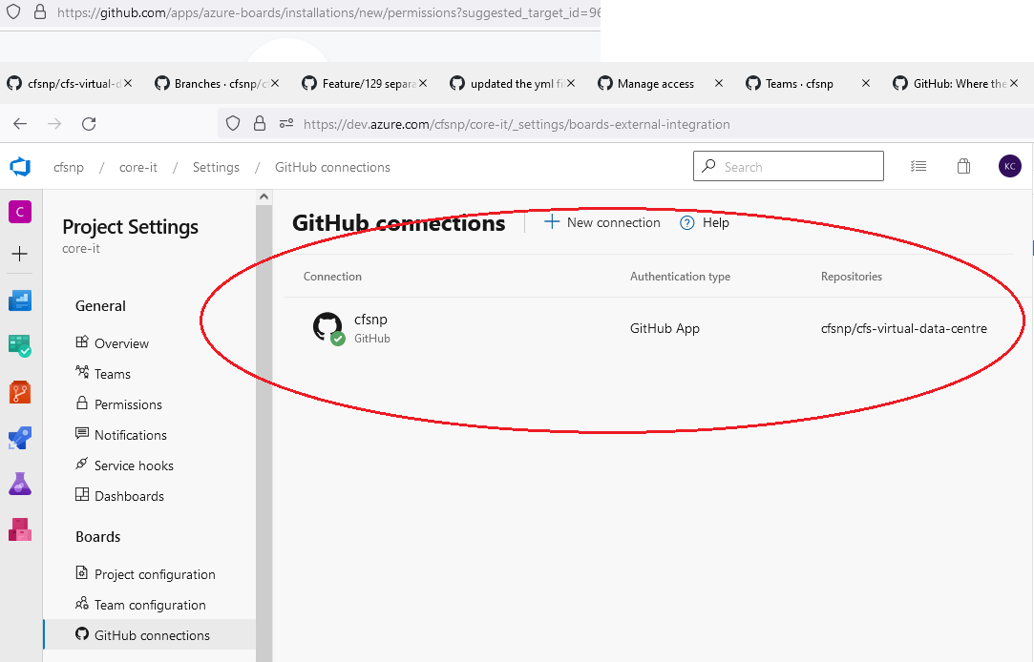

1. Any future commits and pull requests containing AB#123 will have a link in the Azure Boards work-item.

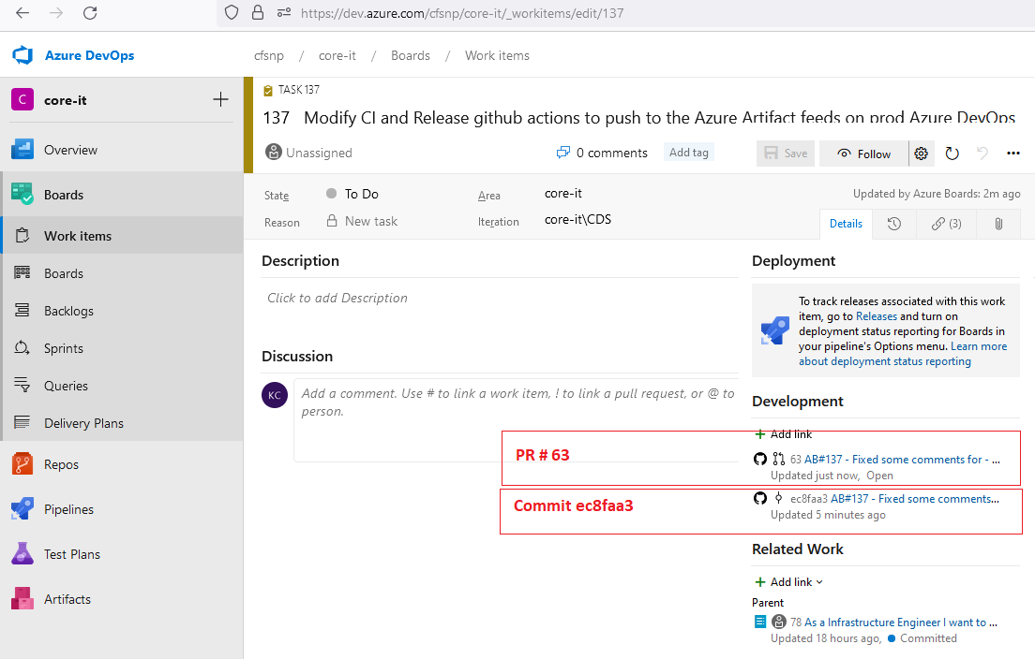

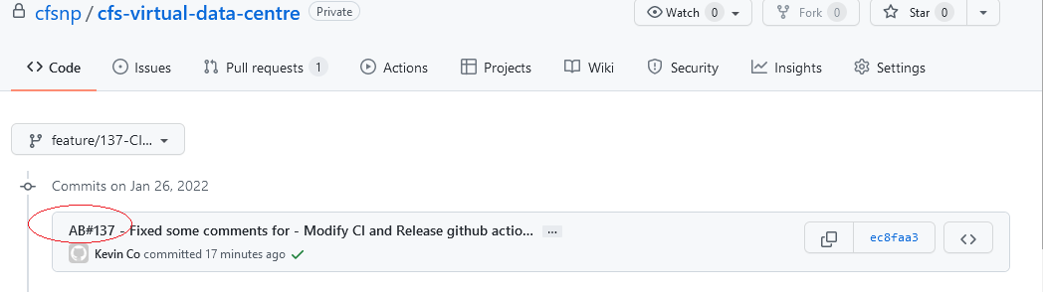

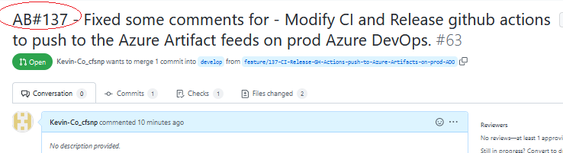

* 1. Azure Pipelines – Connecting to GitHub Enterprise

Azure Pipelines can automatically build and validate every pull request and commit to your GitHub repository. This will show how to configure the integration between GitHub and Azure Pipelines.

1. Sign in to your Azure DevOps organization ([https://dev.azure.com/{yourorganization}](https://dev.azure.com/%7byourorganization%7d))
2. Sign in to GHE ([https://github.com/enterprises/{yourenterprise}/sso](https://github.com/enterprises/%7byourenterprise%7d/sso)
3. Go to ADO Pipelines [https://dev.azure.com/{yourenterprise}/{yourproject}/_build](https://dev.azure.com/%7byourenterprise%7d/%7byourproject%7d/_build)
4. Click on “New pipeline” or “Create Pipeline” and then select GitHub.

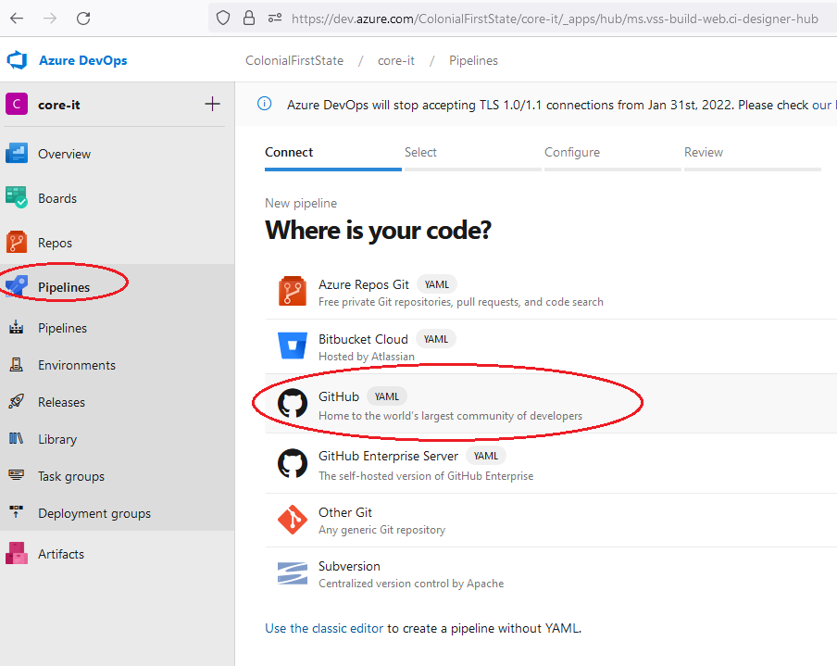

1. Select “All repositories” from the dropdown, then select the repository.

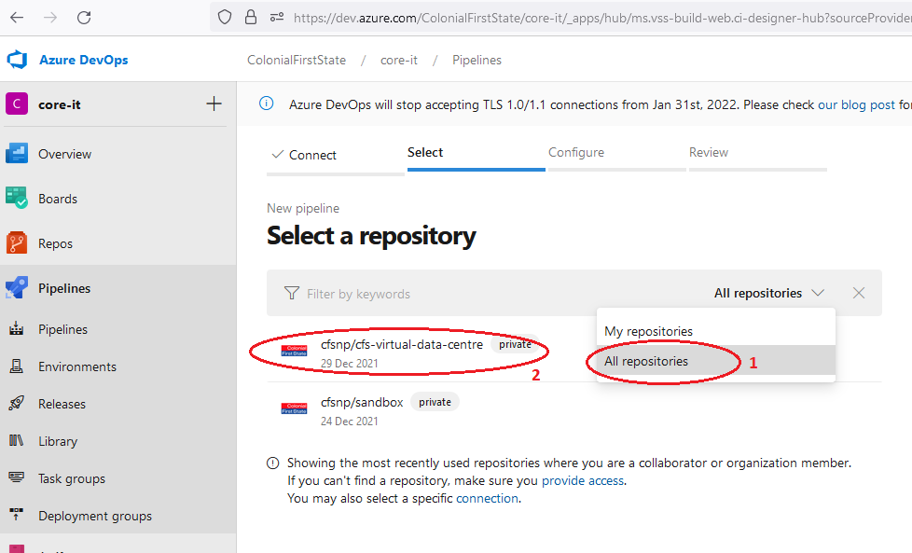

1. Select “Existing Azure Pipelines YAML file”

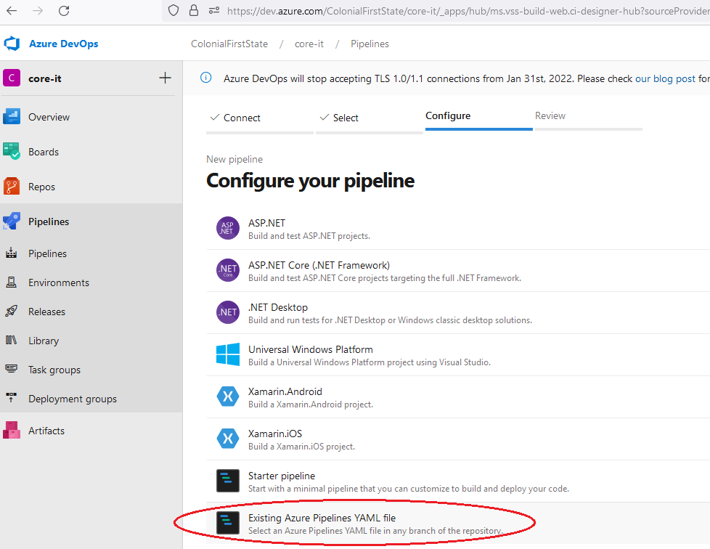

1. Select the branch and select the “Path” of the pipeline’s YML file.

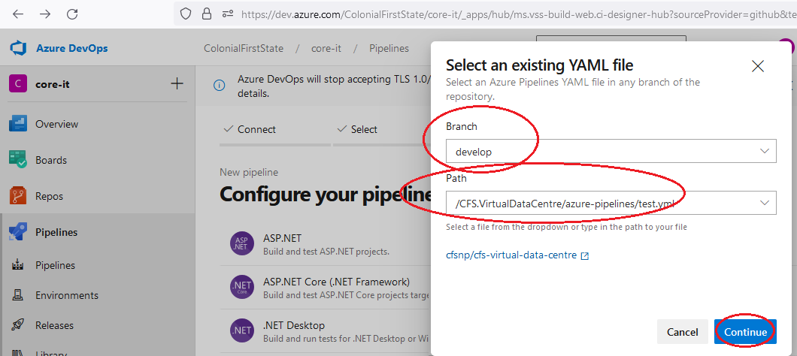

* 1. Azure Pipeline Library

A library is a collection of build and release assets for an Azure DevOps project. Assets defined in a library can be used in multiple build and release pipelines of the project. The **Library** tab can be accessed directly in Azure Pipelines.

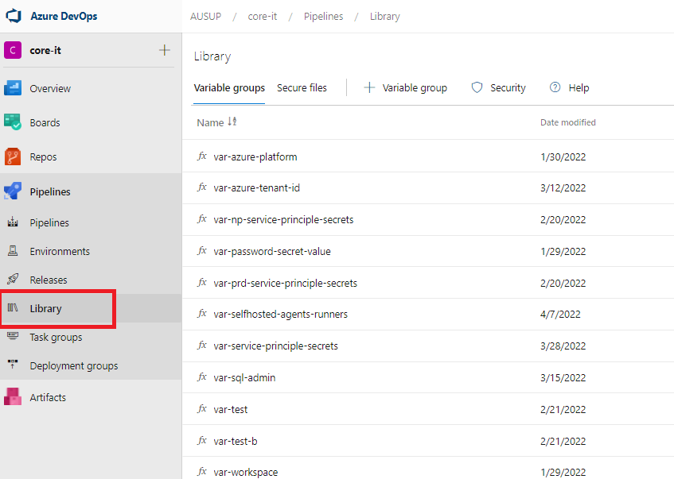

* + 1. Create variable groups

1. Sign in to your organization ([**https://dev.azure.com/{yourorganization}**](https://dev.azure.com/%7byourorganization%7d)). Go Pipelines -> Library



1. In Library, click “Variable groups” then click + Variable group.

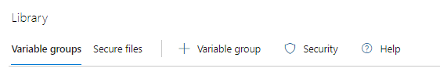

1. Enter the name and value for each [**variable**](https://docs.microsoft.com/en-us/azure/devops/pipelines/release/variables?view=azure-devops#custom-variables) to include in the group, choosing **+ Add** for each one. If you want to encrypt and securely store the value, choose the "lock" icon at the end of the row. When you're finished adding variables, select **Save**.

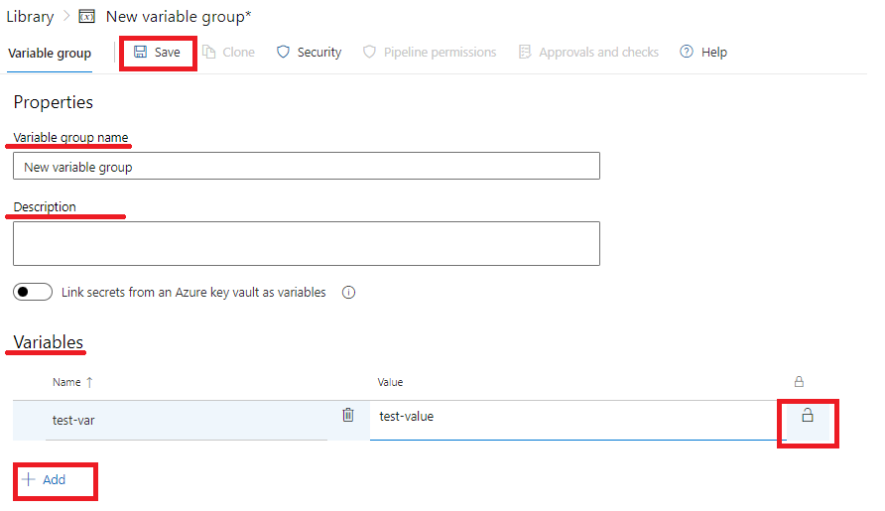

* + 1. Set variables in YAML pipeline

Using variable groups in Azure DevOps allows for us to inject variables inside our library or inside a key vault on our Azure Tenant where our secret values exist, the variable group is imported into a YAML pipeline. Using the following code block:

    variables:

    - group: var-azure-platform

    - group: var-service-principle-secrets

* + 1. CFS core-it variable groups

|  |  |
| --- | --- |
| Variable Group | Description |
| **var-azure-platform** | Variables that are being used to shorten directories to deployments |
| **var-azure-tenant-id** | This contains azure tenant ID for both non-production and production |
| **var-np-service-principle-secrets** | The values that connect the service connection to the relevant azure subscriptions under root management group for non-prod environment |
| **var-password-secret-value** | This contains the password used for DC and PAW servers |
| **var-prd-service-principle-secrets** | The values that connect the service connection to the relevant azure subscriptions under root management group for production environment |
| **var-selfhosted-agents-runners** | Used for PAT and URL variable values in Runner/Agent pipeline |
| **var-service-principle-secrets** | The values that connect the service connection to the relevant azure subscriptions under root management group |
| **var-workspace** | This contains workspace ID and Key |

* 1. Azure “CFSCo Master Pipeline”

This master pipeline is used when you want to deploy resources and stages to select, either deploy stages individually or run all together being a ‘end-to-end’ deployment. The “Depends on:” will ensure that the pre-requisite will be deployed first before progressing to the next stage in a ‘end-to-end’ deployment.

* + 1. Pipeline filename

cfs-master-pipeline.yml

* + 1. Pipeline Parameters and Variables

1. **YAML Parameters**

This is a code example of how parameters are being used in the pipeline to ensure that a single pipeline has the capability to deploy either to non-production or production environments.

**deployEnvironment**

This example is creating a parameter called **deployEnvironment** which lets you choose which environment you want to deploy to when you select the pipeline.

parameters:

  - name: deployEnvironment

    displayName: Target Deployment Environment

    type: string

    default: "Non-Production"

    values:

     - "Non-Production"

     - "Production"

**Artifact/Package version**

This allows to specify a version of the artifact that is different to the latest.

This looks like the following when you go to run this stage in Azure DevOps Pipelines.

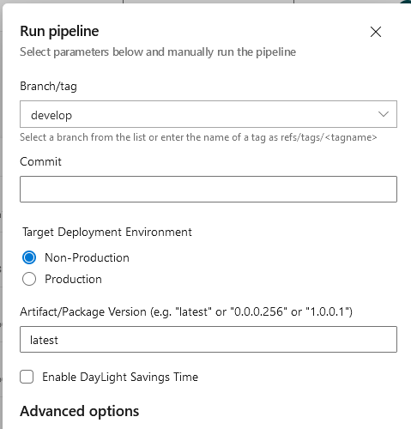

1. **YAML Variables**

Now that the parameters have been defined, we can attach variables to trigger a specific value depending on which string option you select in the pipeline this is an example of how it will dynamically apply changes at each stage.

 - name: AzureEnvironmentPrefix

   ${{ if eq(parameters.deployEnvironment, 'Non-Production') }}:

     value: "np"

   ${{ if eq(parameters.deployEnvironment, 'Production') }}:

     value: "prd"

The way this works is within the YAML code the environment value will change depending on your environment string you selected being either Non-Production and Production.

* + 1. Pipeline Stages

1. **YAML Stages**

The pipeline integrates multiple YAML files into a single pipeline, each resource deployment is separated into an independent stage, doing this allows for all resource modules to be deployed individually or everything.

Each stage will use a different azureSubscription connection name to deploy the resources to the correct subscription as long the Azure DevOps environment has those service connections integrated with Azure AD. This works using variables and that deployEnvironment parameter again example of how the code works.

 # Azure DevOps Connectivity Service Connection Name

 - name: connectivitySubscServiceConnection

   ${{ if eq(parameters.deployEnvironment, 'Non-Production') }}:

     value: "sc-subsc-np-connectivity-001"

   ${{ if eq(parameters.deployEnvironment, 'Production') }}:

     value: "sc-subsc-prd-connectivity-001"

Each stage task will have an allocated variable relevant to the service principle that will deploy it to the correct Azure subscription. Here is a task example of our AzureCLI will change that service connection based on your selection of Non-Production or Production deployment.

     - task: AzureCLI@2

       displayName : Deploy VDC Connectivity Network

       inputs:

         azureSubscription: $(connectivitySubscServiceConnection)

         scriptType: 'pscore'

         scriptLocation: 'inlineScript'

         inlineScript: az deployment sub create --location '$(resourceLocation)' `

                       --name $(deploymentName) `

                       --template-file $(System.ArtifactsDirectory)\$(deployments)\deploy-VDCVirtualNetwork\deploy-VDCVirtualNetwork.bicep `

                       --parameters storageAccountSubscriptionId='$(securitySubscriptionId)' `

                       --parameters workspaceSubscriptionId='$(securitySubscriptionId)' `

                       --parameters environmentPrefix='$(AzureEnvironmentPrefix)' `

                       --parameters owner='$(Owner)' `

                       --parameters costCenter='$(costCenterCode)' `

                       --parameters australiaEastOffsetSymbol='$(AustraliaEastOffsetSymbol)' `

                      --parameters $(System.ArtifactsDirectory)\$(deployments)\connectivity.param.$(AzureEnvironmentPrefix).json

**Note:** azureSubscription: $(connectivitySubscServiceConnection) this will change relevant to how the variable is set above.

* + 1. CFSCo Master Pipeline stages

|  |  |
| --- | --- |
| Stage Name | Description |
| **EnableResourceProviders** | Automate Manual Configurations and Resource Providers |
| **DeployLogAnalyticsWorkspace** | Deploy Log Analytics Workspace first to build and deploy |
| **DeployResourceGroups** | Deploy Resource Groups |
| **EnableMicrosoftDefenderForCloud** | Enable Microsoft Defender for Cloud and Automate the Process |
| **DeployStorageAccounts** | Deploy Storage Accounts |
| **DeployRTandNSG** | Deploy Route Table and Network Security Group |
| **DeployVDCVirtualNetwork** | Deploy VDC Virtual Network Bundle |
| **DeployVirtualNetworkPeerings** | Deploy VDC Virtual Network Peerings |
| **DeployVDCNetworkUDR** | Deploy Network UDR Rules |
| **DeployVDCNetworkSecurityGroups** | Deploy Virtual Network Security Groups Rules |
| **DeployRSV** | Deploy Recovery Service Vault |
| **DeployKeyvault** | Deploy VDC Key vaults |
| **DeployAccessWorkstations** | Deploy Access Workstations |
| **DeployDomainControllers** | Deploy Domain Controllers and Availability Set |
| **DeployVirtualMachineBackup** | Deploy Virtual Machine Backup |
| **DeployPolicyAssignment** | Deploy Policy Assignment |
| **DeployResourceLocks** | Deploy Resource Locks |
| **DeployIPGroups** | Deploy IP Groups |
| **DeployFirewall** | Deploy Firewall |
| **DeployBastion** | Deploy Bastion |
| **DeployFirewallRules** | Deploy Firewall Rules |
| **DeployAVDRequest** | Deploy AVD Request |
| **DeployRoleAssignment** | Deploy Role Assignment to Management Group |
| **DeployPKIServers** | Deploy PKI Servers |
| **WP3LinuxVM** | Deploy WP3 Linux Virtual Machines |
| **DeployExchangeVMs** | Deploy Exchange Virtual Machines |
| **DeployQualysVMs** | Deploy Qualys Virtual Machines |
| **DeployServiceNowServers** | Deploy Service Now Servers |

* + 1. Deployment Process – Manual trigger

To manually run the CFSCo Master Pipeline, below are the required parameters for the run.

1. **Branch/tag -** Branch where the version of pipeline is stored.
2. **Target Deployment Environment** - environment to deploy
3. **Artifact/Package Version** – package version to deploy
4. **Enable Daylight Savings Time –** check/select to enable DST
5. **Stages to run** – select which stage to deploy or run
   * 1. Deployment Approval

Use approval check to manually control when a stage should. Below are the steps on how to add or remove approval to environment deployment.

1. Sign in to your organization ([**https://dev.azure.com/{yourorganization}**](https://dev.azure.com/%7byourorganization%7d)). Go Pipelines -> Environment
2. Navigate to Approvals and Checks for the resource.

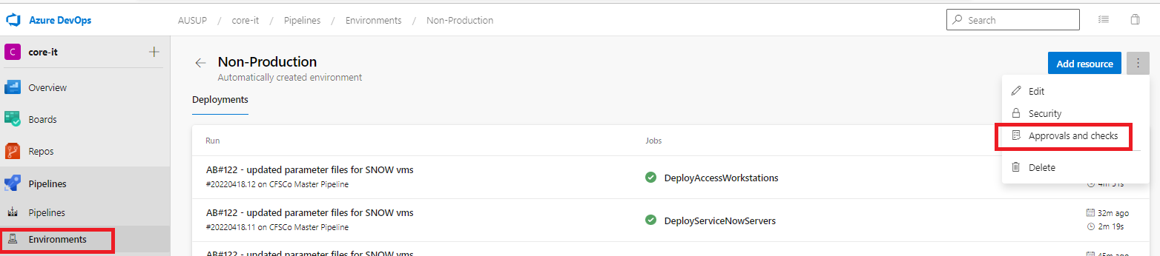

1. Once you have selected Approvals and checks you can add how you want your resources/pipeline managed, in this case we will add an approver to authorize the pipeline to execute and run.



1. Select Approvals a white box will appear on your right side of your browser and input the username of the user who can approve and authorize the pipeline to execute/run. Click Save to apply changes.

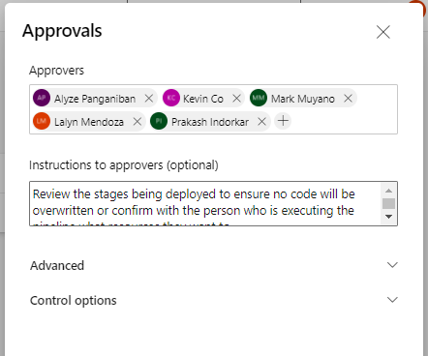

* 1. Azure Artifact

Azure Artifacts enables developers to share their code efficiently and manage all their packages from one place. NuGet packages in Azure Artifacts are being published from GitHub.

* + 1. Artifacts Feeds

Artifacts Feeds are organizational constructs that allow you to store, manage, and group your packages and control who to share it with.

**Project Scoped Feeds**

|  |  |  |
| --- | --- | --- |
| Azure Artifact Feed | GitHub Workflow | Workflow Trigger |
| **cfs-infra-ci** | CI Build | Push to develop branch |
| **cfs-infra-pr-develop** | PR to develop branch Build | Pull Request to develop branch |
| **cfs-infra-pr-main** | PR to main branch Build | Pull Request to main branch |
| **cfs-infra-release** | Release Build | Push to main branch |

1. **SELF-HOSTED AZURE DEVOPS AGENT AND GITHUB RUNNER**
   1. About Azure DevOps/GitHub self-hosted agents/runners

Self-hosted runners/agents offer more control of hardware, operating system, and software tools than what provider-hosted ones provide. The runner/agent machine connects to GitHub/Azure DevOps (ADO) using the self-hosted application.

To achieve this, a separate DevOps pipeline has been implemented to deploy VMs, install the runner/agent application and installs tools. Winget (MS Windows Package Manager) has been used to install tools on the Runners/Agents VM.

The VMs are configured Auto-Shutdown setting - to reduce cost during times of low activity.

A separate pipeline has been created to de-register and destroy Runners/Agents VM, when not required.

* + 1. Self-hosted agent and runner specification

|  |  |
| --- | --- |
| Description | Values |
| **Agent VM name** | **Default Pool**: VM<{ENV}>EDC<{ADO/GH}00{instance_num}  (e.g. VMPRDEDCGH001).  **Test Pool**: VM<{ENV}>EDC<{ADO/GH}{{instance_num}}TST  (e.g. VMPRDEDCGH1TST) |
| **Operating System** | Windows 11 |
| **OS Disk Type** | StandardSSD_LRS |
| **VM Size** | Standard_D2s_v3 |

* + 1. Application or tools installed

|  |  |
| --- | --- |
| Application/Tool | Version |
| **PowerShell** | 7.x.x.x |
| **Azure CLI** | 2.3x.x.x |
| **GIT** | 7.x |
| **Dotnet** | 6.x.x |

* + 1. Firewall rules

Firewall rules to allow outbound port 443 to the following FQDNs and IP ranges

**Self-hosted Azure DevOps Agent – TOOLS IN YELLOW**

|  |  |  |  |  |
| --- | --- | --- | --- | --- |
| FQDN Destination | Protocol | Source Type | Source (non-prod) | Source (prod) |
| **dev.azure.com** | https | IP Group | ig-sub-np-edc-operations-002 | ig-sub-prd-edc-operations-002 |
| **\*.dev.azure.com** | https | IP Group | ig-sub-np-edc-operations-002 | ig-sub-prd-edc-operations-002 |
| **login.microsoftonline.com** | https | IP Group | ig-sub-np-edc-operations-002 | ig-sub-prd-edc-operations-002 |
| **management.core.windows.net** | https | IP Group | ig-sub-np-edc-operations-002 | ig-sub-prd-edc-operations-002 |
| **vstsagentpackage.azureedge.net** | https | IP Group | ig-sub-np-edc-operations-002 | ig-sub-prd-edc-operations-002 |
| **vssps.dev.azure.com** | https | IP Group | ig-sub-np-edc-operations-002 | ig-sub-prd-edc-operations-002 |
| **onegetcdn.azureedge.net** | https | IP Group | ig-sub-np-edc-operations-002 | ig-sub-prd-edc-operations-002 |
| **www.powershellgallery.com** | https | IP Group | ig-sub-np-edc-operations-002 | ig-sub-prd-edc-operations-002 |
| **psg-prod-eastus.azureedge.net** | https | IP Group | ig-sub-np-edc-operations-002 | ig-sub-prd-edc-operations-002 |
| **winget.azureedge.net** | https | IP Group | ig-sub-np-edc-operations-002 | ig-sub-prd-edc-operations-002 |
| **dotnetcli.azureedge.net** | https | IP Group | ig-sub-np-edc-operations-002 | ig-sub-prd-edc-operations-002 |
| **azcliprod.azureedge.net** | https | IP Group | ig-sub-np-edc-operations-002 | ig-sub-prd-edc-operations-002 |
| **dot.net** | https | IP Group | ig-sub-np-edc-operations-002 | ig-sub-prd-edc-operations-002 |
| **aka.ms** | https | IP Group | ig-sub-np-edc-operations-002 | ig-sub-prd-edc-operations-002 | |

|  |  |  |  |  |
| --- | --- | --- | --- | --- |
| Destination IPs | Protocol | Source Type | Source (non-prod) | Source (prod) |
| **13.107.6.0/24** | TCP / 443 | IP Group | ig-sub-np-edc-operations-002 | ig-sub-prd-edc-operations-002 |
| **13.107.9.0/24** | TCP / 443 | IP Group | ig-sub-np-edc-operations-002 | ig-sub-prd-edc-operations-002 |
| **13.107.42.0/24** | TCP / 443 | IP Group | ig-sub-np-edc-operations-002 | ig-sub-prd-edc-operations-002 |
| **13.107.43.0/24** | TCP / 443 | IP Group | ig-sub-np-edc-operations-002 | ig-sub-prd-edc-operations-002 |

**Self-hosted GitHub Runner**

|  |  |  |  |  |
| --- | --- | --- | --- | --- |
| FQDN Destination | Protocol | Source Type | Source (non-prod) | Source (prod) |
| github.com | https | IP Group | ig-sub-np-edc-operations-002 | ig-sub-prd-edc-operations-002 |
| api.github.com | https | IP Group | ig-sub-np-edc-operations-002 | ig-sub-prd-edc-operations-002 |
| codeload.github.com | https | IP Group | ig-sub-np-edc-operations-002 | ig-sub-prd-edc-operations-002 |
| objects.githubusercontent.com | https | IP Group | ig-sub-np-edc-operations-002 | ig-sub-prd-edc-operations-002 |
| objects-origin.githubusercontent.com | https | IP Group | ig-sub-np-edc-operations-002 | ig-sub-prd-edc-operations-002 |
| github-releases.githubusercontent.com | https | IP Group | ig-sub-np-edc-operations-002 | ig-sub-prd-edc-operations-002 |
| github-registry-files.githubusercontent.com | https | IP Group | ig-sub-np-edc-operations-002 | ig-sub-prd-edc-operations-002 |
| *.blob.core.windows.net | https | IP Group | ig-sub-np-edc-operations-002 | ig-sub-prd-edc-operations-002 |
| *.actions.githubusercontent.com | https | IP Group | ig-sub-np-edc-operations-002 | ig-sub-prd-edc-operations-002 |

* + 1. Library and variable setup

On the Library section of Pipeline please verify “var-selfhosted-agents-runners” Variable group is present and the following variables have been set a correct value.

* + 1. **ADO-ORG-AGENT-REGISTRATION-PAT**: Personal Access Token generated (PAT) on ADO with Agent Pools – R Read & manage permission selected
    2. **ADO-ORG-URL**: “https://dev.azure.com/AUSUP”
    3. **GITHUB-ORG-RUNNER-REGISTRATION-PAT**: Personal Access Token (PAT) generated on GitHub with – R Repo (Full control of private repositories) permission selected
    4. **GITHUB-ORG-URL**: “https://github.com/CFSCo”

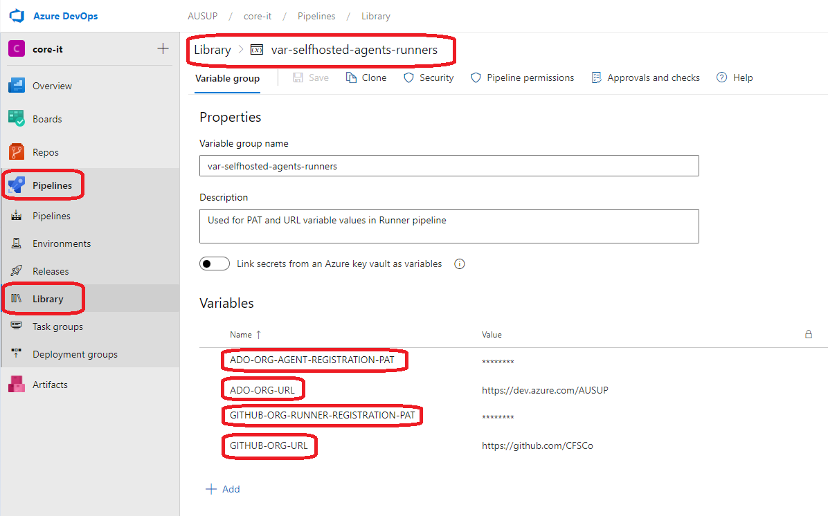

* + 1. Auto Shutdown Config

VM’s created by Bicep code has been setup with Auto-shutdown config. By default, all runners/agents VMs will be shutdown at **9:00 PM AEST**. This is done in consideration to reduce the significant cost of running the VMs during times of low activity. Please note, when VM are in shutdown or de-allocated state, the runners/agents will appear offline.

* + 1. Scheduled and manual start-ups of VMs

All VMs used for runners/agents are set to auto-start at 8:00 AM AEST in both Production and Non-production environment. This is done via “**CFSCo.start agents runners**” pipeline. A CRON job has been setup using this pipeline which is scheduled to start at 8:30 AM Monday to Friday. This pipeline can be used to start VMs manually if required.

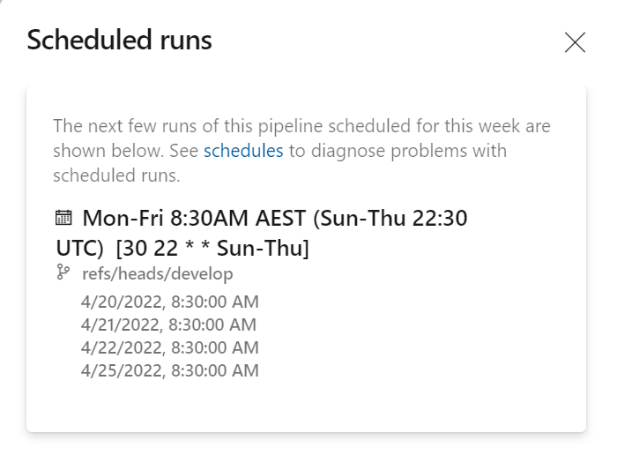

* 1. GitHub Runners/ADO Agents and Tools Installation

To install GitHub Runner/ADO agent use “**CFSCo agents runners pipeline**”. This pipeline has been configured to install both GitHub Runner and ADO Agent. The pipeline requires mandatory parameters input before it can be run.

* + 1. Parameters Specification/Description

|  |  |
| --- | --- |
| Parameter Name | Description / Values |
| **Branch/Tag** | Select the branch where code/changes have been merged (Please note: You need to wait for CI Build to finish) |
| **Target Deployment Environment** | Default: [Non-Production]. Select the environment where you want to install the Agent/Runner. Note: GitHub runners are only available to install on the Production environment. |
| **VM Instances** | Default: [“- 1” \n “- 2”] A valid YML parameter must be entered. The default values (given as an example), will create 2 VMs with 1 and 2 Appended to the VM name respectively  E.g.: VMPRDEDCADO001, VMPRDEDCADO002, VMPRDEDCADO1TST, VMPRDEDCADO2TST, VMPRDEDCGH001 |
| **Agent/Runner Type** | Default: [Not Selected] Pipeline will install either ADO Agent or GitHub Runner at a time. Apart from the “Default” pool, a Test Pool is also available in ADO and a Test Runner Group in GitHub.  Depending on the “Test Agent Pool / Test Runner Group” is selected, the VM name will be Appended with **TST** e.g., “VMPRDEDCADO1TST”. |
| **Install Tools on Runners/Agents?** | Default: [No Selected] Select this option to install tools. (This option is provided in case of VM already has tools installed and may only needs registration on ADO/GitHub OR the VM is registered previously, and tools are required to install later) |
| **Artifact/Package Version** | Default: [latest] |
| **Enable Daylight Saving Time** | Select this option depending on Daylight Saving guidelines |

* + 1. Steps to run Agent/Runner pipeline

1. Select the “CFSCo agents runners pipeline” pipeline

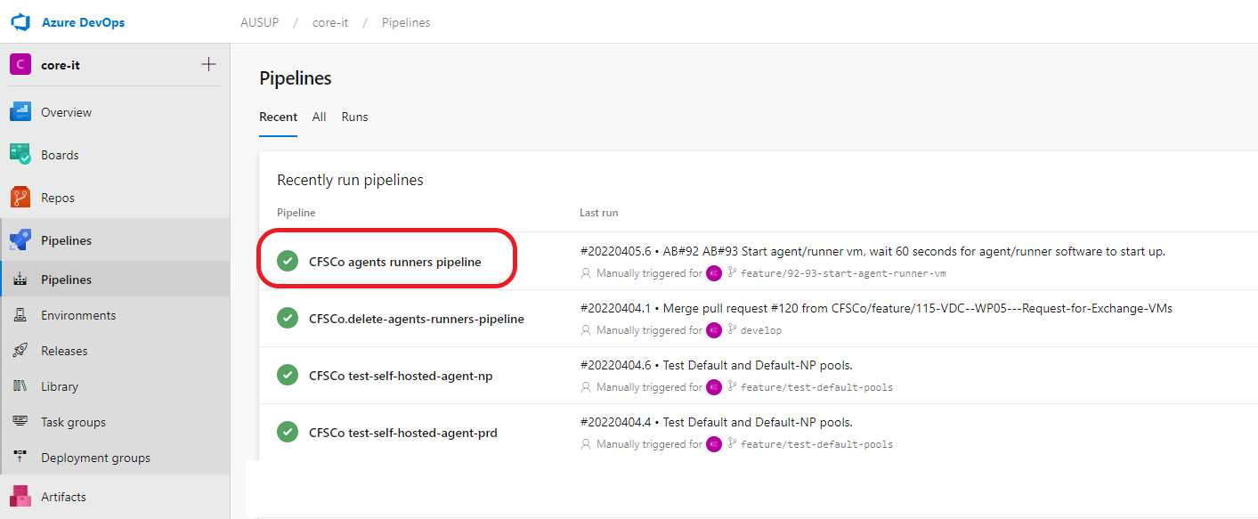

1. Use the Run pipeline button as the pipeline is configured to run manually.

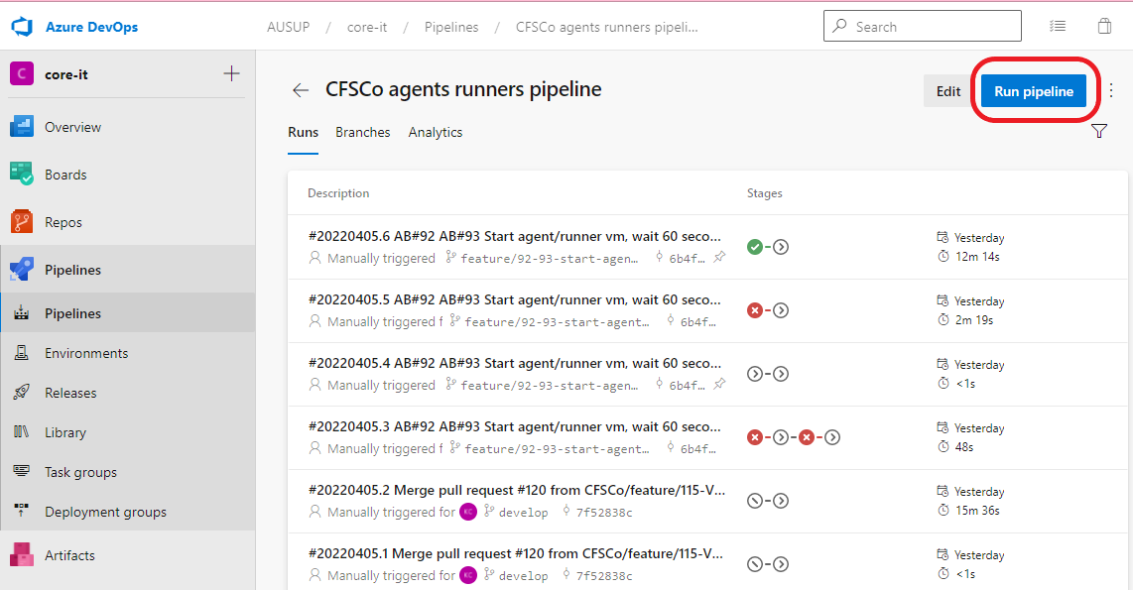

1. Select the parameters as described in **5.2.1 Parameters Specification/Description** section and click Run

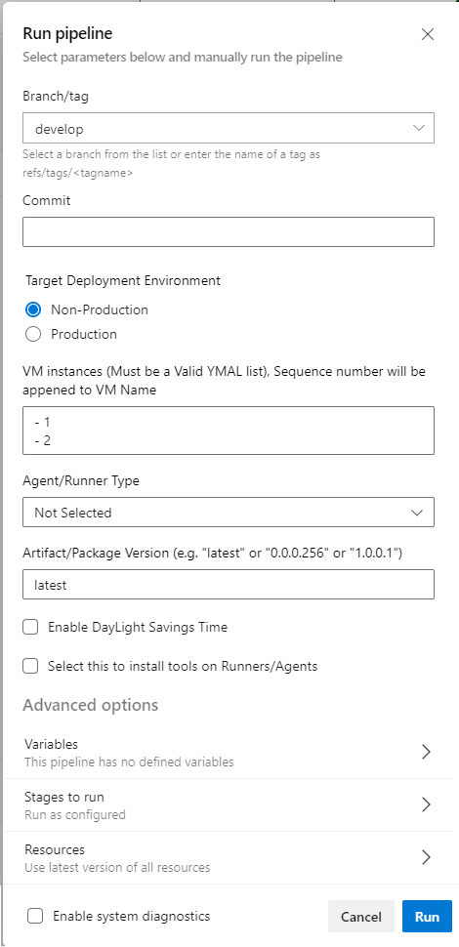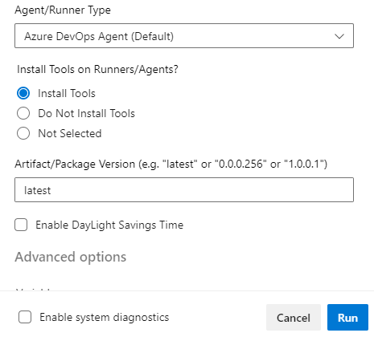

1. Approvals are required at each stage before the pipeline can be run. In the non-Production environment, only 1 Approval is required whereas in the Production environment 2 Approvals are required.

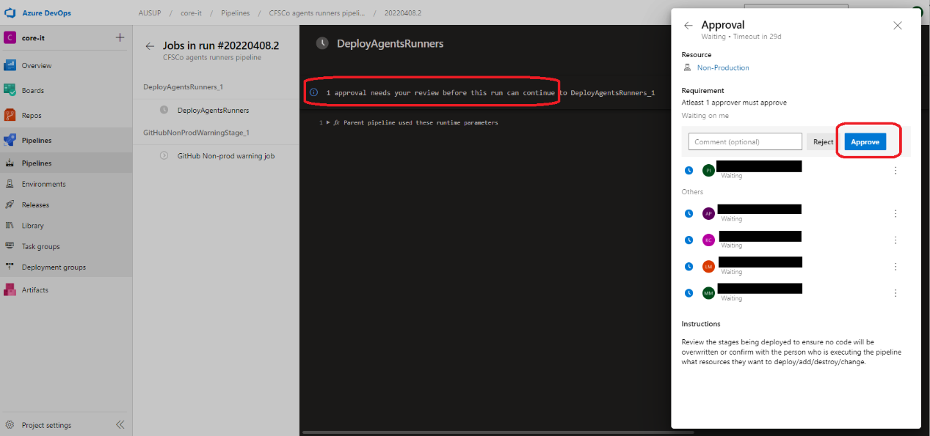

1. Wait for the pipeline to run and finish successfully. Notice DeployAgentRunnerTask was successfully completed. Following this, the Register Task is also successful, means the newly created VM has been registered on Azure DevOps. You may verify this on Self-Hosted agents list on Azure DevOps and on the GitHub Runners list on GitHub.

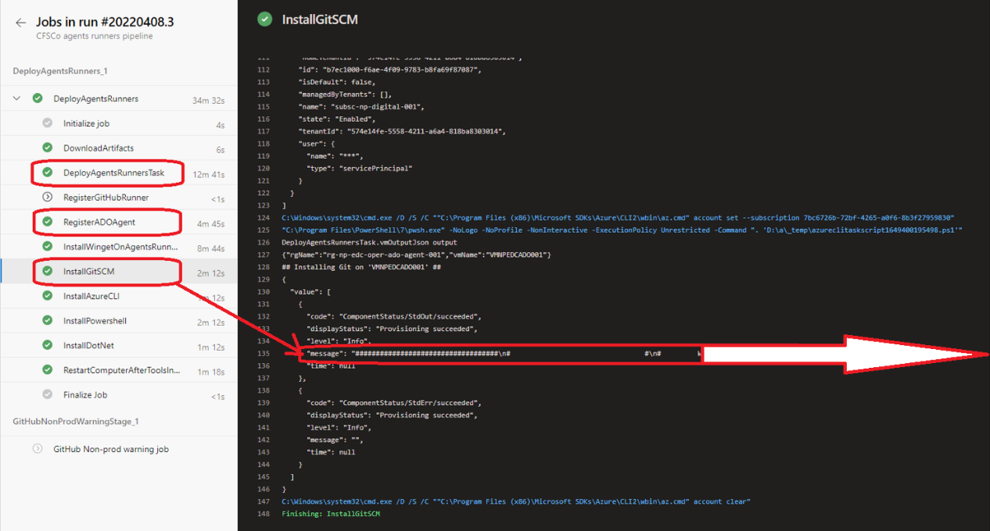

* + 1. Verify tools installation was successful

Please verify the tools have been installed as expected.

Scroll to the end of the message as highlighted in the above image, if the tool/App Name and Version parameters are correct you should see the message ends with “<App Name> Successfully Installed”. If tool/App Name is not specified as per Winget package name format, the installation of tool may not be successful. Check the troubleshooting steps in following section of this documentation.

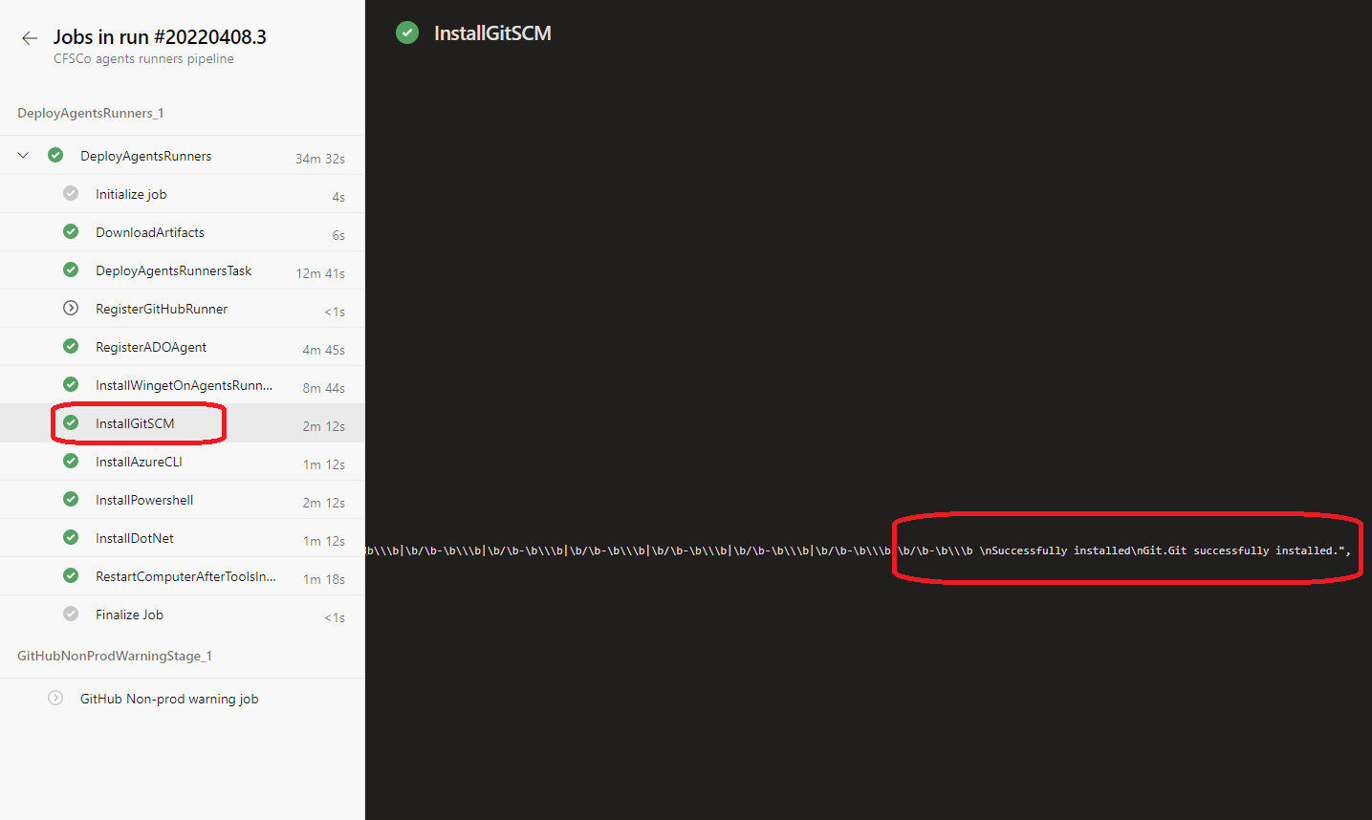

* 1. Verify ADO Agents are running and registered

After successful finishing of the pipeline run, we can verify the ADO for Agent’s running status.

To verify the agent’s running status on ADO follow the below steps

1. On the ADO page, go to project settings, located on the left bottom side of the page.

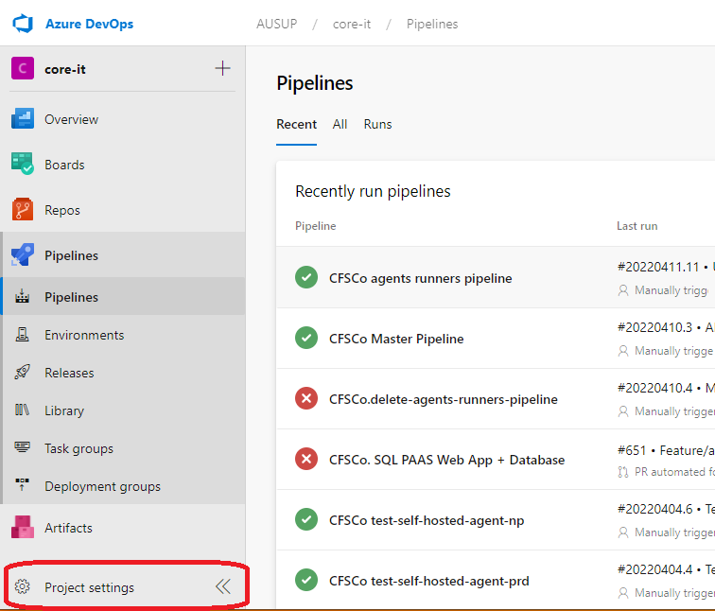

1. Click on Agents pools under pipelines section. On this page, you may see 4 or 5 Agent pools. For our example we are using “Test Pool” on the Production environment.

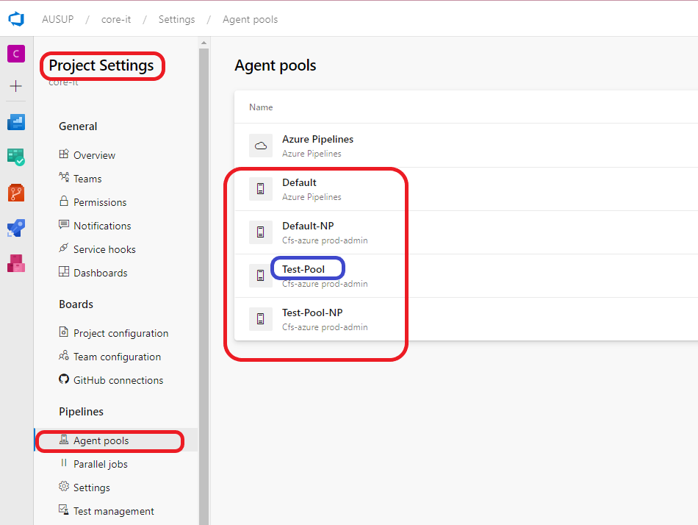

1. Click on the Agents tab. This page lists all the agents currently registered on ADO “Test Pool” for Self-hosted agents. You see the status of Agents Online/Offline.

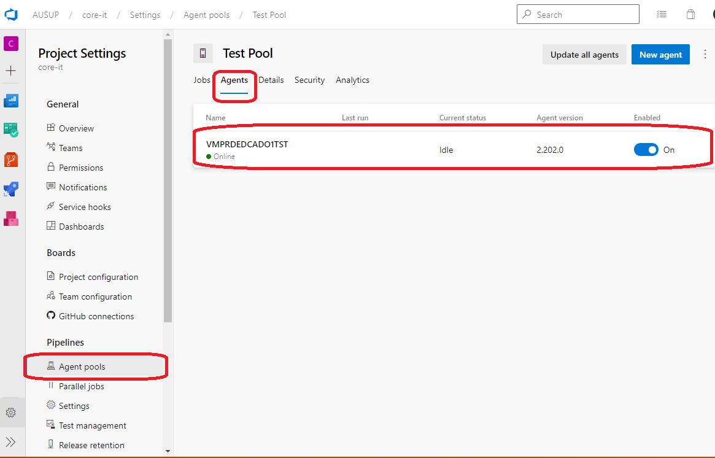

1. Please note, if the VMs are in STOP or de-allocated state, the Agent/Runner will be shown as offline.
   1. Verify GitHub Runners are running and registered

To verify the GitHub runner’s running status, follow below steps.

1. Go to GitHub organization page “**[CFSCo (github.com)](https://github.com/CFSCo)**”. On this page click on the Settings tab menu as in the image below.

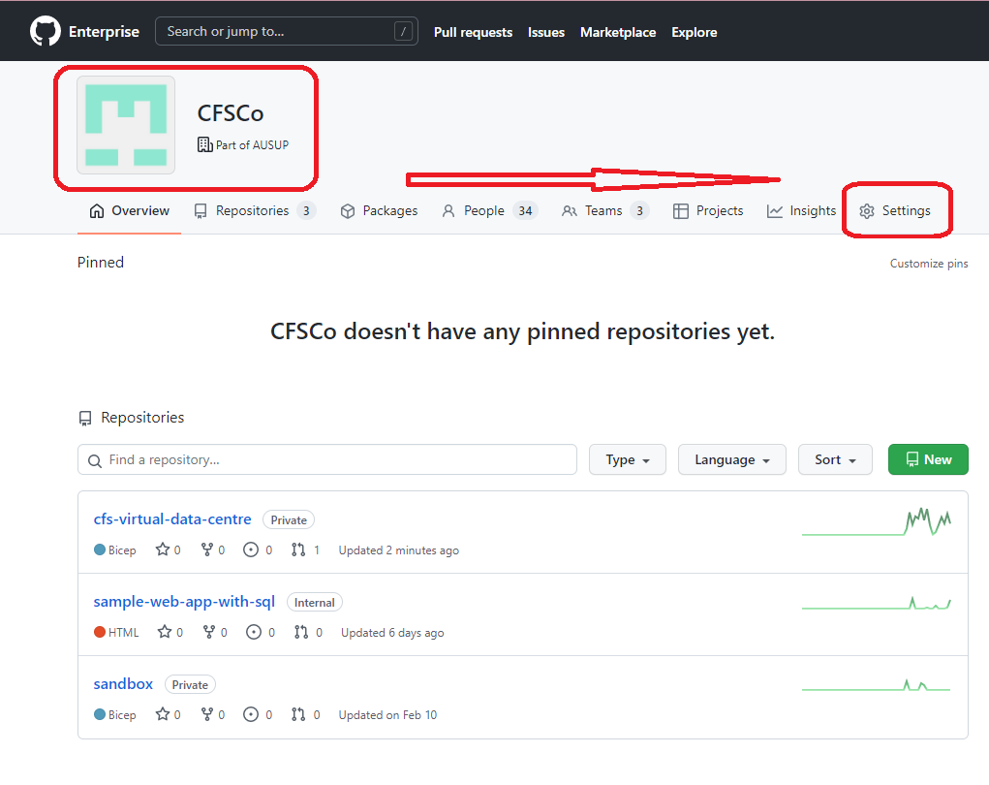

1. On this settings page, click on Agents -> Runner groups. This page list all the runner groups available within the organisation. Each runner group may or may not contain Runner. The number of runners available is shown as well.

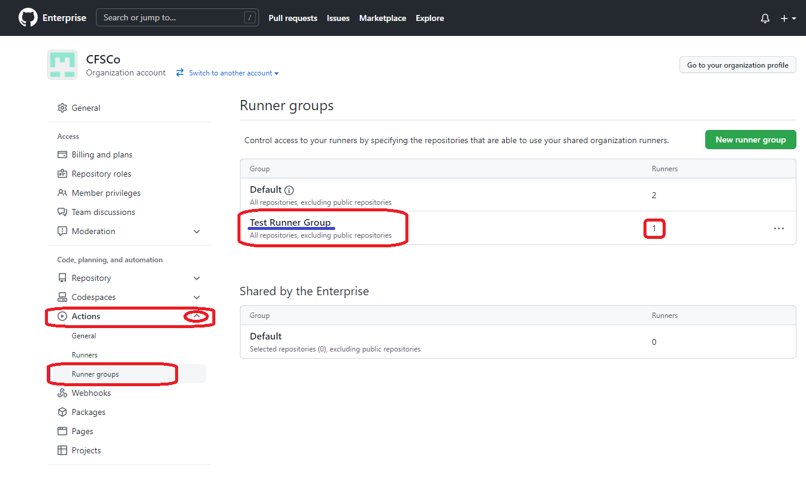

1. Click on the “Test Runner Group” link, this page list all the runner within this runner group. For our example, we have taken the Test Runner Group and 1 runner is available in the offline state. Please note, that if VM in the Azure portal is on STOP or de-allocated state, the runner will appear offline. Once the VM has started/restarted the status will change back to online.

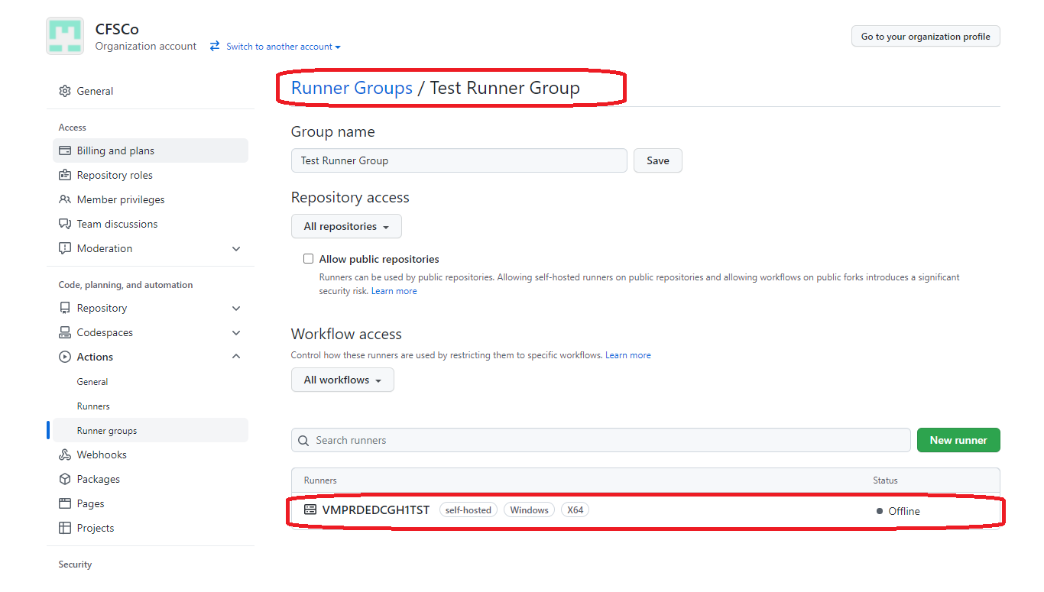

* 1. Production only GitHub Runners

The “CFSCo agents runners pipeline” is setup in such a way that, it will allow to create GitHub runners only in the Production environment. When Non production is selected for GitHub runner deployment, the pipeline stage (**GitHubProdCheckStage**) will fail with error message showing “GitHub Runners are deployed only in the Production tenant”.

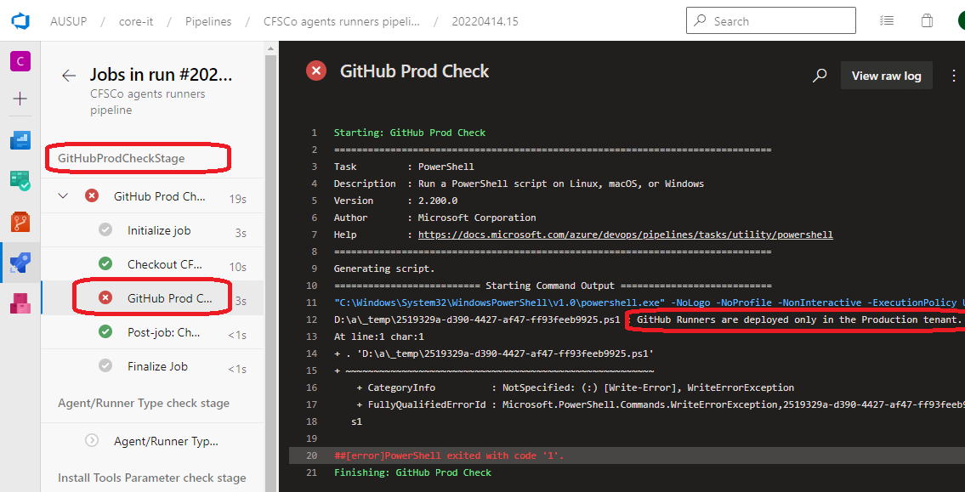

* 1. De-register and Delete GitHub Runner/ADO Agent resource

For de-registering and deleting the GitHub Runner/Ado Agent resource, use “CFSCo.delete-agents-runners-pipeline”. This pipeline has been configured to accept VM names as a mandatory parameter.

* + 1. Parameters Specification/Description

|  |  |
| --- | --- |
| Parameter Name | Description / Values |
| **Branch/Tag** | Select the branch where code has been merged |
| **Target Deployment Environment** | Default: [Non-Production]. Select the environment where you want to install the Agent/Runner. Note: GitHub runners are only available to install on the Production environment. |
| **Artifact/Package Version** | Default: [latest] |
| **Delete Resource Group for Self-Hosted Agents/Runners** | Default: [] Un-selected. If unselected, the pipeline will only de-register the Agents/Runners and will not delete the VM resources. If this is selected, the pipeline will perform both de-register and deletion of VM resources. |
| **VM Names** | Default: [“- VMNPEDCADO001” \n “-VMNPEDCGH1TST”]. Valid YML parameters must be entered. These default values will search for VM names as provided. |

* + 1. Steps to run De-register/Delete Agent Runner pipeline

1. Select the pipeline to run

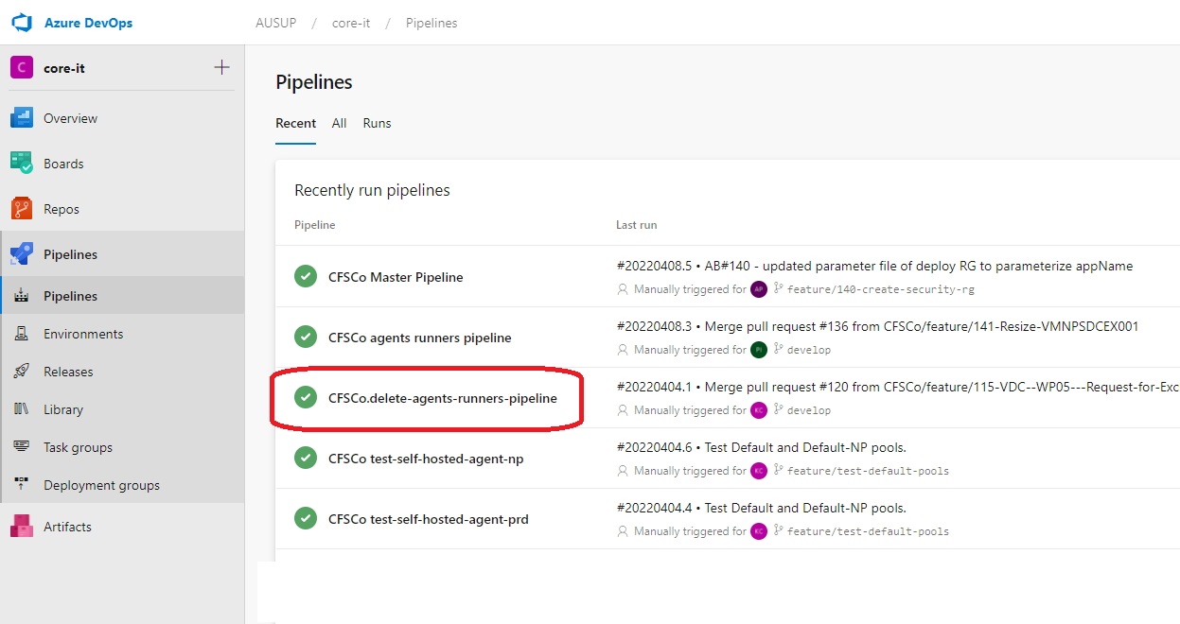

1. Select the parameters as described in the table and click Run

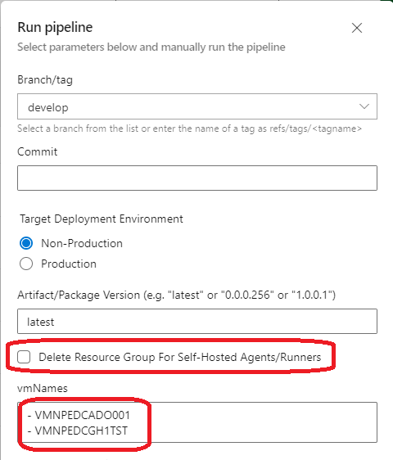

1. Approvals are required at each stage before the pipeline can be run. In the non-Production environment, only 1 Approval is required whereas in the Production environment 2 Approvals are required.
2. Upon successful finish of pipeline run, the agents/runners will be unregistered and if “Delete Resource Group” is selected, the resource will be deleted from Azure.

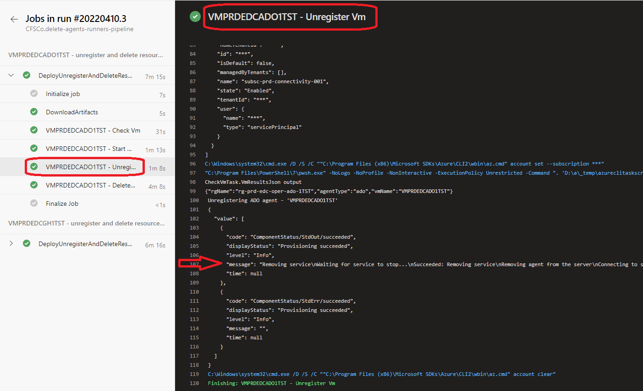

This can be verified manually by going to Azure portal and check the VM’s resources have been deleted. Also, in Runners/Agents page, VMs have been removed.

* 1. Manually deleting the Runners/Agents

This process may be required in case of runners/agents not responding, showing offline even after VMs have restarted, registration is failing multiple times or VM has been deleted from azure portal before running the “CFSCo.delete-agents-runners-pipeline”.

* + 1. Delete the ADO agents manually

1. Go to agent pools page on Azure DevOps. Click on the pool where agents are listed.



1. Click on the Agent name you want to delete manually. Find the three dots towards the end of row for more option. You will find the delete option in down drown menu. Click on delete and confirm to delete.   
     
   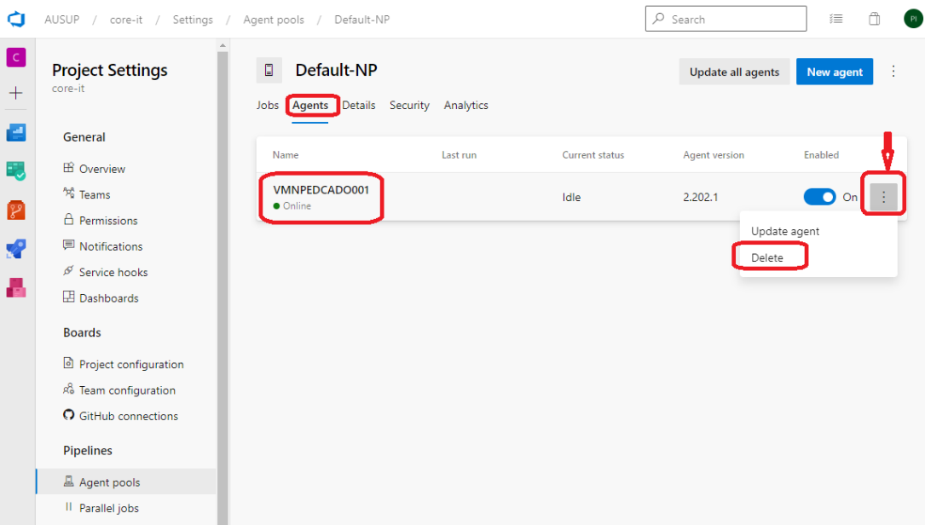
2. Delete the Resource group on Azure portal where this Agent was installed.
   * 1. Delete the GitHub runners manually
3. Go to actions->runners page on GitHub organisation settings page. Click on VM/Runner name from this you want to delete.

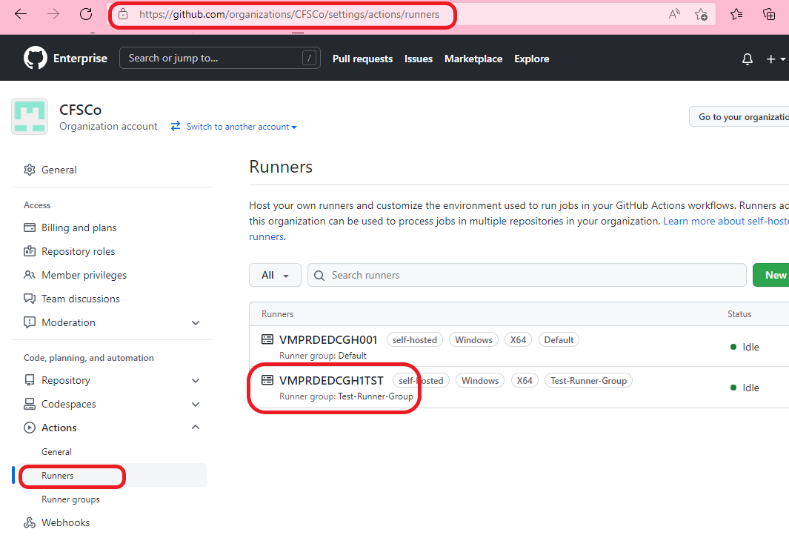

1. Click on **Remove** button to delete the runner. A confirmation dialog window will appear. Click on **Force remove this runner** to delete it.  
     
   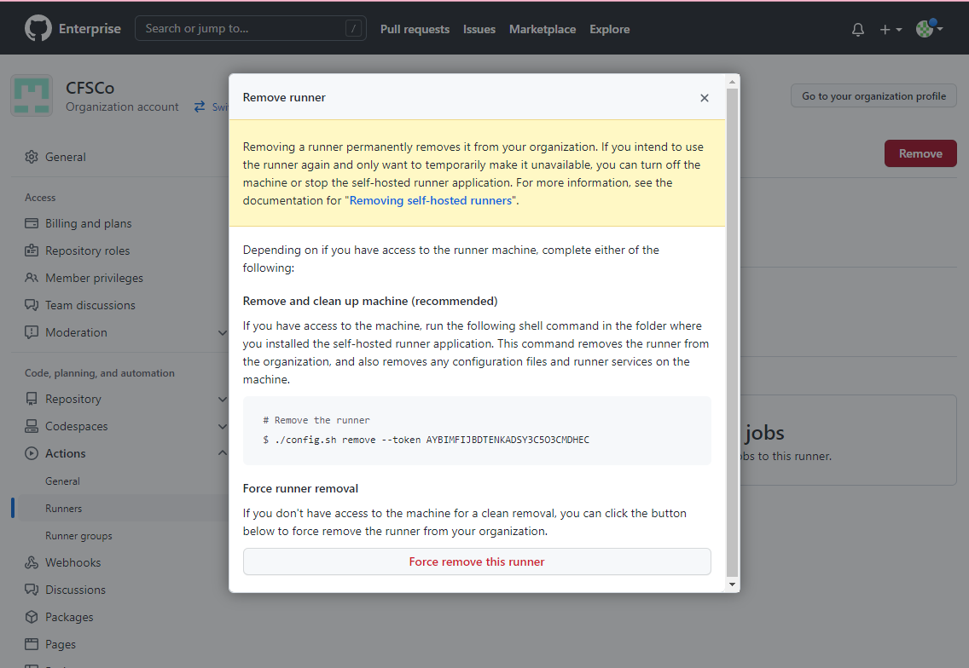
2. Delete the Resource group on Azure portal where this runner was installed.
   1. More details on ADO agent pool and GitHub Runner Groups
3. **ADO Agent pools**

Below image lists all the agent pools available in the ADO. “Azure Pipeline” is default pool provided by Microsoft and it contains Microsoft hosted agents. Other four Agent pools are available for Self-Hosted Agents. The two pools highlighted with red arrow “**Default**” and “**Test-Pool**” are used for **Production** environment. The other two highlighted with blue arrow “**Default-NP**” and “**Test-Pool-NP**” are used for **Non-Production** Environment.

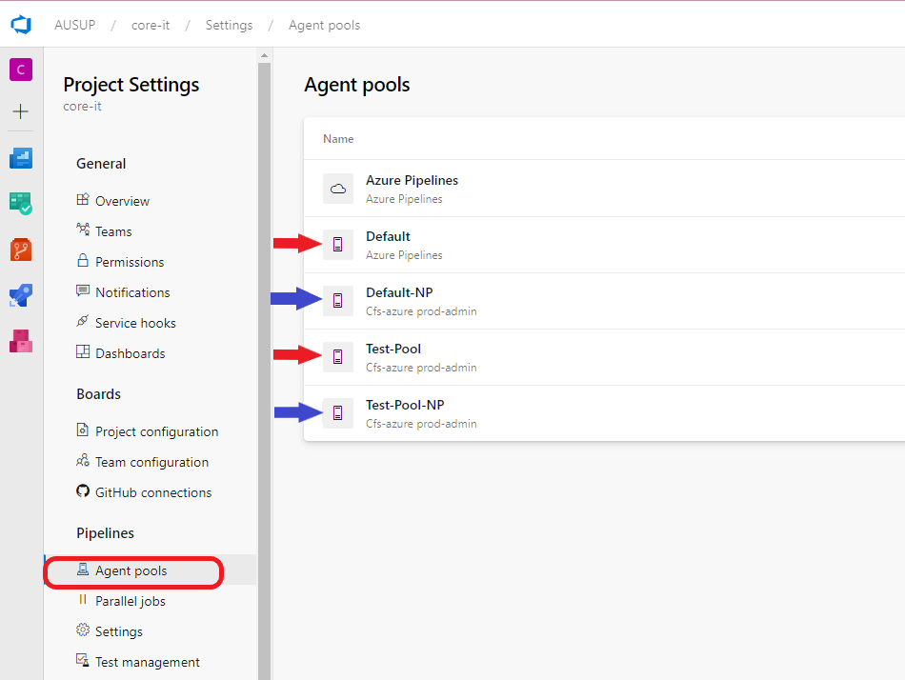

1. **GitHub Runner Groups**

Below image lists Runner group available on GitHub. Please Note: Both the runner groups are available for production environment only. “Default” runner group highlighted with red arrow is used for Self-Hosted runner’s default pool. “Test Runner Group” highlighted with blue arrow can be used for placing test runners.

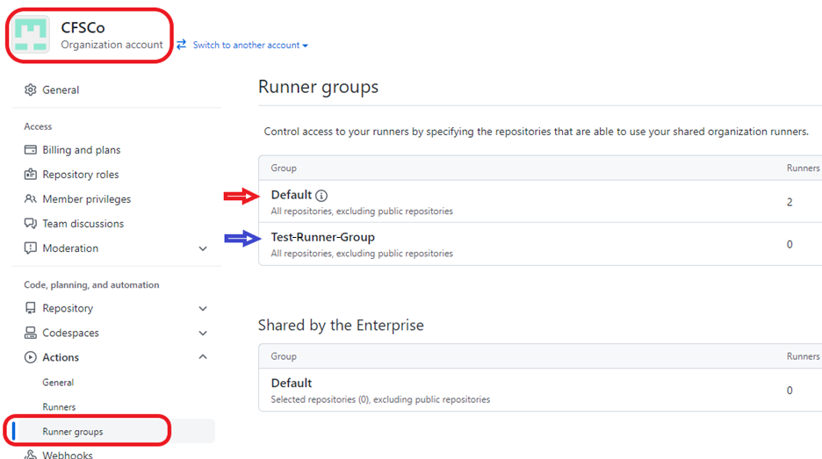

* 1. Testing the Runners/Agents for running a Pipeline
     1. Test pipeline to use ADO Self-Hosted Agent

1. **Run test pipeline for Non-production Environment**

To run a pipeline on non-Production environment self-hosted ADO agents, go to Azure DevOps pipelines page and use a sample “**CFSCo test-self-hosted-agent-np**” pipeline. This pipeline uses VM’s created in Non-Production and must be used to run Non-Production pipelines only.

1. **Run test pipeline for Production Environment**

To run a pipeline on Production environment ADO self-hosted agents, go to Azure DevOps pipelines page and use a sample “**CFSCo test-self-hosted-agent-prd**” pipeline. This pipeline uses VM’s created in Production Environment and must be used to run production pipelines only.

The current sample pipeline will display Version number of tools installed during creation of VM’s.

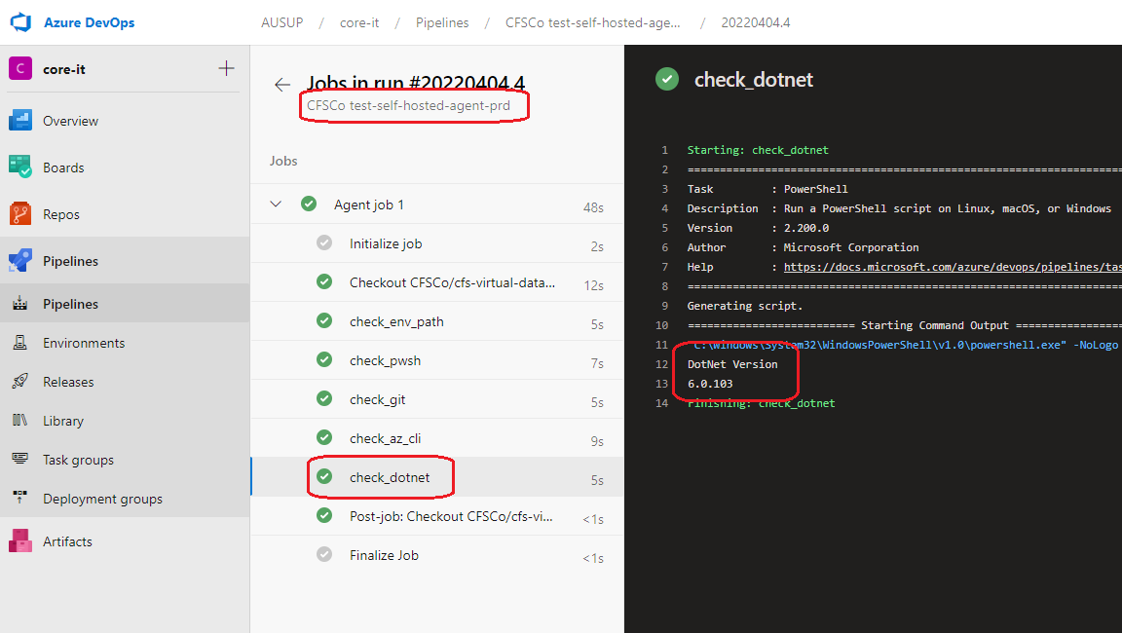

* + 1. Test Pipeline to use GitHub Self Hosted Runner

1. To run sample a pipeline on GitHub self-hosted runners, go to GitHub page “<https://github.com/CFSCo/cfs-virtual-data-centre/actions>” and under **Actions** tab select the “**Test Self Hosted Runner**” workflow.

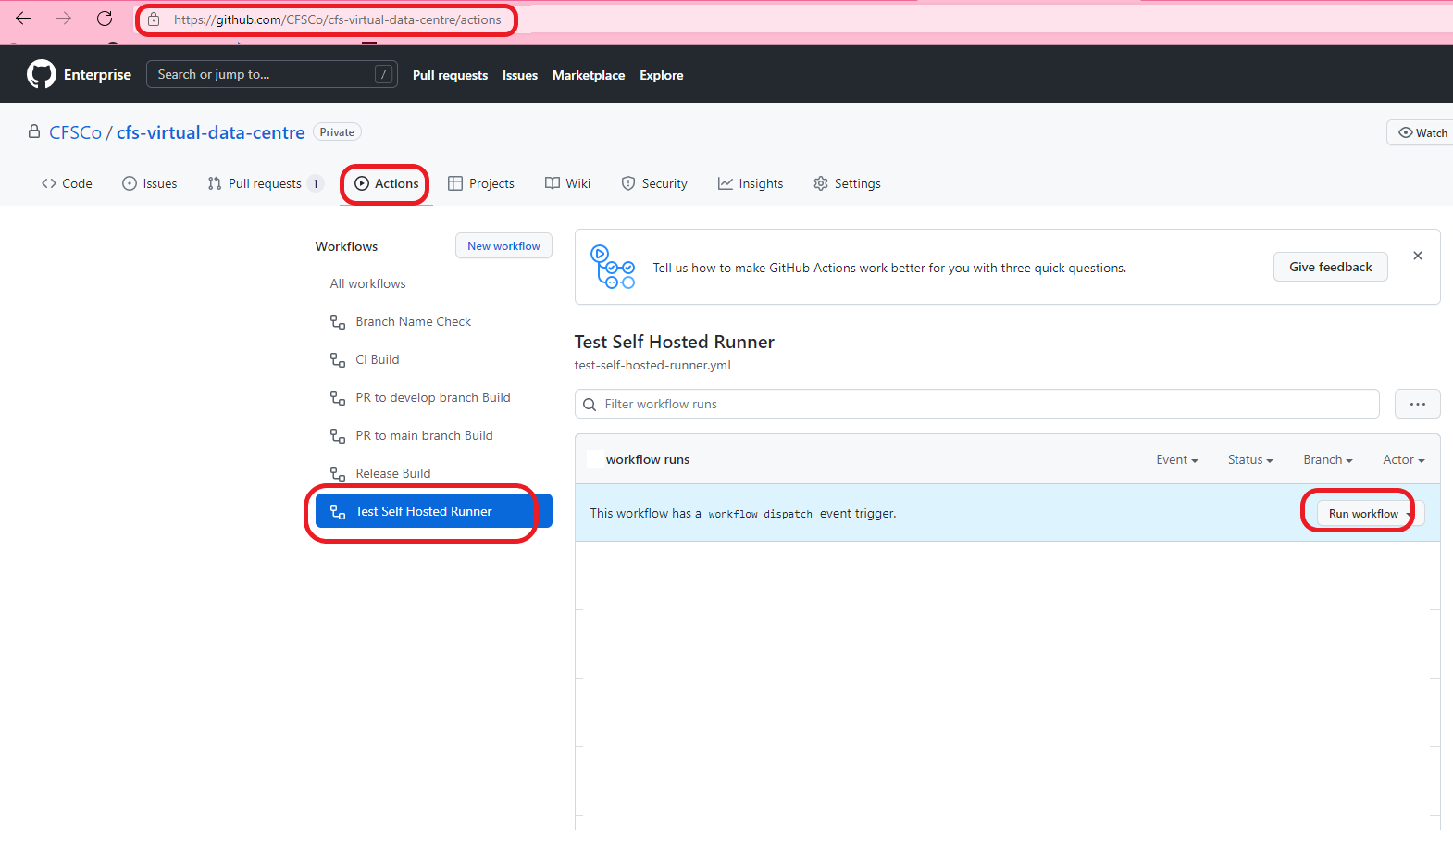

1. Click on “Run workflow”. Upon successful run of the workflow, it will display version details of the tools installed in the runner VM in the log.

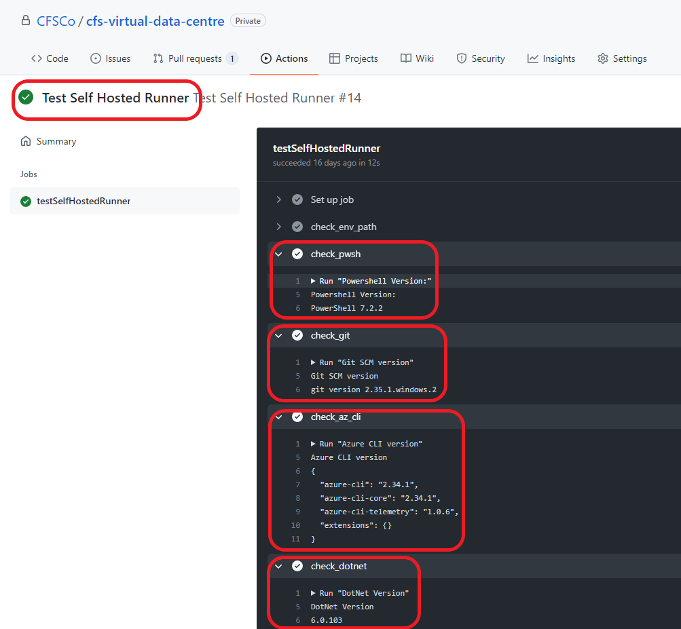

* 1. Troubleshooting
     1. Agent/Runner failed to register

Check the logs for any error related to pipeline code, wrong parameter value or any other issues. Check if the **DeployAgentsRunnersTask** task was successful. If the VMs were already existed, make sure they are turned on. Try re-starting the VMs and run the pipeline again.

* + 1. Agent/Runner showing Offline

Check that VMs are running in Azure portal. If VMs have stopped or deallocated, try re-starting them and run the pipeline again. If re-starting VMs does not solve the issue, VMs could be in corrupt state. Follow manual delete steps to manually deleting agents/runners. And run the “**CFSCo agents runners pipeline**” again.

* + 1. Tools Installation failed on Agent/Runner

There could be various reasons for failing to install the tool. One of the common issues is incorrect tool/app name provided in the Yaml pipeline script. Find the correct name of App you want to install by going to www.winget.run website and use it with in the script.

Other reason could be related to Azure Firewall. Any tool (third party) which is not available either on msstore or winget package repositories, will require additional firewall rules to be added.

* + 1. Agent/Runner failed to de-register

Check if the VMs are running and online. If VMs are not running, first restart them on Azure portal and then try running the “CFSCo.delete-agents-runners-pipeline” again. If for any reason VM’s are not bale to de-reregister, follow the Delete Manual steps.

* + 1. Timed Out

This issue can happen if there are multiple VMs creates at a time. There is a maximum timeout limit on pipeline jobs which is 120 Minutes. Try limiting the number VMs to 1 or 2 at a time. If time out happens during the tools installation, this could be due to Firewall issue.

1. **BROWSERSTACK**
   1. About BrowserStack

BrowserStack is a cloud web and mobile testing platform that provides developers the ability to test their websites and mobile applications across on-demand browsers, operating systems, and real mobile devices.

BrowserStack gives you instant access to their Selenium Grid of 3000+ real devices and desktop browsers. We are using Selenium tests with C# on BrowserStack for this implementation testing.

More Details can be found in “[Integrate Selenium tests with Azure Pipelines | BrowserStack Docs](https://www.browserstack.com/docs/automate/selenium/azure-pipelines#introduction)”

* 1. BrowserStack Account

To use BrowserStack, you must have created an Account on BrowserStack portal (<https://www.browserstack.com/users/sign_up>). The pipeline we have created is based on “**Automate**” product from BrowserStack.

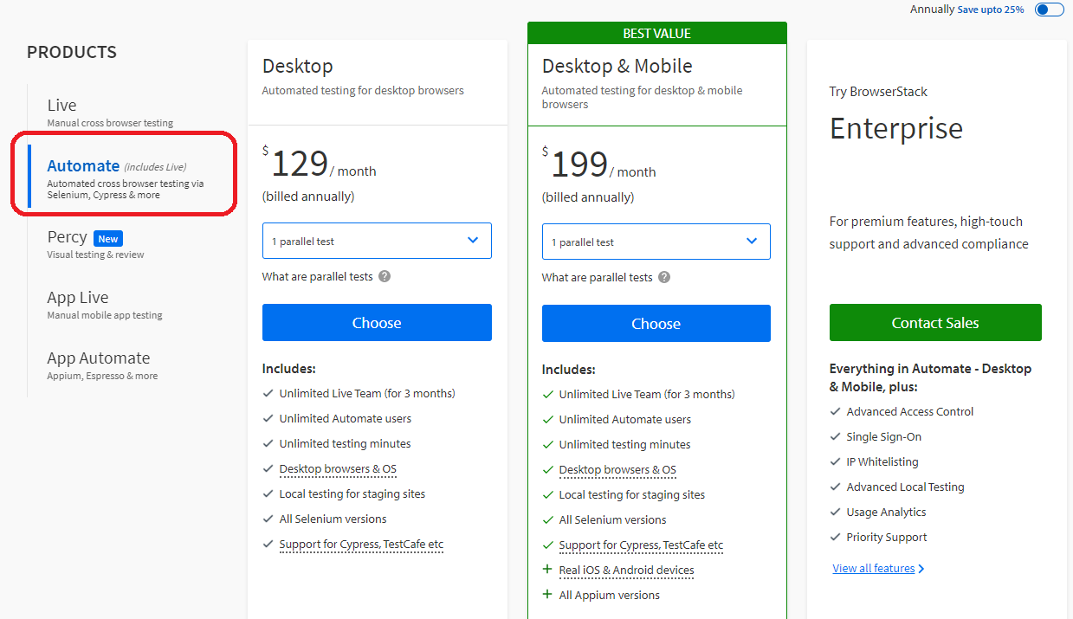

Once email and been verified with BrowserStack, a username and access_key will be available to use.

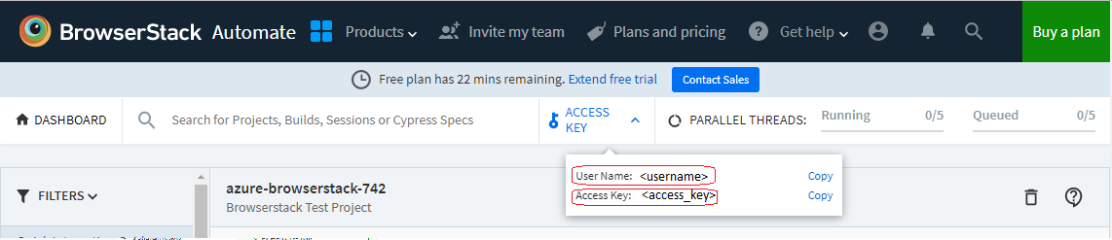

* 1. Install the BrowserStack Azure DevOps Extension

To use BrowserStack with DevOps, we need to install the BrowserStack Azure DevOps Extension. Follow the below steps:

1. In the [Visual Studio Marketplace](https://marketplace.visualstudio.com/), click **Azure DevOps**.
2. Search **for**[**BrowserStack**](https://marketplace.visualstudio.com/items?itemName=browserstackcom.browserstack-vsts-extension) (<https://marketplace.visualstudio.com/items?itemName=browserstackcom.browserstack-vsts-extension>).

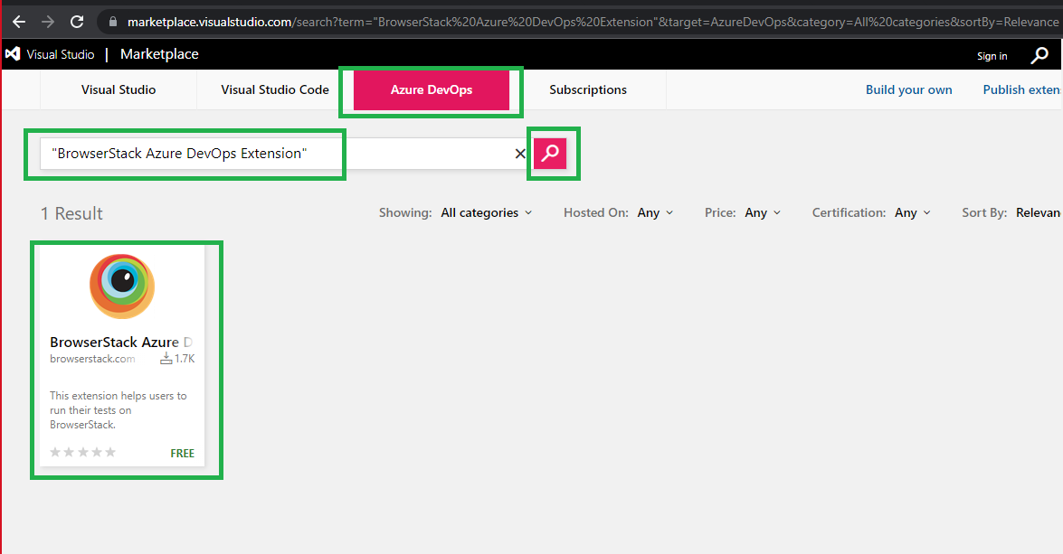

1. In the **BrowserStack Azure DevOps Extension** page, click **Get it Free**.

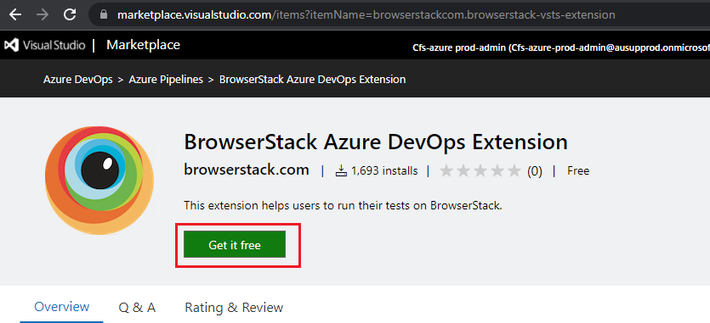

1. The **Sign-in** page opens to sign into your Azure account. After you sign in, **click Select an Azure DevOps organization** and select your organization.

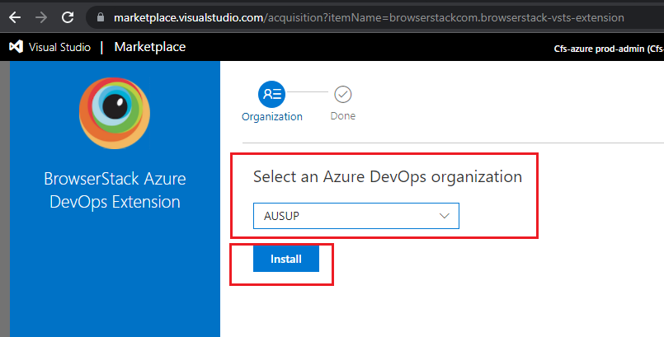

1. Click Install to add the extension. This will Install the extension at ADO Organization level.
2. Installation of extension is complete.

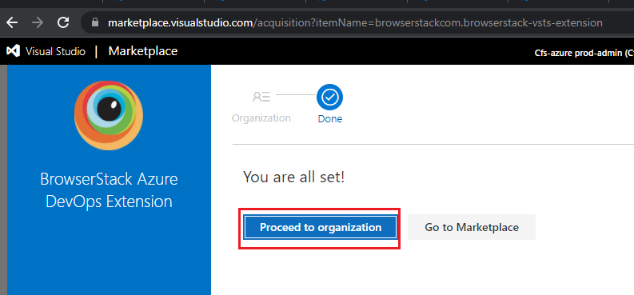

* 1. Service Connection

Before we can use the BrowserStack in the DevOps pipelines, we need to create a service connection as a mandatory step to start. Below are the steps:

1. Create service connection inside the project.

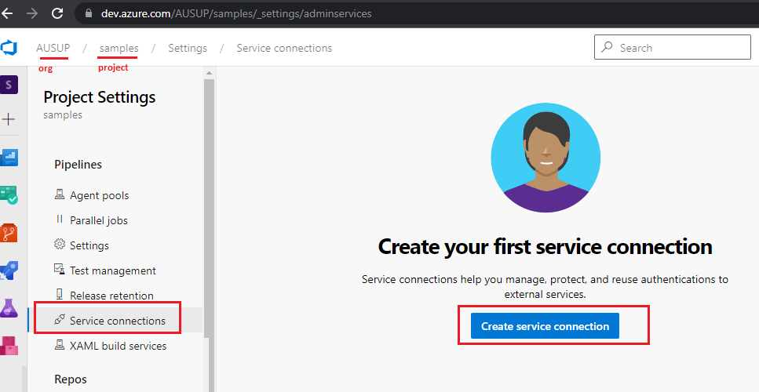

1. Select **BrowserStack**

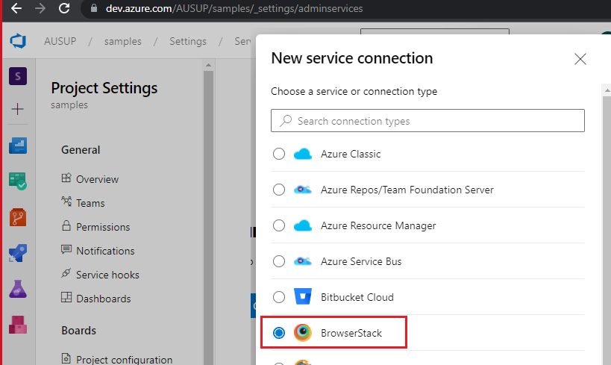

1. Provide credentials and pipeline access options

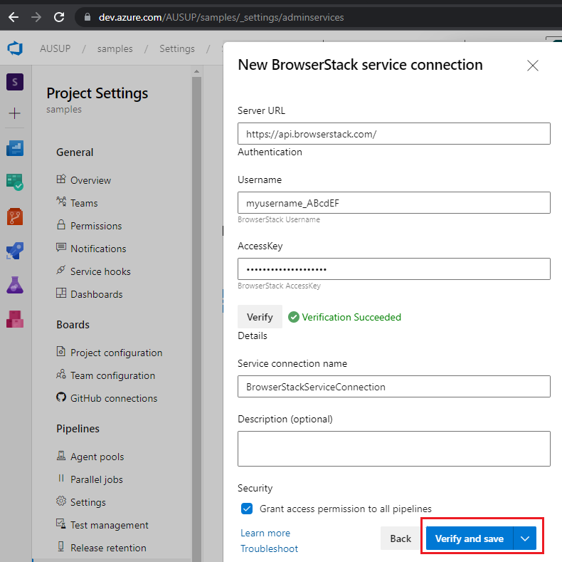

1. Once the username and access key from the BrowserStack has been verified, this will create a service connection.

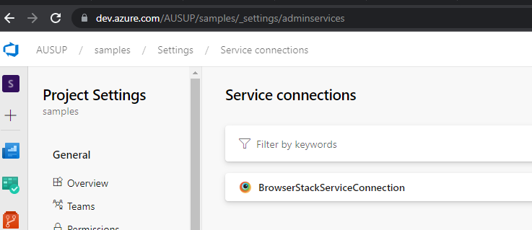

* 1. Testing DevOps pipeline with sample C# code

The sample code for BrowserStack testing can be found in the Sample project. This project also contains azure pipeline that is triggered when code is committed on **browserstack** repo inside this sample project.

* + 1. Sample code for Selenium Webdriver tests with C#

BrowserStack has provided with sample code that we can use to test in the app. We are leveraging the c# code to demonstrate the working pipeline. This sample C#.NET console app can accessible be from Azure Repos under Sample Project

1. Go to <https://dev.azure.com/AUSUP> page and select Sample project.

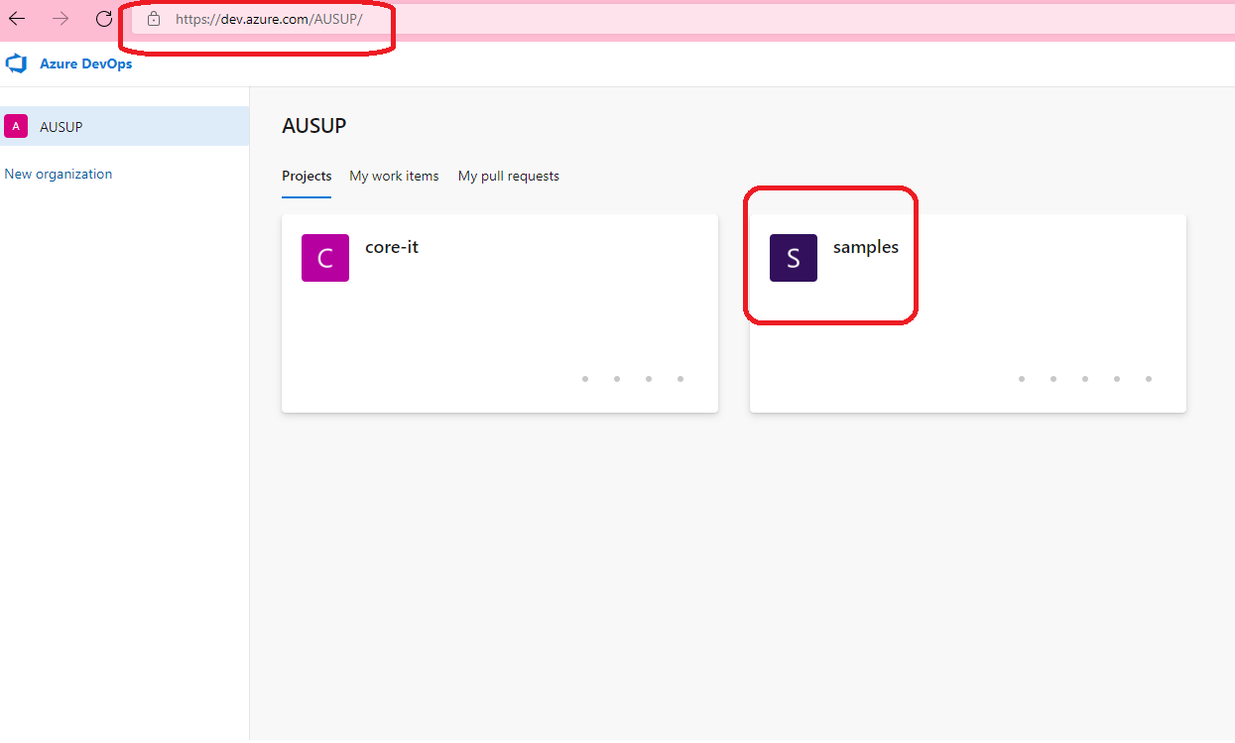

1. Select “browserstack” repo from the top and this will open content within the repo.

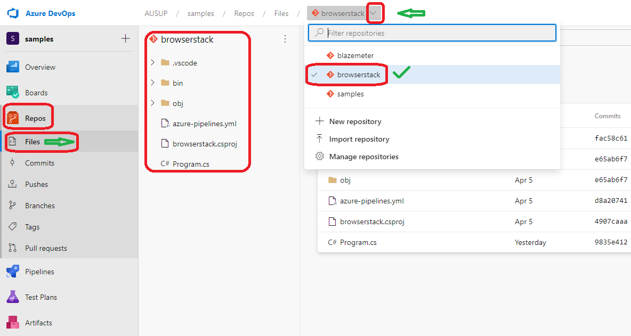

1. Program.cs file contains the sample code taken from BrowserStack documentation. You may refer the link <https://www.browserstack.com/docs/automate/selenium/getting-started/c-sharp> for in-depth explanation.
   * 1. Integrate BrowserStack Automate with Azure Pipelines
2. Prerequisite for integration requires, Service Connection to be setup, and we must use below environment variable within the test code:
3. BROWSERSTACK_USERNAME
4. BROWSERSTACK_ACCESS_KEY
5. BROWSERSTACK_LOCAL
6. BROWSERSTACK_LOCAL_IDENTIFIER
7. BROWSERSTACK_BUILD_NAME
8. A sample pipeline has been created to build and run the C#.NET code whenever code is committed and pushed in the **browserstack** repo.
9. To run the pipeline manually, select the **browserstack** pipeline and Click on Run pipeline.

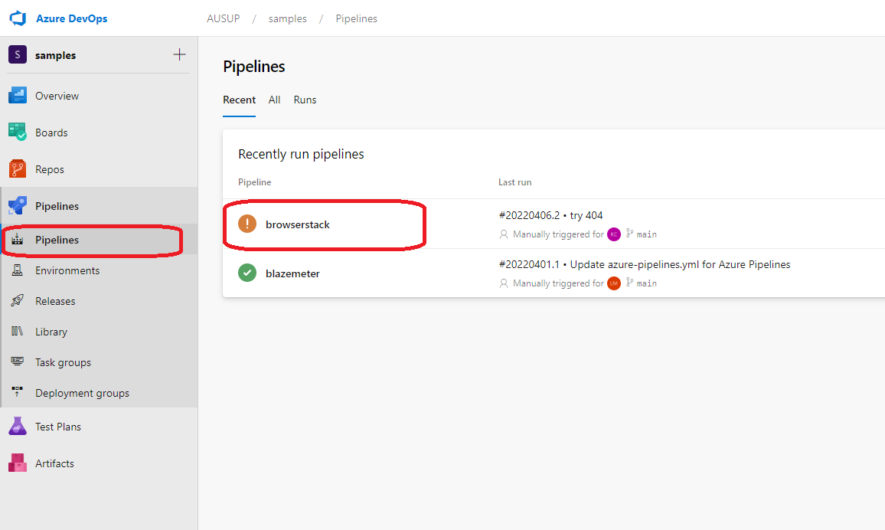

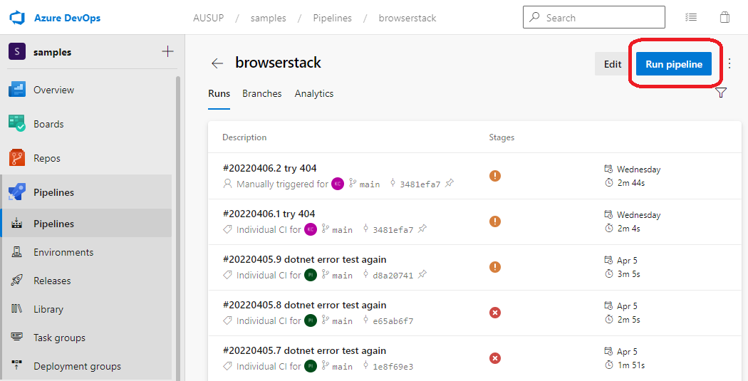

1. Once the pipeline run has finished successfully, the test report will be published on BrowserStack portal.

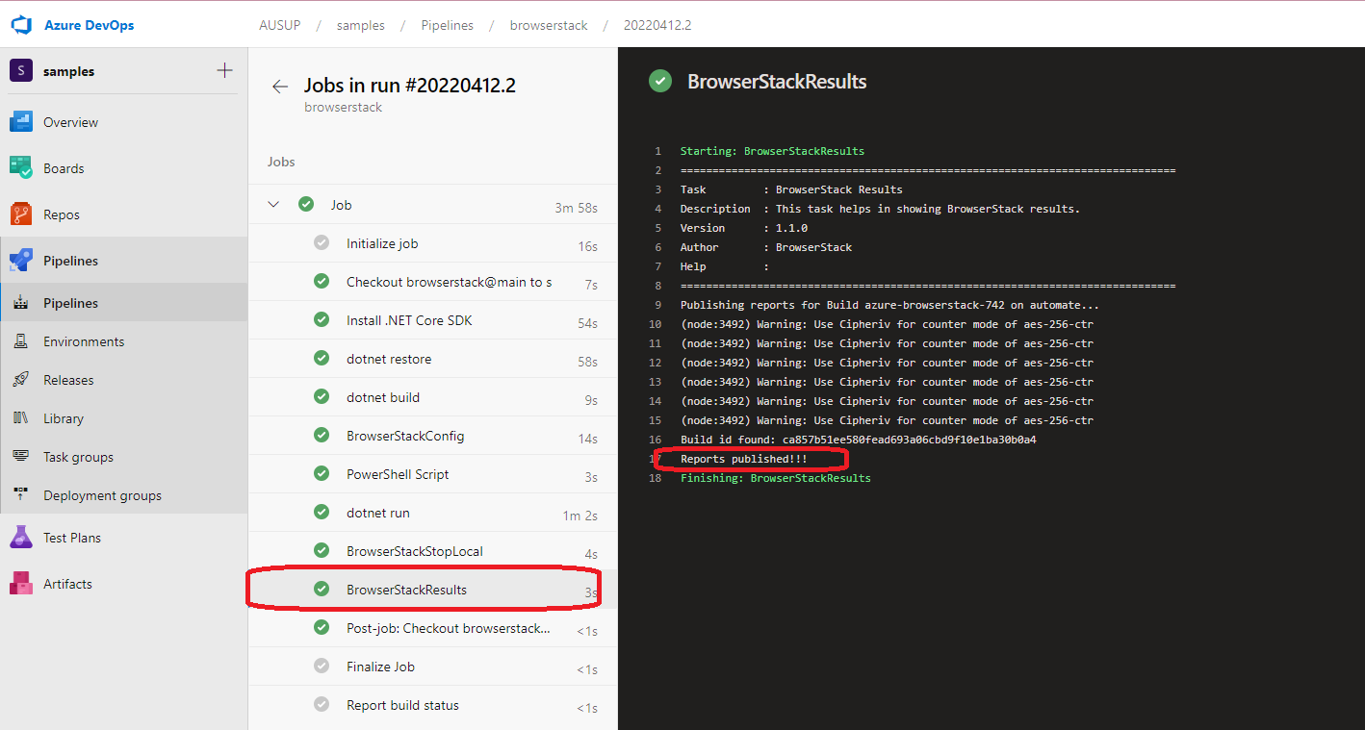

1. Got to BrowserStack portal -> Dashboard and verify the build status.

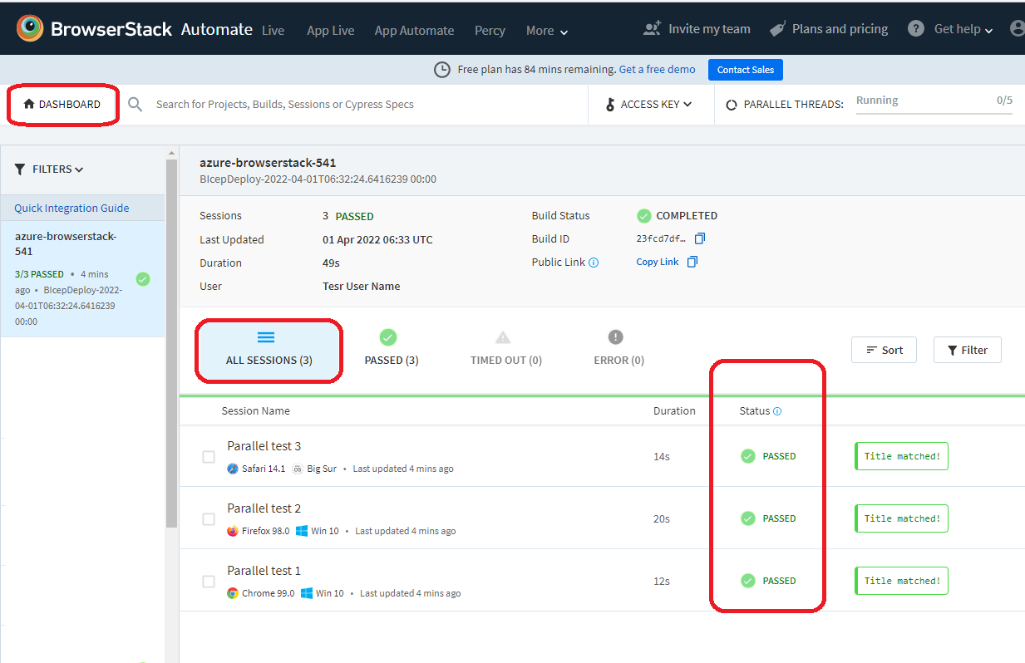

1. Detailed documentation can be found on BrowserStack documentation <https://www.browserstack.com/docs/automate/selenium/azure-pipelines>
2. **BLAZEMETER**
   1. About BlazeMeter

BlazeMeter provides a performance testing tool that you then configure to your particular needs, be it in the form of a load test or stress test or something else. This is where you scale up your test to run across multiple engines and even from multiple locations around the world, if you like.

* 1. BlazeMeter Account

In order to use BlazeMeter, you must have created an Account on [BlazeMeter register page](https://auth.blazemeter.com/auth/realms/blazect/login-actions/registration?client_id=account&tab_id=v7xpVZNBBlw). Below are the available subscription and they also have free subscription with 10 tests only per month.

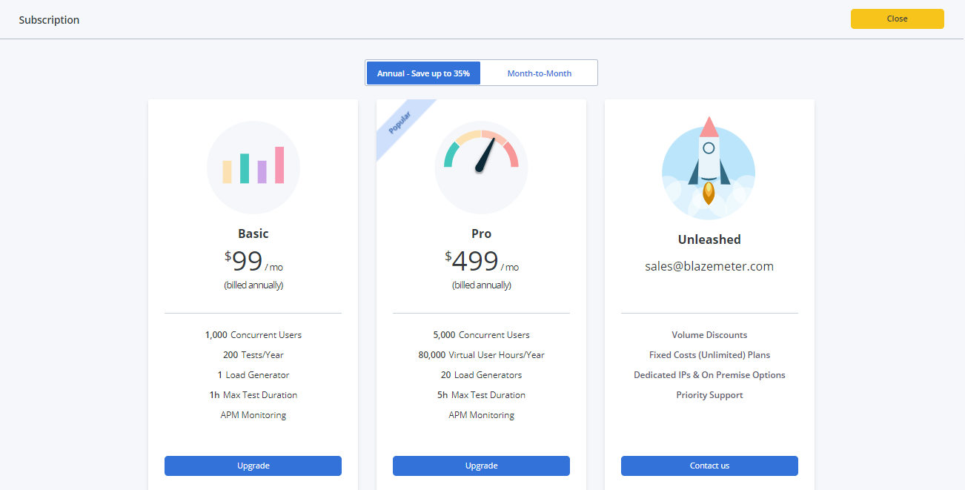

* 1. Creating a performance test

BlazeMeter engines run on Taurus and support various open-source testing tools. Upload your own JMX script to run a JMeter test, or run a Gatling test by uploading a .scala file. In our case we will be uploading and using a JMeter test.

1. In the main menu, click the Performance tab.
2. Click Create Test.
3. Click Performance Test.

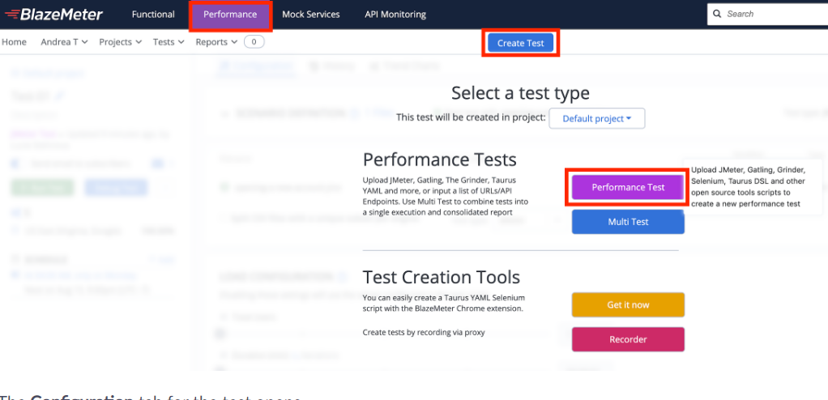

1. Go to Configuration tab. Click + to upload your JMX script and any additional test files, or drag the files over the Upload Script box.

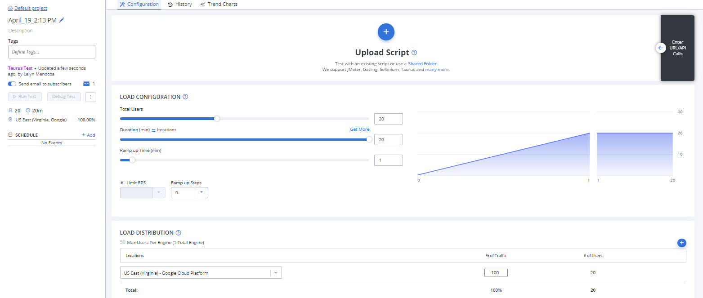

1. Configure your test options and set up overrides in preparation for running the JMeter Performance Test.
2. Click run test or you can also click **Debug Test** to validate your test configuration.

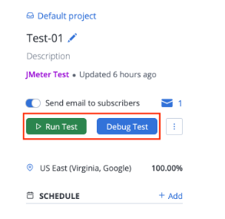

1. After the test run, the test report summary will be uploaded and available on your blazemeter account.

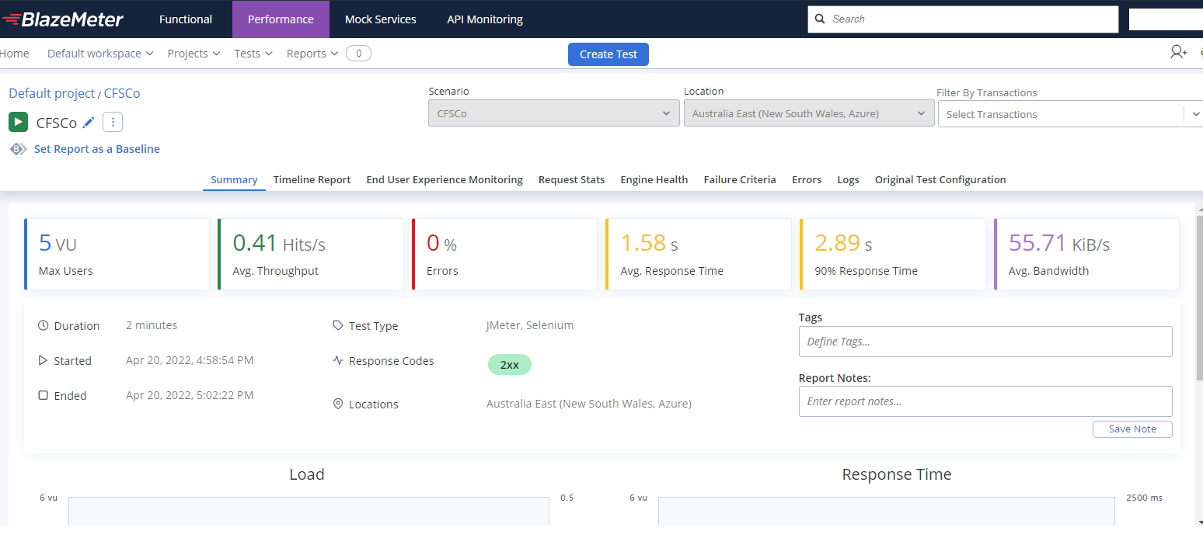

* 1. Install the BlazeMeter Azure DevOps Extension

In order to use BlazeMeter with DevOps, we need to install the BlazeMeter Azure DevOps Extension. Follow the below steps:

1. Go to the marketplace and search for “BlazeMeter Azure DevOps Extension”.

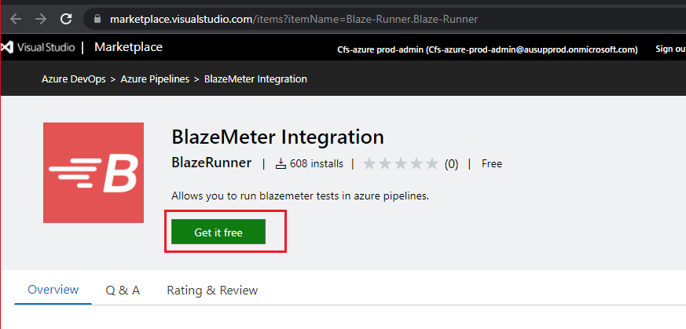

1. Install the extension at ADO Organization level.

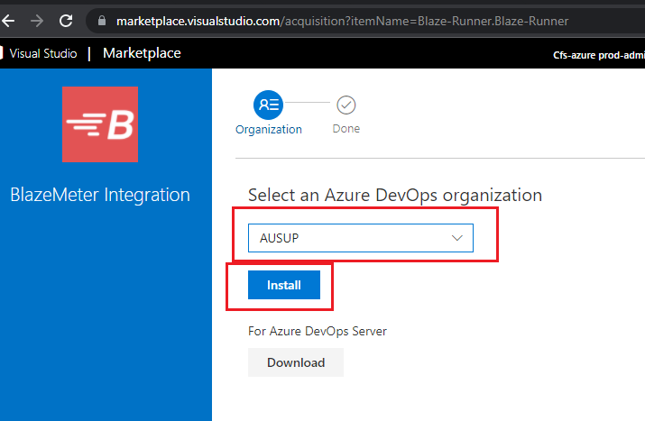

1. Installation of extension is complete.

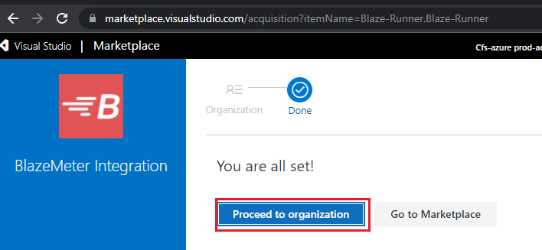

1. You can now include “BlazeMeter Integration” tasks into your pipelines.
   1. Testing via Azure DevOps Pipeline

BlazeMeter tests can now be executed via Azure DevOps Pipelines by using our BlazeMeter Azure DevOps Extension.

* + 1. YAML Pipeline for BlazeMeter Integration

This is a code example on how to run a BlazeMeter test via Azure Pipelines. The Test URL, API Key and API Secret values are stored in Azure Library variables. You may refer to section ***4.5.1 Create variable group*** on how to create variables in Azure DevOps.

variables:

    - group: var-blazemeter-test

steps:

- task: BlazeMeter Integration@2

  inputs:

    testurl: 'https://a.blazemeter.com/app/#/accounts/$(AccountID)/workspaces/$(WorkSpaceID)/projects/$(ProjectID)/tests/$(TestID)/edit'

    apikey: '$(APIKEY)'

    apisecret: '$(APISECRET)'

* + 1. BlazeMeter test reports

1. Once a release is successfully deployed, you will see a screen like below. If any failure criteria have been triggered, the task would show up as Failed.

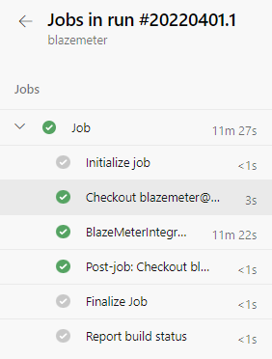

1. Click on BlazeMeter Integration to view the log.
2. The log displays the test Report URL at the beginning of the test execution. You should be able to navigate to that URL to view the detailed report on BlazeMeter.

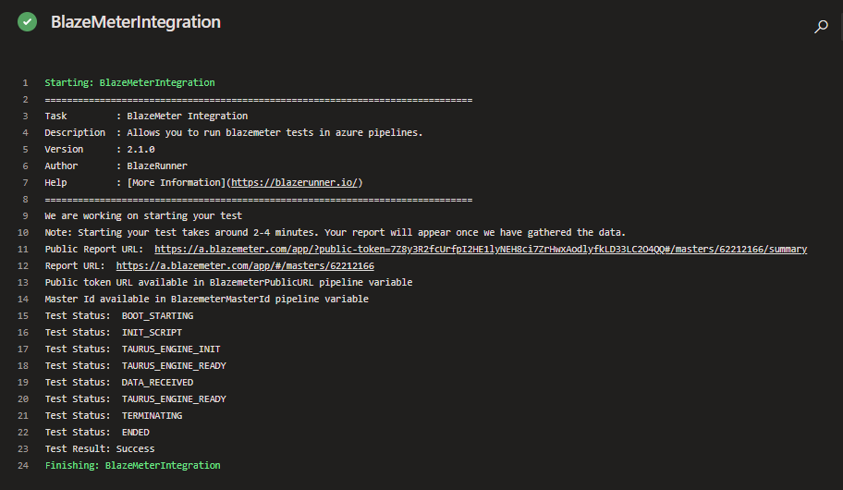

1. **GITHUB PACKAGE REGISTRY**
   1. About GitHub Package

GitHub Packages is a platform for hosting and managing packages, offering different package registries for commonly used package managers: such as npm, RubyGems, Apache Maven, Gradle, Docker, and NuGet.

* 1. Publish NuGet packages with GitHub Actions

You can publish a package to GitHub Packages to make the package available for others to download and re-use. You can configure a workflow in GitHub Actions to automatically publish or install a package from GitHub Packages.

**Prerequisites**:

* Personal Access Token
* Write Access to repository

We use GitHub actions to automatically publish package as part of our continuous integration (CI) flow. This workflow runs CI Build every time a developer pushes code to develop or main branch. If the tests pass, the workflow can publish a new package version to GitHub Packages. The relevant commands are explained in the following table.

|  |  |
| --- | --- |
| Command | Description |
| dotnet build  dotnet pack | Package the project |
| dotnet nuget push | Publish the package to GitHub Packages |